SpineOMatic and Okidata Printer Configurations - Cal Poly Pomona
Environment
OS: Windows 7
Printer Model: Okidata Microline 320 Turbo
Label: spine & pocket labels -- 3” sheet, 2 sets labels per sheet
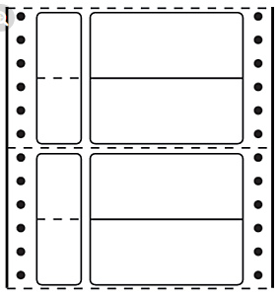
Okidata settings: page length is set to 3”
Add custom size paper to the printer driver
- Open ‘Devices and Printers’ in the Control Panel
- Select the printer: Okidata ML 321 Turbo/D (IBM)
- Click ‘Print server properties’ on the menu bar
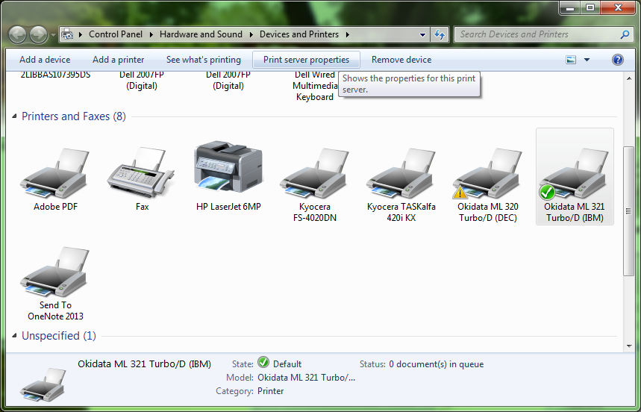
- Click ‘Create a new form’ and enter a Form name, e.g., PerLabel,
- Enter the width and height for your label stock
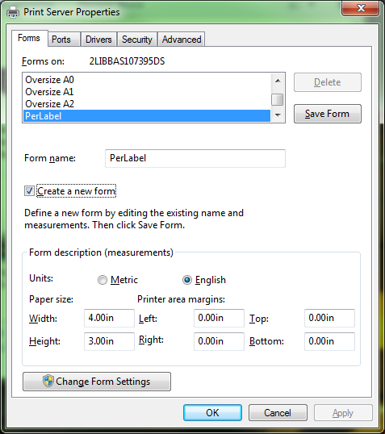
- Click ‘Save Form’ to save the new form settings
- Click ‘OK’ to exit.

SpineOMatic Print Setup
- Select ‘Batch print’ (there are two sets of labels per sheet)
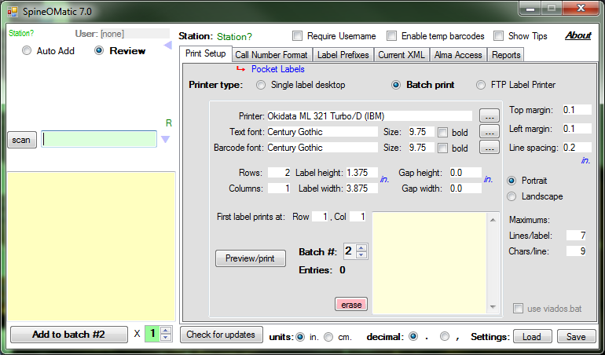
- Printer settings:
  - Click to select the Okidata printer;
Click ‘Preferences’ to set printing preferences
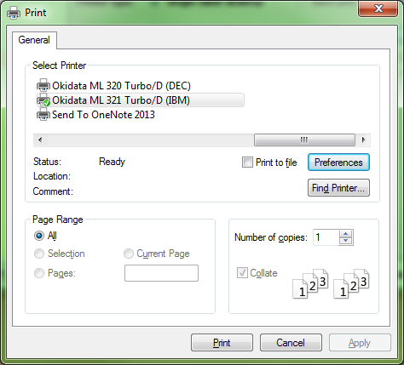
  - Click ‘Advanced..’ to select the newly created form
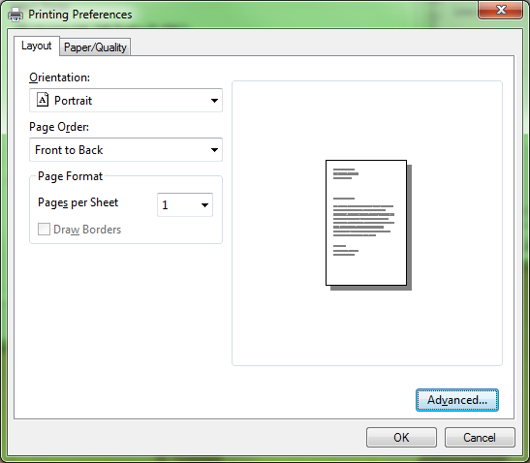
  - For Paper/Output, Select the new form, e.g, PerLabel, from the drop down list;
Click ‘OK’ to save the settings
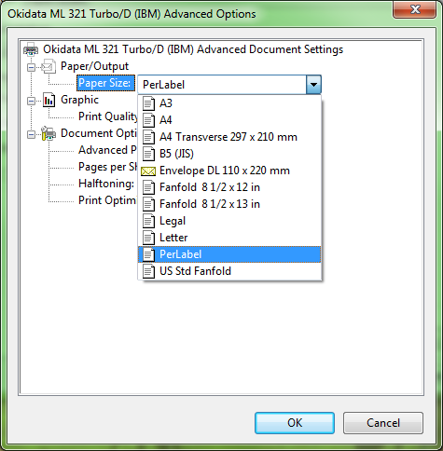
- Define rows, columns, label height, label width, etc. for the label sheet
SpienOMatic Call Number Format
- Select Pocket Labels
- Set Pocket label distance
- We select ‘Custom’ format to print only title on the pocket label

