Spine-O-Matic Instructions (Northridge)
Lauren Magnuson / Marcus Jun, CSUN
- Environment: Windows 7
- Printer: Epson LQ-590 Dot-Matrix Printer
- Label WxH: 3”x 2”
Spine-O-Matic Setup
- Download Spine-O-Matic from http://arc.bc.edu/som/SpineLabeler.exe
- Drag the downloaded file (SpineLabel.exe) program to your Desktop.
- Double-click to open. You may get a popup message telling you the publisher is not verified. Click Run. Agree to the terms of use.
- The application will open up in label printing mode, with all settings hidden by default. To access the settings menus, click the top arrow pointing right:
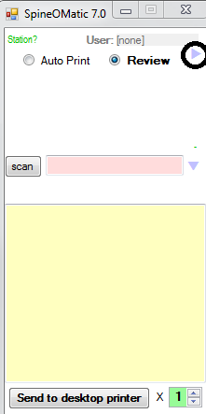

- On the Print Setup tab, select your Epson LQ-590 spine label printer by clicking the … button next to the Printer line:
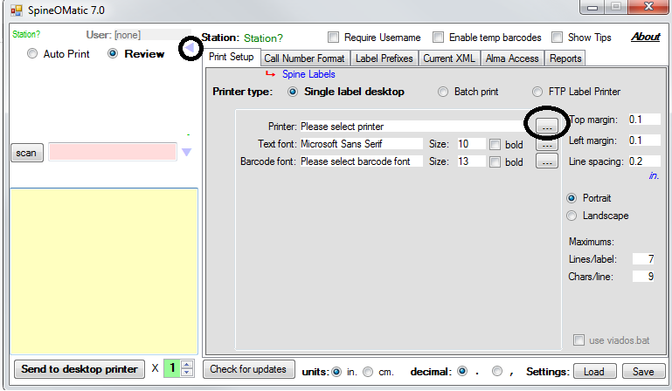

- Click on the Alma Access tab and change the following settings:
- check the button for “Use RESTful API” at the bottom
- Alma URL: https://api-na.hosted.exlibrisgroup.com
- Method: (do not change; looks like : /almaws/v1/items?view=label&item_barcode={item_barcode})
- API Key: copy/paste API key from top of this document (starts with I and ends with 0)

Configuring Epson label printers to work with Spine-O-Matic
- Go to Control panel > devices and printers
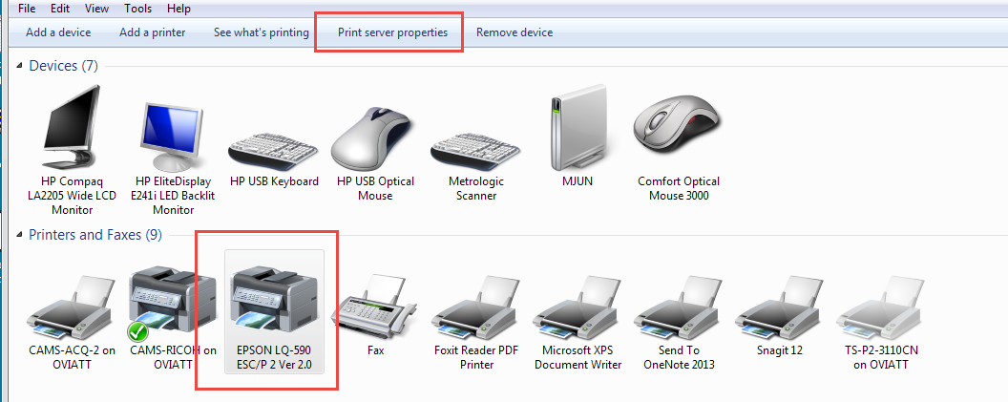
- Select Print Server Properties

- Select Create a new form, type a Form name, and click Save Form
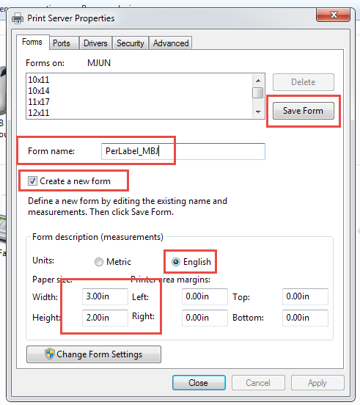

- Right-click on label printer, then select Printing Preferences
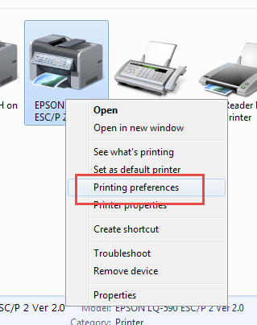

- Select Advanced…
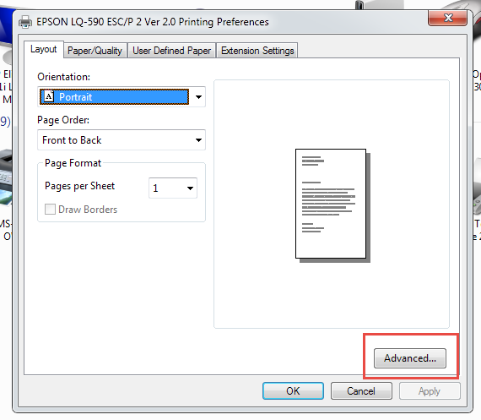

- In Paper Size, choose the form you just created.
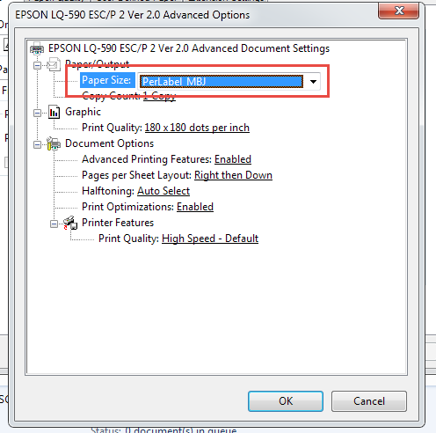
You will get a warning message. It is okay to ignore it.
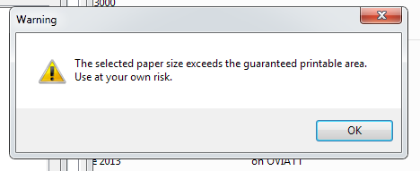
Your printer should now be configured to work with Spine-o-Matic.

