1. **Fresno**: Yes we do for all 15 large, 6 small.   
  
Sent from Peter's iPad

2. Sonoma: Yes, we use Libcal for our 12 study rooms and four media viewing rooms.

Karen

3. **San Marcos**: Yes, here is our awesome system!

<https://biblio.csusm.edu/groupstudy/reservation_calendar.php>

**Jennifer L . Fabbi, Ph.D.**

Dean, University Library

California State University San Marcos

[jfabbi@csusm.edu](mailto:jfabbi@csusm.edu) |  760-750-4330 |  [www.csusm.edu](http://www.csusm.edu/)

4. **Northridge**: Here is our LibCal system:  <http://library.csun.edu/Services/reserve-room>

Mark Stover, Ph.D.

Dean, Oviatt Library

California State University, Northridge

18111 Nordhoff Street

Northridge, CA 91330-8326

(818) 677-2271

[mark.stover@csun.edu](mailto:mark.stover@csun.edu)

California State University, Northridge - Home

5. **Dominguez Hills**: Yes, for all 11 of ours.  We are working on an online reservation system and had explored LibCal.  However, there are issues with LibCal gathering the stats for individuals in the rooms.  Here is the link for us:  <http://www4.csudh.edu/library/services/groupstudy/index#howto>

Stephanie

6. **Bakersfield**: It is currently first come first served, but it is one of my goals to have a reservation system

7. **San Francisco State**: Yes, we have 18 group study rooms that students can reserve themselves directly using EMS. We typically have over 100 reservations for group study rooms every day during fall and spring semesters.

Here's the info. on them: <http://library.sfsu.edu/group-study-rooms>​

There is a link to the reservation system on that page.

Debbie

8. **Pomona:** Yes.  We have 45 and can be reserved online.

Ray

9. **Eastbay**: We have 9 (still can't believe that San Marcos has 40!!). Eight of them can be reserved on D!Bs <http://csueastbay.evanced.info/dibs> -- a good mobile friendly system that sends students a text at the beginning and end of their reservation. The other one is a fancier presentation room that students have to reserve in person.

John

10. **Channel Islands**: 12 first come first serve except final and it is manual.  We are looking for online and had a pilot with room wizard that did not go well.

11. **Sacramento**:

We have 14 group study rooms for undergrads (<http://library.csus.edu/studyrooms.html>) and an additional 15 or so for our grad students.

We recently changed our reservation system as students were able to book for the entire semester and a very small group of students were being selfish and scheduling the rooms for months at a time. Now students can only sign up for a room once a day for 2 hours max. I don’t know what system we use, I suspect it is homegrown. This change went into effect this semester.

The grad student rooms are located on the lower level and are single person rooms that used to be open. Security/police were asking to close the rooms as the homeless and others w/nefarious reasons were taking over the rooms.  I put locks on the door and we now ONLY check them out to grad students on the assumption that they are slightly more mature and will use the rooms responsibly. Also, we have very little space that is grad student specific.

I have also rekeyed all of the faculty rooms and we are restarting that program. When I looked into these rooms when I first started, it was apparent that most faculty had signed up for the rooms over 7 years ago.  We are refreshing all of these services!

Amy

**SECOND QUESTION ON ISSUE OF LOCKED GROUP STUDY ROOMS**

1. Chico State: Meriam Library currently has 26 total study rooms:

19 group study rooms (first come, first served)

7 reservable “Net Study” rooms (with PC and large screen)

All rooms remain unlocked. Library staff rarely need to intervene to enforce reservation times; the students tend to work it out themselves 99% of the time.

2. San Francisco State: Ours are unlocked all the time. Debbie

3. Dominguez Hills: At DH they are locked.  Our staff or students walk students to the rooms and unlock the doors.  Stephanie

4. Sonoma: Ours are unlocked. They can reserve rooms online. I have wondered if there are ever collisions between students who use rooms on a walk-in basis and those who have reserved rooms – this was an issue at my prior institution, since there is no way to know if a room is reserved just by looking at it. I am told it’s not a problem, but then, we haven’t surveyed students in ages.

Karen / SSU

5. SLO: Same at Cal Poly SLO; rooms are unlocked but they can be reserved online. We print the daily reservation schedule and post it in each study room first thing in the morning, so students know when the room is reserved and when is open and available. It's been working well so far; we survey the students every year and this never came up as an issue.

Adriana

6. San Jose: Ron- ours are unlocked at all times Tracy

7. **San Francisco State**: Our group study rooms also reserved online, daily reservation schedule printed and posted in each room for reservations made in advance. Online schedule also available to view, and students can make same-day reservations for any available rooms/times that would not appear on the printed schedule, but would be viewable online. We had originally indicated students should post their confirmation of the reservation when they are occupying the room, but I don't think most do that and we don't enforce it since we can always check the reservation online to see who made it and ask for ID if there is any question.

Debbie

8. **San Diego**: We have a combination of locked (reservable with staff mediation) and unlocked rooms.

9. **Sacramento**: At SacState we have a combination of options.

The undergrad rooms are unlocked and can be reserved. The schedule is online. If empty at 15 after the hour, they are open for fair use.

Our PhD group rooms have a punch code the students use to enter. Not reserved.

Our grad student room keys can be checked out at circ, not reserved (we gave them the choice between semester-long check out and daily. They chose short term).

Our faculty, of course, are locked.

Amy

10. **San Marcos**: Here's an interesting twist. Ours are unlocked, BUT last year, after much discussion and a bit of contention, we decided to put "thumb locks" on our group study doors so they can be locked from the inside in a lockdown situation. Our campus safety manager and UPD were in full support. So far, we have not had any problems of note.

Jen 

11. **East Bay**: At CSUEB, 9 unlocked and 1 locked. The locked room is larger with more sophisticated equipment. I forgot to count in response to the first question. We have 10 rooms it total, not 9.

Almost no issues regarding someone coming in for a reservation and finding someone else there. Students sort it out for themselves. Before we set up the reservation system, however, staff were constantly resolving disputes b/c some students would camp out all day in the rooms or try to use them as personal office space.

John

12. **Northridge**: At Northridge, we have a total of 32 group study rooms and 46 individual study rooms.

Of the group study rooms, 30 are unlocked (all the time) and only 2 are locked.

Of the individual rooms (some of which are reserved for graduate students, assistive technology students, and faculty), 19 are unlocked and 27 are unlocked.

Best,

Mark

13. **Bakersfield**:

19 unlocked Group Study Rooms

11 Unlocked Individual Rooms

27 Locked Individual Rooms (reserved for the semester by individual students, priority to grad students)

We are in the process of developing a reservation system for the group rooms, but currently first come, first served.  Construction of additional large group areas scheduled for summer 2018.

Curt

**OTHER IDEAS:**

1. San Jose: Since we are discussing study rooms, some of you may be interested in our trial of a SmartBlock.  The company is letting us try it for free, including free installation.  Our hope is that we can use these to add to our current number of study rooms, particularly on our collaboration floor in which we have 300 seats.  The floor has become incredibly noisy and although exciting and vibrant, it makes group work a challenge for some of our students.  Currently, there are no study rooms on this floor.   We are going to be seeking feedback from students, but we just installed today and we’ve had literally over a hundred students ask us about it.  Please see the photo below.

Tracy

2. Humboldt: Cool concept.

If folks are interested, we just installed 10 group study areas using a partition wall system (KI), whiteboards and D tables (Steelcase)...

10 'rooms' for just under $20,000 total. Very popular with the students, funny to see how they enclose their areas with mobile whiteboards.

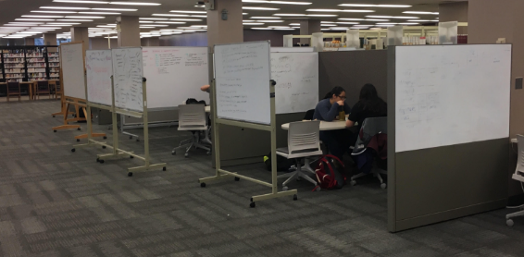

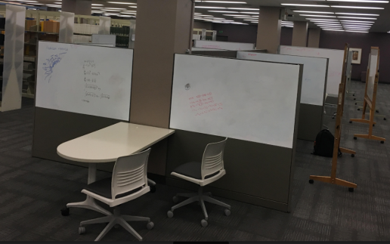

Partition Walls                   $7,183.13

10 Tables                             $5,872.50

30 Chairs                              $6,133.50

                                                $19,189.13 (plus installation of about $4,500)

The partition walls carry power to all the tables between 3 pillars. Fun to design with Keelye Wilson, Library Budget Analyst

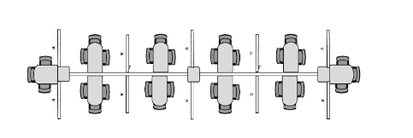

(you should see the 3D plans she made!)

Best wishes,

Cyril

3. Sonoma: Cyril, would love the specs on that. I just ordered 40 more rolling KI markerboards, which have magnetic edges perfect for building ad hoc study spaces. But we definitely need more study areas.

kgs