Primo Central Index Overview

- What’s the difference between Primo and PCI?

Primo is the front end public facing interface to discover your holdings (print, electronic, images) from Alma (OCLC, vendor, CZ records), from external sources such as ContentDM, and from Primo Central Index (PCI)

Each CSU has its own Alma, Primo and PCI to reflect its particular content; and we have the Network zone to reflect our shared content.

- What is the PCI?

Primo Central Index is an index that includes scholarly articles, ebooks, conference proceedings, newspaper articles, and more. Review the PCI collections lists (alternative coverage, books, open access).

- What are you searching in the PCI?

PCI allows you to search both restricted (subscribed databases) and free access data sources.

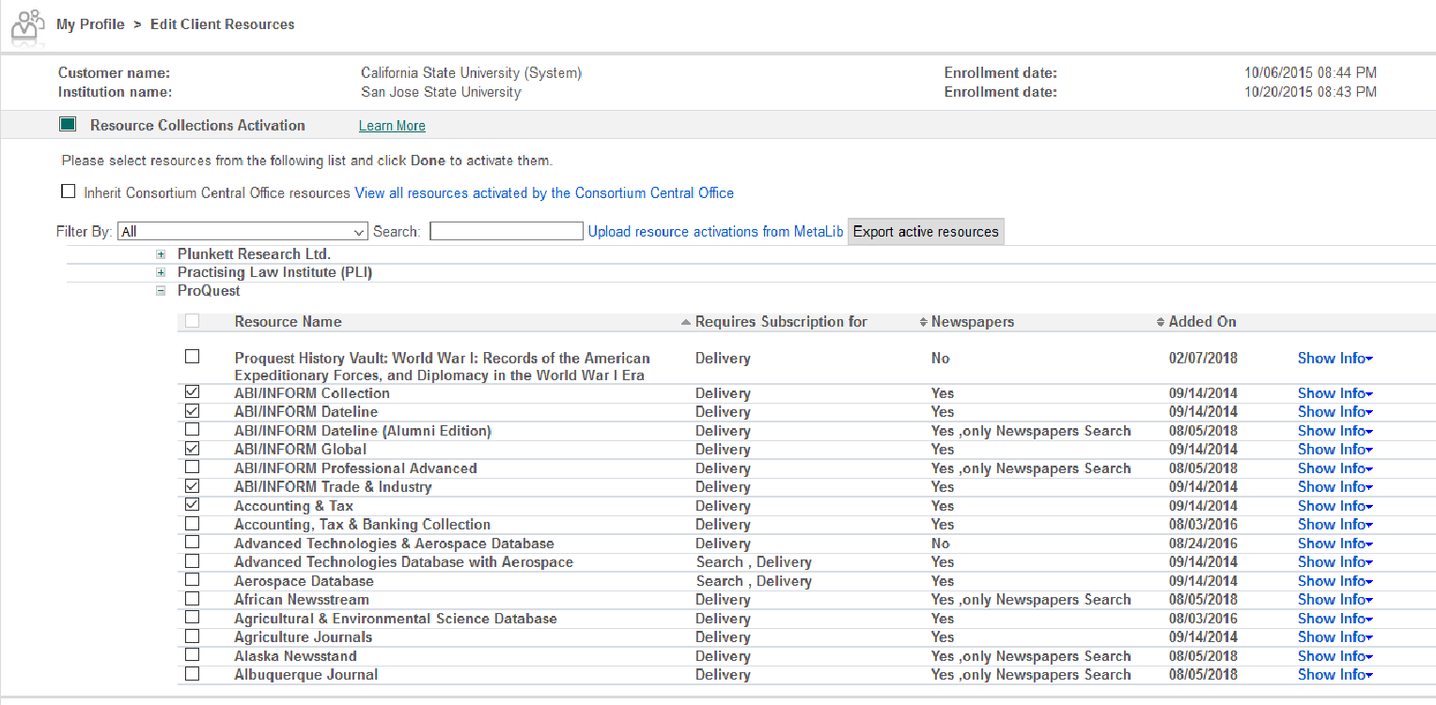

4. What is meant by availability and delivery?

In Primo, delivery for physical resources consists of an availability statement and the ability to place holds or requests. For electronic, delivery and availability may come from a record for an ebook in Alma or it may come from the collections activated in PCI. Availability and Delivery are both controlled by items you activate in Alma. To determine a PCI record's availability, the system must first determine which of the following availability types is supported by the PCI collection

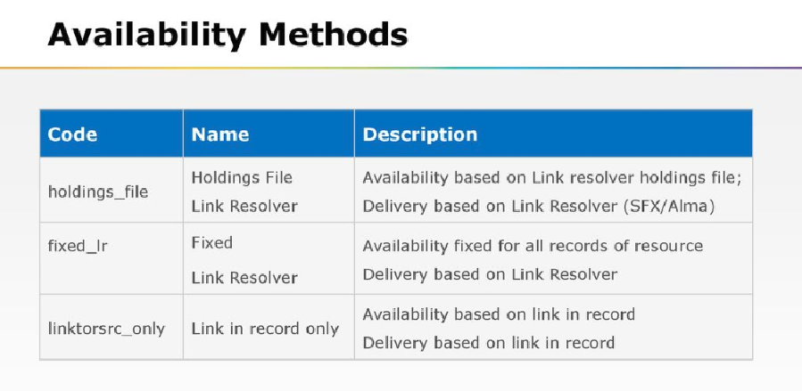

- Your Link Resolver – As a link resolver, Alma publishes the activation status of electronic holdings (all unsuppressed holdings) to Primo Central in an institutional holdings file, which Primo Central then uses to determine the full text availability of electronic holdings for each institution. Availability is determined by what’s in your Institutional Holdings file, a publishing profile in your IZ that runs weekly.
- Link in Record – Based on the presence of a direct link to the resource in the record. Known as “fixed availability”. The Link in Record availability type is usually provided when the vendor cannot supply sufficient metadata for matching against holdings, or when it is the only way to reach the full text (for an image collection, for example). PCI prefers to use the Link in Record method for free for delivery collections and for subscription collections when holdings matching cannot be used.

Here’s a list from Primo Central Index Availability Delivery Method (September 2018)

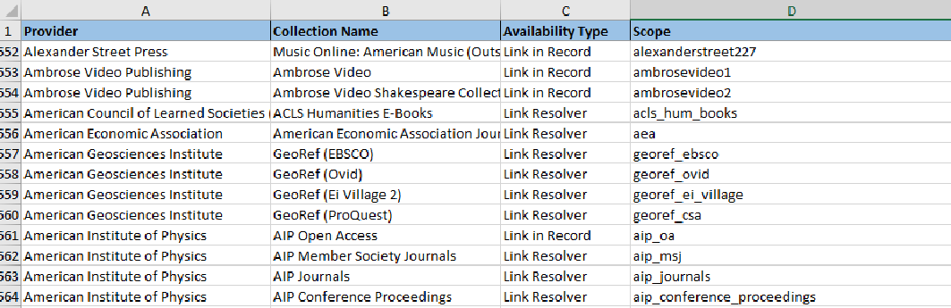

From PCI:

ProQuest ABI/Inform uses availability type link resolver.

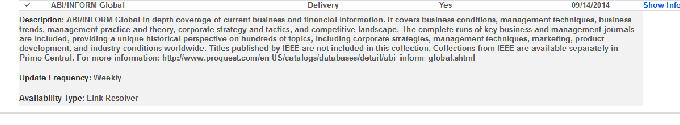

ProQuest History Vault uses availability type Link in Record

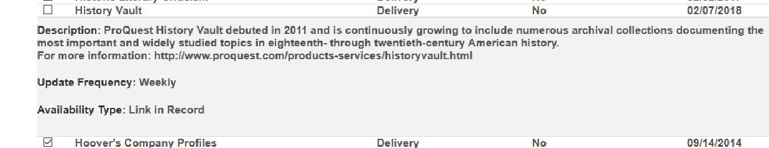

Alexander Street Press Am. Civil War uses
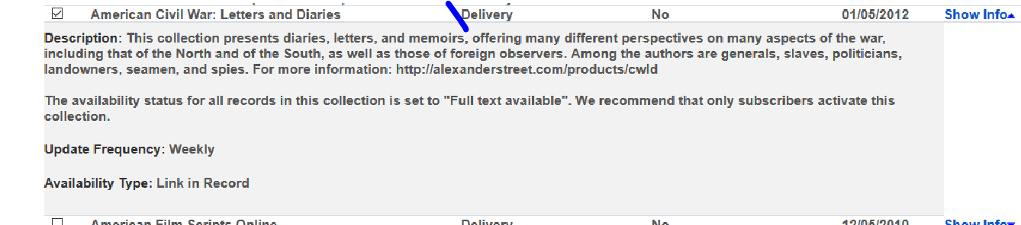

Here’s an example for Encyclopedia Britannica for “Link in Record”. It’s activated in PCI and Alma.

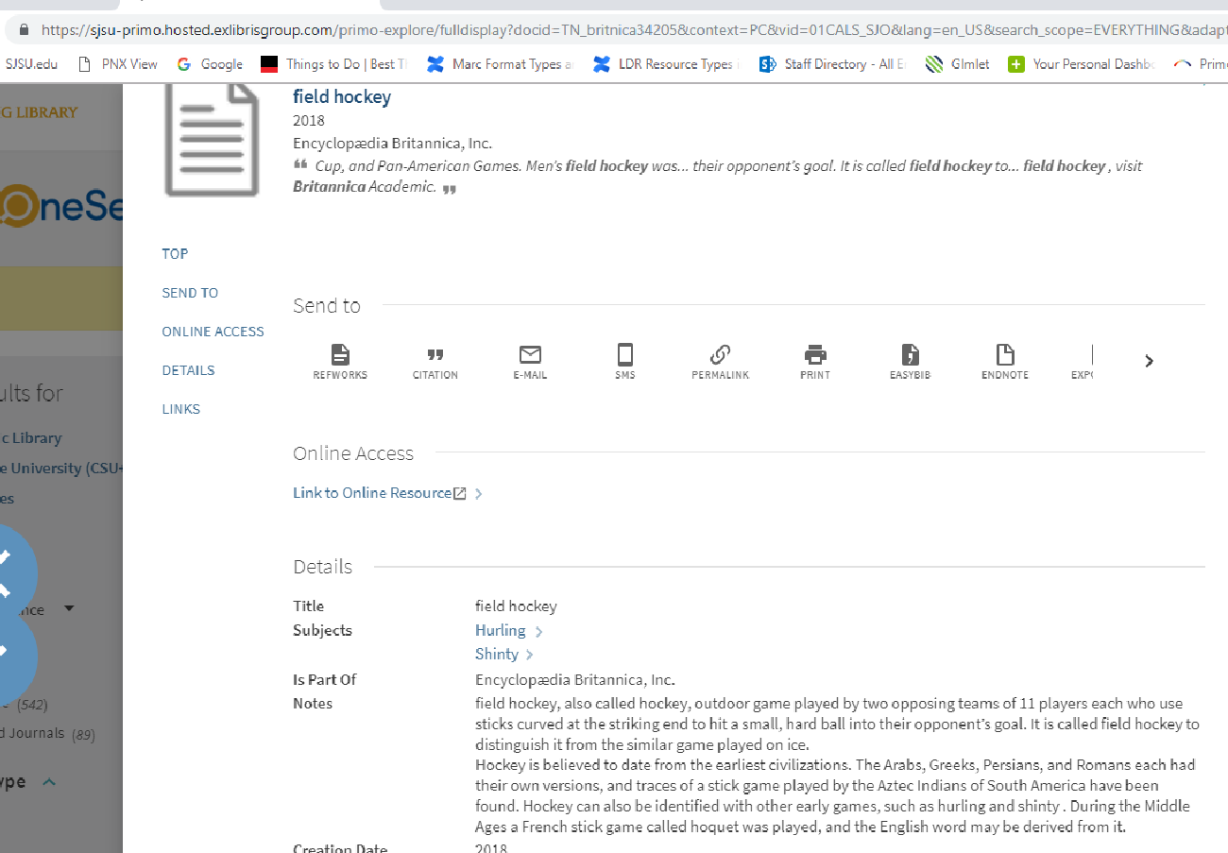

For more information:

Publishing to Primo Central Index (also includes Configuring the Publishing Profile)
Primo and Alma - The_Synchronization of Alma with Primo and Primo Central

5. How to identify a record from the PCI for an article?

Look at the “source” found at the bottom of a record, or possibly “link” at bottom of record, and also the “docid” in the URL. Here’s an example:

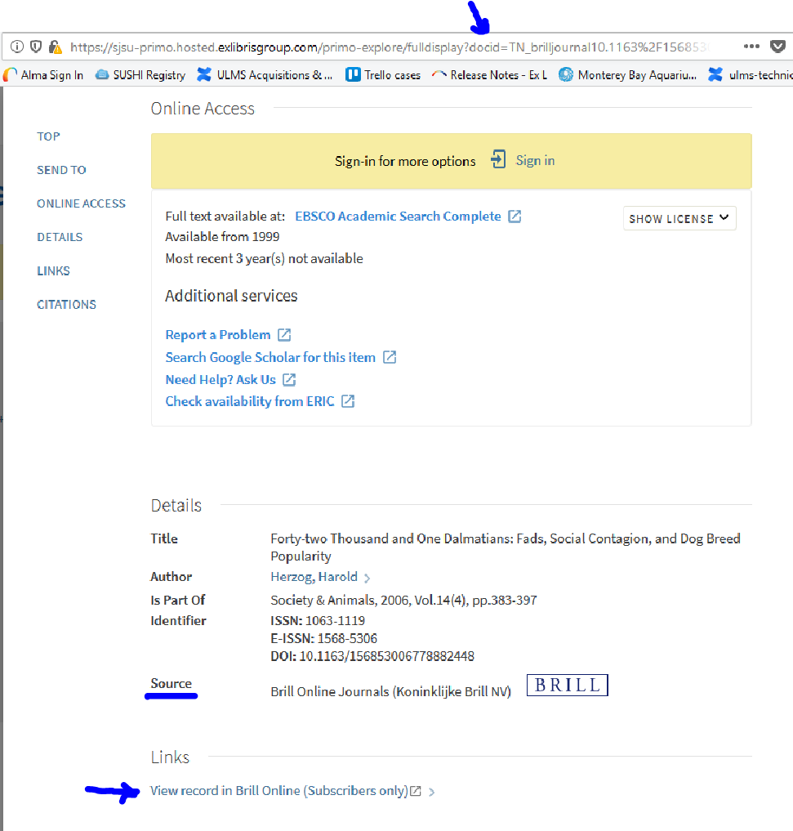

6. How to identify an ebook in Onesearch is from Alma not the PCI?

Look at the source:

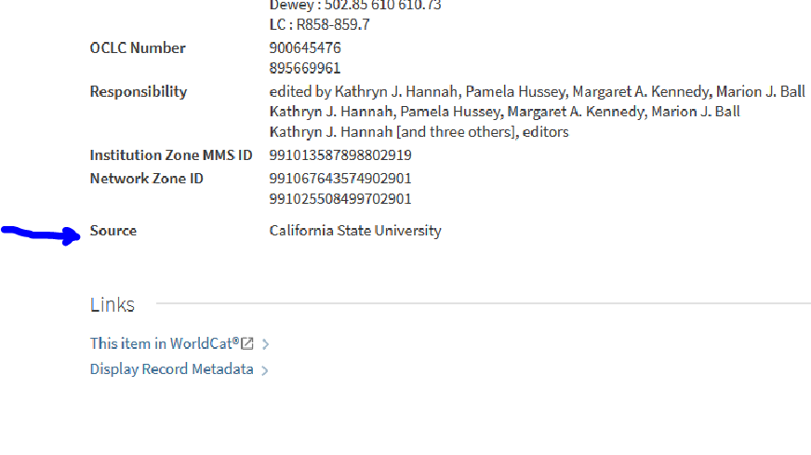
Or the docId in the browser address. Notice it says 01CALS_Alma
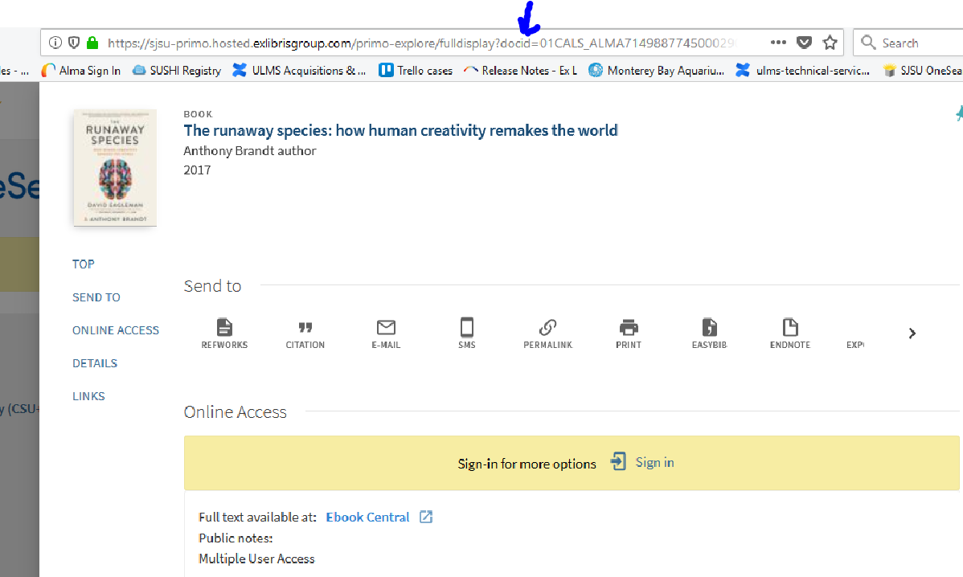

7. If I activate in Alma and not PCI then what will display in Primo/OneSearch?

Only ebook and ejournal records from ALMA will display in Primo. Nothing from PCI will display (no articles, reviews, book chapters, etc). If you want things like book chapters, articles, and reviews for the collection you’re activating to also display in Primo, then you need to activate the corresponding PCI collection. For example, if you only activate the portfolios from the ABC EJournals e-collection in Alma, but you DO NOT activate the corresponding PCI Collection, then you’ll only see ebook and/or ejournal level Alma records appear in Primo. If you also wanted to see article level records display in Primo for ABC Ejournals, you’d need to activate the ABC Ejournals PCI collection as well.

A side note to the above info: If you don’t activate the corresponding PCI Collection (ABC Ejournals), but have other alternative PCI Collections activated (ex: DEF Ejournals) that have some overlap in the content they index (i.e. the same article is indexed in ABC Ejournals and in DEF Ejournals), then you may still see some article results in Primo in some instances as a result of this.

8. Are EBSCO e-books and articles included in Primo search results?

EBSCO has chosen not to contribute content to the Primo Central Index (PCI). However, most article and some e-book content indexed by EBSCO is also indexed by other providers who do cooperate with Ex Libris by contributing content to the PCI ("alternative coverage"). Access to this material can be achieved by activating these alternative coverage collections for searching in Primo Central. EBSCO databases activated in Alma have no equivalent or corresponding collection in PCI. However, by activating alternative coverage (a database such as Gale OneFile), your EBSCO articles will display in OneSearch.

9. If I activate in PCI but not Alma what will display in Primo/Onesearch?

The PCI records (articles, ebooks, reviews, etc) that are indexed in PCI collections you activate (let’s say ABC EJournals) will be discoverable in your Everything and Article search scopes ONLY. Nothing will appear in the ALL CSU search scope. However, in this scenario, the PCI records you find in Primo will show NO FULL TEXT if you do not also activate the corresponding portfolios in the ABC Ejournals e-collection in Alma.

As a link resolver, Alma publishes the activation status of electronic holdings (all unsuppressed holdings) to Primo Central in an institutional holdings file, which Primo Central then uses to determine the full text availability of electronic holdings for each institution. The Institutional Holdings file is a publishing profile in your IZ that runs weekly. So, if you don't activate the ABC Ejournal collection’s portfolios in Alma, then the PCI records for the articles in that collection will show No Full Text. You also will not see any journal level records for that e-collection in Primo. It doesn't know what you have.

The same rule applies to Open Access PCI collections that use the link resolver, but which are not activated in Alma. The PCI records will be discoverable in the Everything and Article searches, but will show NO FULL TEXT. (The only exception for needing to activate in Alma is if the PCI Collection you’re selecting is the Link in Record type OR if there simply aren’t any portfolios available (either CZ or local) that can be activated in Alma).

