ProQuest DDA Ebooks -- Suppressing Visibility from PQ LibCentral in Batch
8/22/2018

- Copy column of ISBNs

- Log on to ProQuest LibCentral

- Select “Title Match”
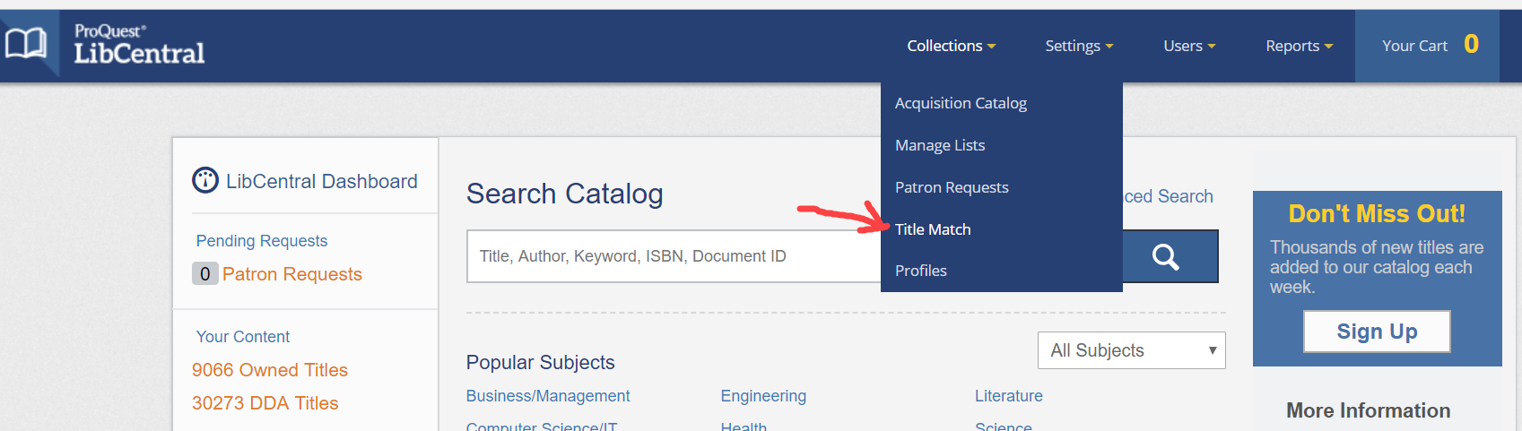

- In Title Match search,
- Under “List Data” paste the list of ISBNs as text only
- Under “Visibility” choose Don’t Update AND Only Add Visible Items
- Click Submit
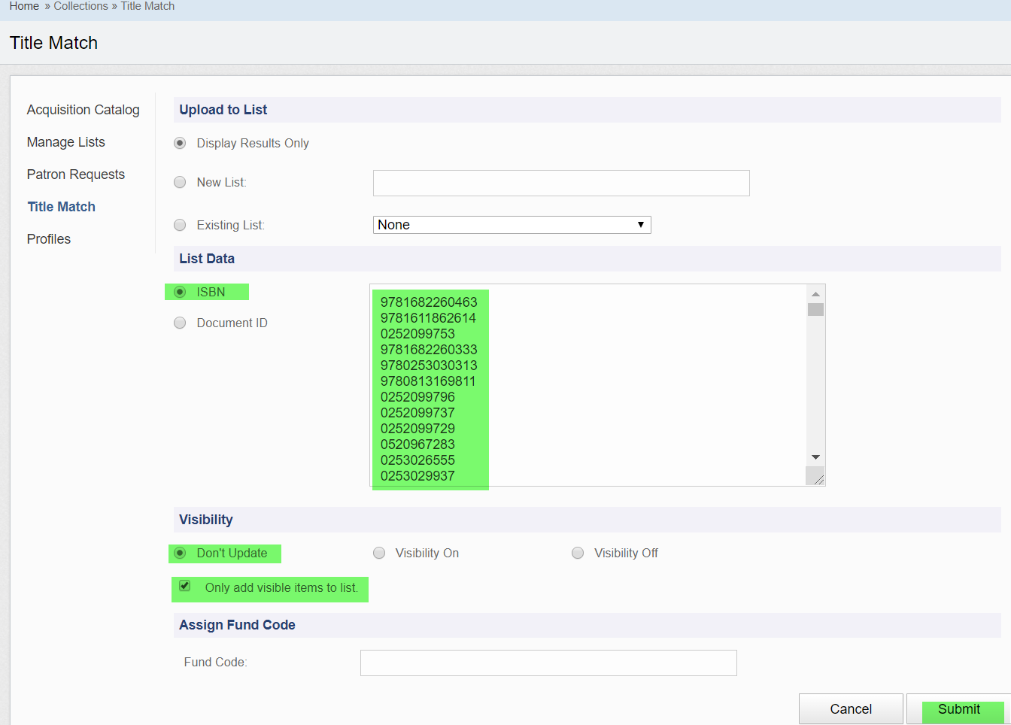
- Select “View Matches” for list of results
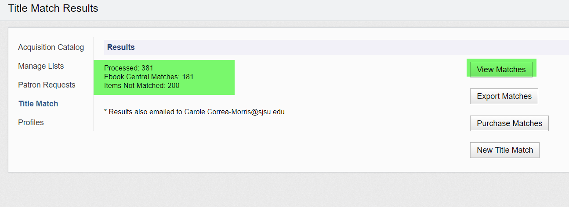At

- At results page:
- Under “Holding Type”, check “DDA” titles. (to avoid suppressing any owned or subscribed titles.)
- Once filtered to DDA only, click to “Select All.”
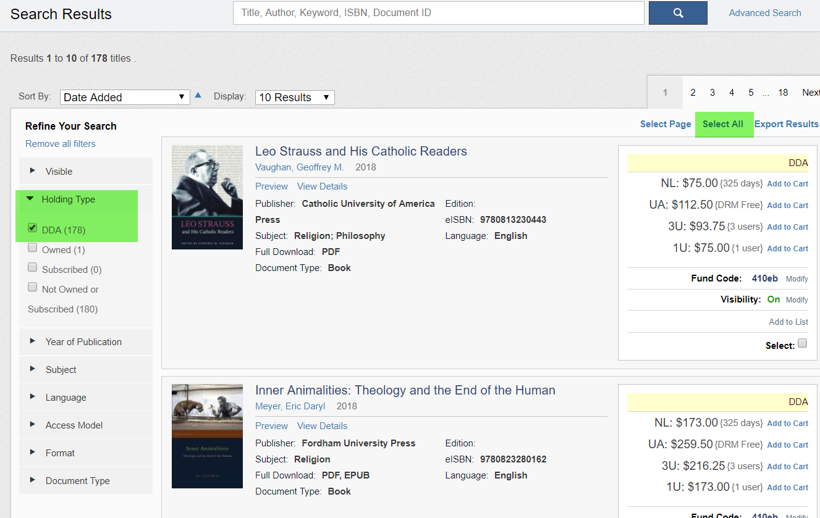

- Choose “Update Selected.” (Note: visibility is shown as “On.”)
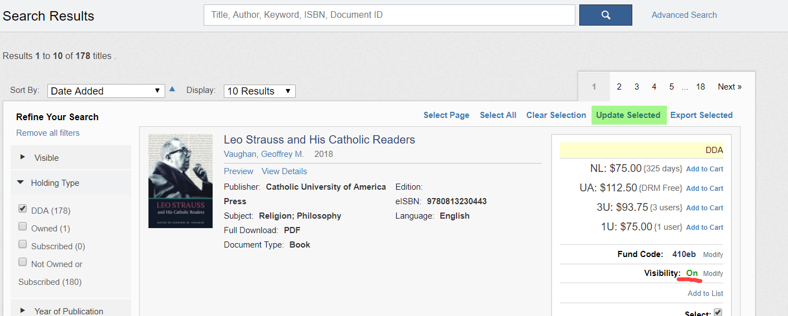

- At pop-up window:
- Check “Update Visibility” and the “Off” button
- Scroll down and click “Save”
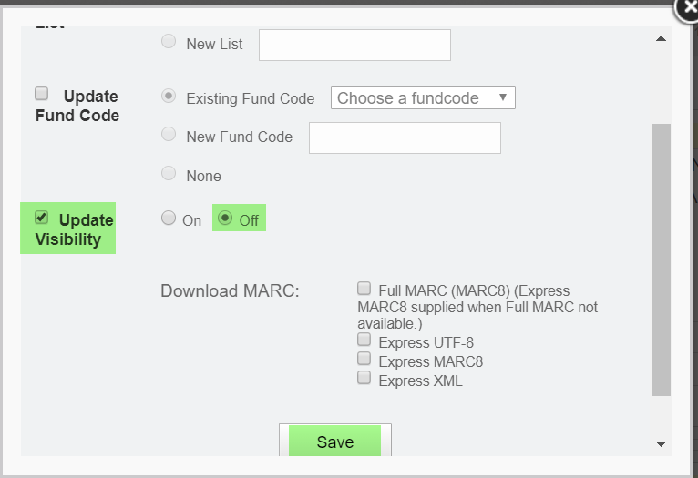

- Visibility now displays as “Off.”
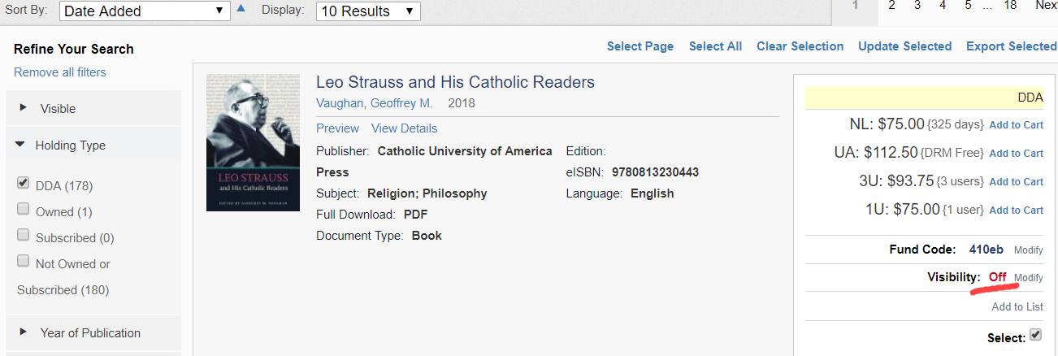

Done.

