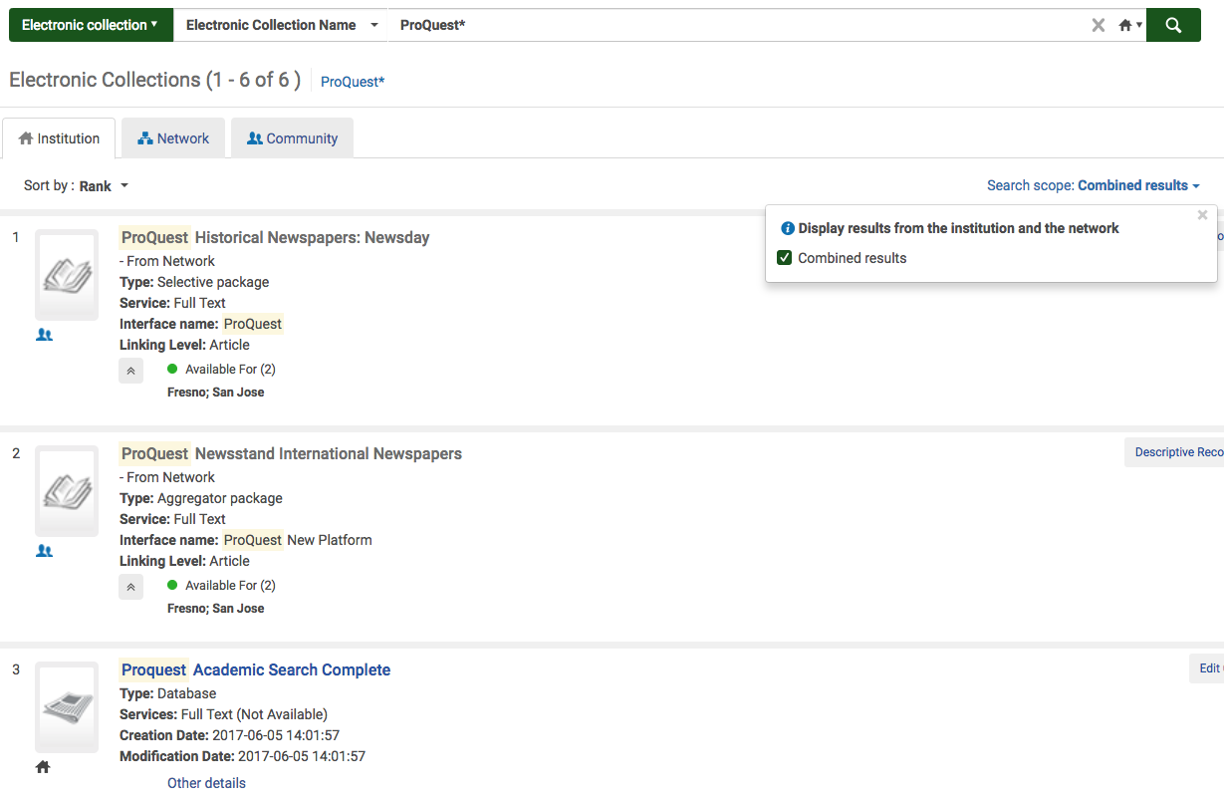
IZ-only
Institution Zone search
Combined results
NZ &IZ
Combined search checkbox

Combined search results of the IZ and NZ e-collections from the IZ can be set up in Alma.
A library can search their local and shared e-collections from the IZ tab.

