Tax Handling in Alma Invoicing

Contents
Introduction 1
Scenarios 1
Scenario 1: Vendor bills tax correctly 1
Option 1a: Use VAT functionality with invoice-level calculation 2
Option 1b: Use VAT functionality with per-line rates 2
Option 1c: Ignore built-in VAT functionality; create all lines manually 3
Scenario 2: Vendor bills no tax; use tax must be reported 3
Option 2a: Use “Report tax” function with government vendor 3
Option 2b: Use “Exclusive” VAT function to remove tax from “Total amount” 4
Option 2c: Ignore built-in VAT functionality; create a separate invoice manually 4
Scenario 3: Vendor partially bills tax; remaining use tax must be reported 4
Option 1a: Ignore built-in VAT functionality; create a separate invoice manually 4
Other scenarios and options 4
Manually create Use Tax lines as part of invoices 4
Use Adjustment lines to automatically create a separate taxes line 5

Introduction
This document describes options for handling taxes in invoices, including scenarios for vendors properly billing for tax, vendors failing to bill for tax (use tax), and vendors partially billing for tax.
Information in this document is supplementary to the Ex Libris Knowledge Center’s Alma Product Documentation, which is the authoritative (and up-to-date) resource for Alma functionality. See, in particular, the following page, which contains information about all Tax (VAT) fields, including examples of how the system calculates tax in different scenarios.
https://knowledge.exlibrisgroup.com/Alma/Product_Documentation/Alma_Online_Help_(English)/Acquisitions/030Invoicing/020Creating_Invoices
Note that the details of the interface may change as the Alma UX project is deployed into production.

Scenarios
The following scenarios describe different options for vendor billing: the vendor bills taxes correctly, the vendor fails to pay or bill taxes, and the vendor partially bills taxes. For each scenario, several options are described depending on the needs of the library for recording and reporting tax.

Scenario 1: Vendor bills tax correctly
In this scenario, the vendor has billed tax correctly on the invoice. The goal is to report the tax as billed to be paid to the vendor. In all examples, assume two resources billed at $60 and $40, with a shipping charge of $10.

Option 1a: Use VAT functionality with invoice-level calculation
Choose this option to use built-in VAT calculation across an entire invoice. Note that this does not support differing tax rates for different lines. (See 1b for line-level tax rates.) In this scenario, both the material and shipping charge are taxed at the same rate of 9%, and expended from the same funds as the base materials. Shipping charges are recorded as an additional line.

Workflow
- Create an invoice header. Under the "VAT" section, enter the tax rate in "VAT %" as “9.0”. Select "Inclusive" to reflect the fact that the vendor has billed tax and it is included in the amounts set for each line. Check the “Expended from fund” box to include tax charges in the funds billed for the materials.
- Create the invoice lines.
  - Add a line for the $40 material. Price: 43.60. Expenditure amount: $43.60 (price + tax).
  - Add a line for the $60 material. Price: 65.40. Expenditure amount: $65.40 (price + tax).
  - Add a line for $10 shipping. Price: 10.90. Expenditure amount: $10.90 (shipping + tax).
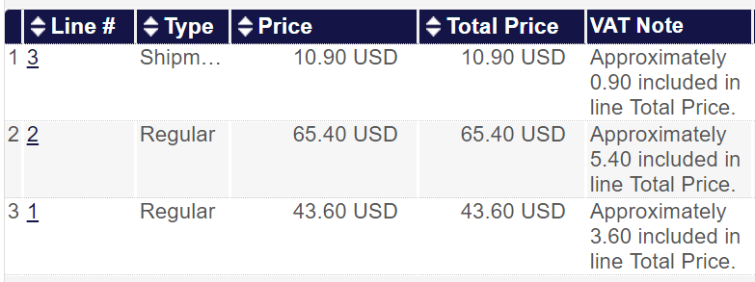
- Choose “Save and Continue” to finalize the invoice.

Notes
- In the above example, all taxes are included in the materials funds, and the tax amount is reflected in the “VAT Note” field.
- You can optionally configure a VAT percentage to be set by default for all new invoices. This option is under Acquisitions configure --> General --> Other Settings --> vat_percent_default
- You can optionally configure "VAT codes" that allow you to select the tax percentage from a drop-down. VAT codes are designed to reduce errors from manual input, and will remove the option to manually enter the VAT rate.

Option 1b: Use VAT functionality with per-line rates
Choose this option to use built-in VAT calculation when different lines have different tax rates (e.g., when shipping is not taxed, or different materials are subject to different tax rates). Alma will calculate the appropriate percentage for each line. In this example, materials are taxed at 9%, while shipping is untaxed.

Workflow
- Create an invoice header. Under the "VAT" section, check the "VAT per invoice line" option. For "VAT type", choose "Line Exclusive". This will allow you to add tax to each line in addition to the list price of materials.
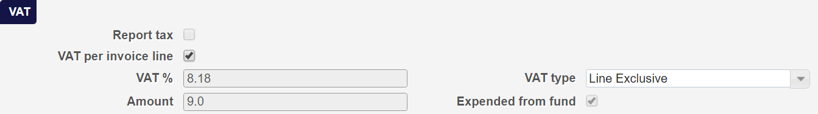
- Create the invoice lines.
  - Add a line for the $40 material. Price: 40. VAT%: 9.0. Beneath the fund, select "Redistribute lines" to add the tax to the total expenditure. Expenditure amount: $43.60 (price + tax).
  - Add a line for the $60 material. Price: 60. VAT%: 9.0. Beneath the fund, select "Redistribute lines" to add the tax to the total expenditure. Expenditure amount: $65.40 (price + tax).
  - Add a line for shipping. Price: 10. VAT%: 0. Expenditure amount: $10 (shipping).
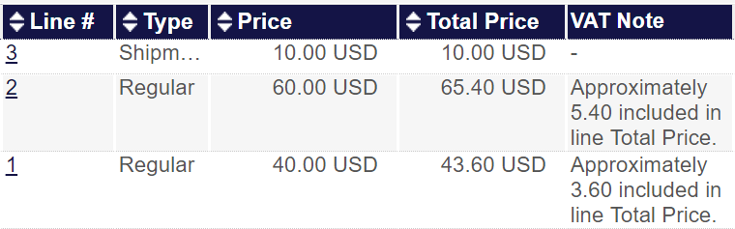
- Choose "Save and Continue" to finalize the invoice.

Notes
- This approach requires enabling "invoice_allow_vat_in_line_level" under Acquisitions Configuration --> General --> Other Settings
- The invoice header “VAT %” field will reflect an incorrect percentage, as it’s being calculated against the total (not factoring in the untaxed lines). You can verify that taxes are correct by referring to the “Amount” field in the VAT section.
- All taxed lines include tax in the materials fund, and each taxed line reflects the amount in the “VAT Note” field.
- You can optionally configure multiple "VAT codes" that allow you to select the tax percentage from a drop-down for each invoice line. In the above example, you would configure two codes: "No tax (0%)" and "Standard tax (9%)". Additional percentages can be created to reflect partially taxed items (e.g., if the vendor billed state but not municipal or other taxes--for more information see Scenario 3). Creating VAT codes is designed to prevent errors and removes the ability to manually enter a different tax rate.

Option 1c: Use VAT functionality and pro-rate charges
When you wish to distribute additional charges (such as shipping or handling) across the funds paying for the materials, you can choose the “Use pro rata” function. In this case, you can enter the additional charges in the invoice header to have Alma distribute the charges according to each line’s contribution to the total invoice amount. When you are not charged tax for the handling charges, add tax as an amount rather than a percentage to correctly distribute the tax amount across all lines.
For this example, we’ll use two invoice lines in the amounts of $40 and $60, with a shipping charge of $10.

Workflow
- Create an invoice header.
  - Under the “Additional Charges” section, check the “Use pro rata” box and enter a “Shipment amount” of “10”.
  - Under the "VAT" section, set the "VAT type" to “Inclusive.” Enter the total of tax in the “Amount” line. Using an amount rather than a percent will allow you to reflect the actual taxed amount, which might be lower than your tax rate when additional charges are not taxed.
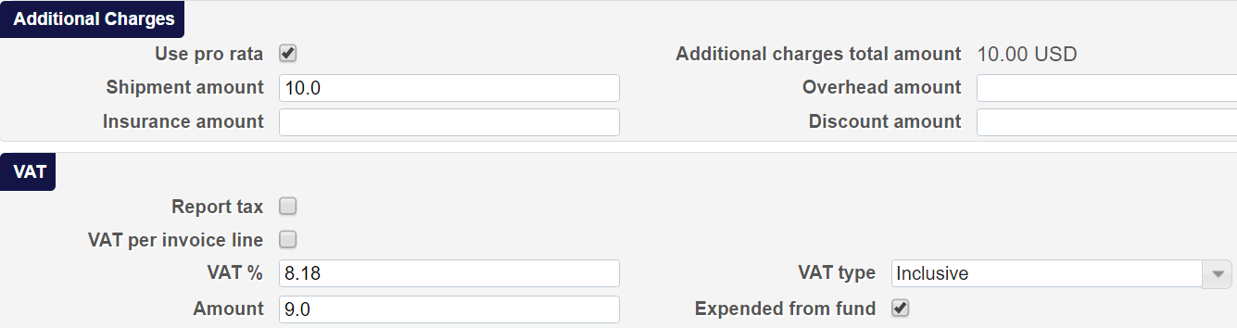
- Create the invoice lines.
  - Add a line for the $40 material. Price: 43.60. Expenditure amount: $47.60 (price + tax + pro-rated shipping).
  - Add a line for the $60 material. Price: 65.40. Expenditure amount: $71.40 (price + tax + pro-rated shipping).
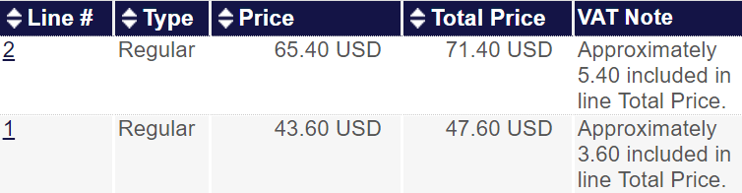
- Choose “Save and Continue” to finalize the invoice.

Notes
- This approach relies on manually entering a VAT amount. If any additional charges are untaxed, the invoice header “VAT %” field will reflect an incorrect percentage, as it’s being calculated against the total (not factoring in the untaxed lines). If all additional charges are taxed at the same rate as the materials, then the “VAT %” should reflect your tax rate.
- If you wish to use this method, do not configure VAT codes. VAT codes prevent you from manually entering a VAT amount. Because you are entering a direct amount for each line, the percentage will vary depending on what additional charges exist and how they are or are not taxed.

Option 1d: Ignore built-in VAT functionality; create all lines manually
Choose this option to manually create a tax line on each invoice. This option assumes you have special requirements for how to report tax to the financial office that do not adhere to the Alma tax model. (For example, if you must report tax on a distinct line attached to a fund rather than as a "VAT note" attached to the existing lines.) In this example, materials are taxable but shipping is not.

Workflow
- Create an invoice header. Leave VAT options blank.
- Create the invoice lines.
  - Add a line for the $40 material. Price: 40. Expenditure amount: $40.00.
  - Add a line for the $60 material. Price: 60. Expenditure amount: $60.00.
  - Add a line for $10 shipping. Price: 10.00. Expenditure amount: $10.00.
  - Add a line for tax. In this case, the tax will be 9% of the material cost, with shipping untaxed. Price: 9.00. Expenditure amount: $9.00.
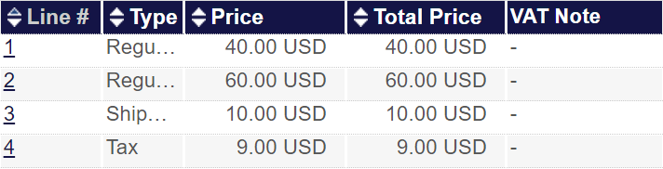
- Choose "Save and Continue" to finalize the invoice.

Notes
- This approach requires no configuration or special functionality, but does require manually entering all tax information into its own line. Tax lines will require a fund, which can either be the same as the materials fund or separate.
- In the example above, a new invoice line type of “Tax” has been defined (by repurposing one of the unused out-of-the-box line types). For more information on defining custom line types, see “Configuring Invoice Line Types” in the Alma Documentation:
https://knowledge.exlibrisgroup.com/Alma/Product_Documentation/Alma_Online_Help_(English)/Acquisitions/110Configuring_Acquisitions/150Configuring_Invoice_Line_Types

Scenario 2: Vendor bills no tax; use tax must be reported
In this scenario, the vendor has left tax off of the invoice. The goal is to pay the vendor invoice as billed, but also to report out taxes separately for payment by the university directly to the relevant government tax office. (Taxes owed but not billed are referred to as “use tax”.)

Option 2a: Use “Report tax” function with government vendor
Choose this option to automatically calculate use tax for an entire invoice and have Alma create a separate, linked invoice consisting only of use tax. Note that this option only supports a single tax rate across the entire invoice and does not support differing tax rates for different lines. (See 2c for line-level variances in use tax.) To use this option, coordinate with your financial office such that they expect a separate invoice for use tax.

Workflow

- Go to Alma > Acquisitions > Acquisitions Infrastructure > Vendors
- Create a new vendor and input name and code
- Choose Governmental as the vendor type and input the liable tax rate
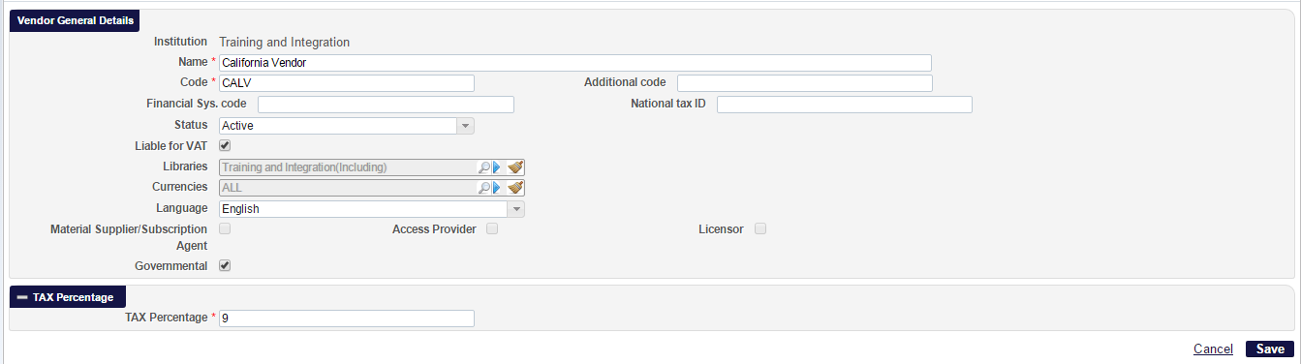
- Create an Invoice Header. Choose Report Tax.
- Create Invoice Lines
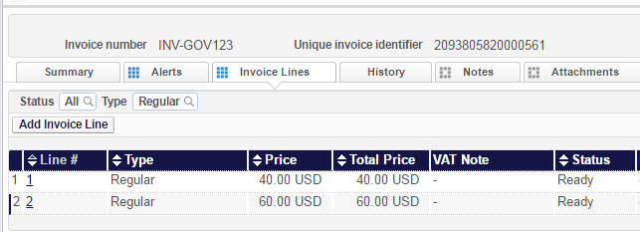

Notes
If a governmental vendor is associated with the institution, and the vendor is defined as liable for VAT (liable for use tax), and an invoice is set to report (use) tax, then, when the invoice is created, a separate invoice for use tax is automatically generated for the use tax.

Option 2b: Use “Exclusive” VAT function to remove tax from “Total amount”
Choose this option to create a single invoice that records tax as a separate “adjustment” line not included in the “Total amount” from the invoice header. To use this option, coordinate with your financial office such that they pay the “Total amount” to the vendor, while reserving the “Adjustment” as use tax. (While this does not support entering different tax rates in each line, the actual owed amount can be entered at the header level to record the adjustment that needs to be paid.) Note that this method does not support assigning Use Tax to a fund.

Workflow
- Create an invoice header. Under the VAT section, choose Exclusive.
- Create Invoice Lines. Because you’ve chosen Exclusive VAT, a VAT Note is automatically added explaining how much will be billed for VAT.
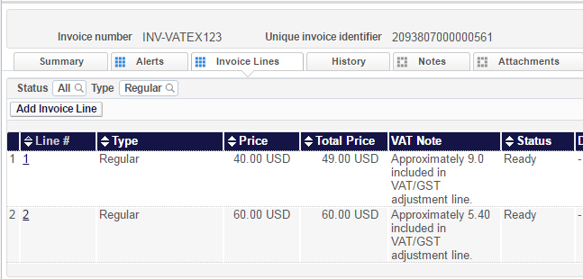
- Save and Continue.

Notes

Option 2c: Ignore built-in VAT functionality; create a separate invoice manually
Choose this option to create a separate invoice for use tax manually. This provides full control of all aspects of the reporting, including vendor (a government vendor), tax rate, and funding for each tax line.

Workflow
- Create invoice header for tax invoice. Do not choose any options for VAT.
- Create invoice lines of type tax for each line.
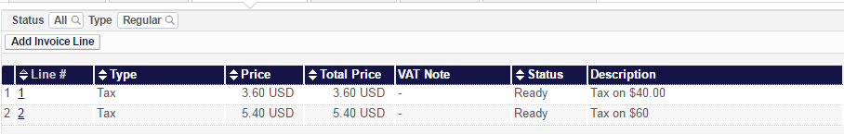
- Save and Continue.

Notes
- This process will require the manual creation of invoices but will allow for better control of all reporting aspects
- Depending upon scripting capabilities at the institution this may be the best solution for passing use tax to the financial system

Scenario 3: Vendor partially bills tax; remaining use tax must be reported
In this scenario, the vendor has left off some (but not all) tax—either failing to tax lines that required it, or taxing at a lower rate that must be covered separately (e.g., paying state but not municipal tax). Because of the variability of per-line tax rates and partial reporting, a manual approach is the best method.

Option 3a: Ignore built-in VAT functionality; create a separate invoice manually
When a vendor has paid part of the owed tax – such as the state tax – but not all of it, the best option is to create a separate invoice. This allows for minimal scripting for the export to the financial system.

Workflow

- Create Invoice Header.
- Create lines of type Tax for the tax that has been paid
- Create lines of type Use Tax for the tax that has not been paid
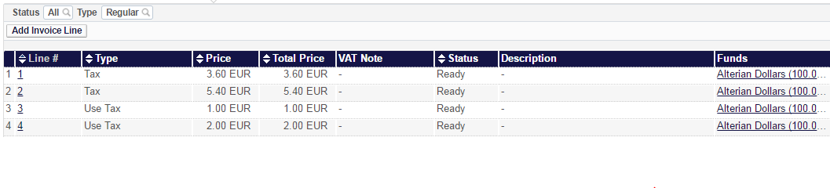

Notes
- This process may require the creation of separate invoices for each line, depending upon the variability of the partial tax payment by the vendor
- If scripting is possible to account for differences in invoice amounts, it may be feasible to instead create separate tax lines on the original invoice instead of manually creating invoices.

Other scenarios and options
Alma supports other approaches to VAT handling. Additionally, when exporting invoices to a financial system for payment, logic can be included in the scripts to handle other methods of recording tax and use tax. Options that require significant custom programming are not listed above. A few additional options are not in the recommended list above, with explanations here.

Manually create Use Tax lines as part of invoices
For invoices that don’t bill taxes (Scenario 2) or partially bill taxes (Scenario 3), one option is to manually create a Use Tax line. However, this will add to the “Total amount” in the invoice header, which is typically the amount to be paid to the vendor. For this solution to work when exporting invoices for payment by the finance office, a custom script would need to clearly mark the Use Tax line to be paid separately, as well as remove the Use Tax amount from the “Total amount” field reserved for recording the amount to pay to the vendor.

Use Adjustment lines to automatically create a separate taxes line
In Option 2b above, the “Adjustment” line is used by unchecking the “Expended from fund” box to create a separate line for use tax. Using this function outside the context of Use Tax is also possible to create a separate adjustment line. This isn’t recommended, however, in order to preserve the semantics of the Adjustment line as a vehicle for Use Tax that should be paid separately. Having situations in which the Adjustment line is simply recording tax to be paid outside a specific fund simply muddies the waters without adding value to the workflow.

