This document provides the instructions on how to use the delivered CSU AP Voucher Spreadsheet Upload modification for the following operation areas:

- Library Invoice
- Quarterly Rideshare

CMS has delivered a standard Excel spreadsheet template to assist in compiling the upload data. To facilitate the transactions for Cal Poly Pomona, two separate spreadsheet files are created to handle the business needs for both Library and Accounts Payable. The file only contains fifty-two (52) formatted rows. If additional data rows are needed, please insert between rows 51 and 52 to preserve data format.

Please refer to Appendix A for a list of the required data values to be included in the upload file.

Once the data has been created in the Upload Template, forward the file to the following staff members at University Accounting Services:

Sheryl Adams samartin@csupomona.edu (909) 869-2025
Manisha Patel mkpatel@csupomona.edu (909) 869-2024
Michelle Cardona mdcardona@csupomona.edu (909) 869-2154

The data in the file will be imported into PeopleSoft based on weekly processing schedule. System generated reports will be sent back to the requesting department(s) as confirmation.

Below are the sample report outputs when the data is successfully loaded into the production database:

Report Name | Report Description
Voucher Upload Process Report | This report provides a list of invoices that are processed through the Voucher Spreadsheet Upload program (CSUAP09009).  Navigation: Menu > CSU Administer Integration > CSU Manage Interfaces > AP Voucher Upload
PeopleSoft Query | This query provides monetary amounts, taxes, and chartfield information on the uploaded invoices for final review/approval prior to Payment Processing.  Navigation: Menu > Reporting Tools > Query > Query Viewer
CSU AP Control Group Report | This report provides the mailing address information and other important information for the processed invoices.  Navigation: Menu > Accounts Payable > Reports > Vouchers > CSU Control Group Report
Once the spreadsheet upload file is received from either Library or Accounts Payable, the following steps must be performed:

- Make sure all required columns contained correct data
- Delete empty rows from the spreadsheet
- Delete header rows (1 and 2)
- Save the data as CSV format
- DO NOT attempt to open the CSV file in Excel again as the data format will be lost
- Do open the CSV file in Notepad or other Text Editing application, if needed, for review
- Only update upload data in the original spreadsheet file (then repeat steps 1 ~ 4) to retain data format

Navigation | Screen Shots
Review sample spreadsheet data.  In this example, extra rows to be deleted starts from row 11  Also don’t forget to delete the header rows (1 and 2)  Save the file as CSV format. | 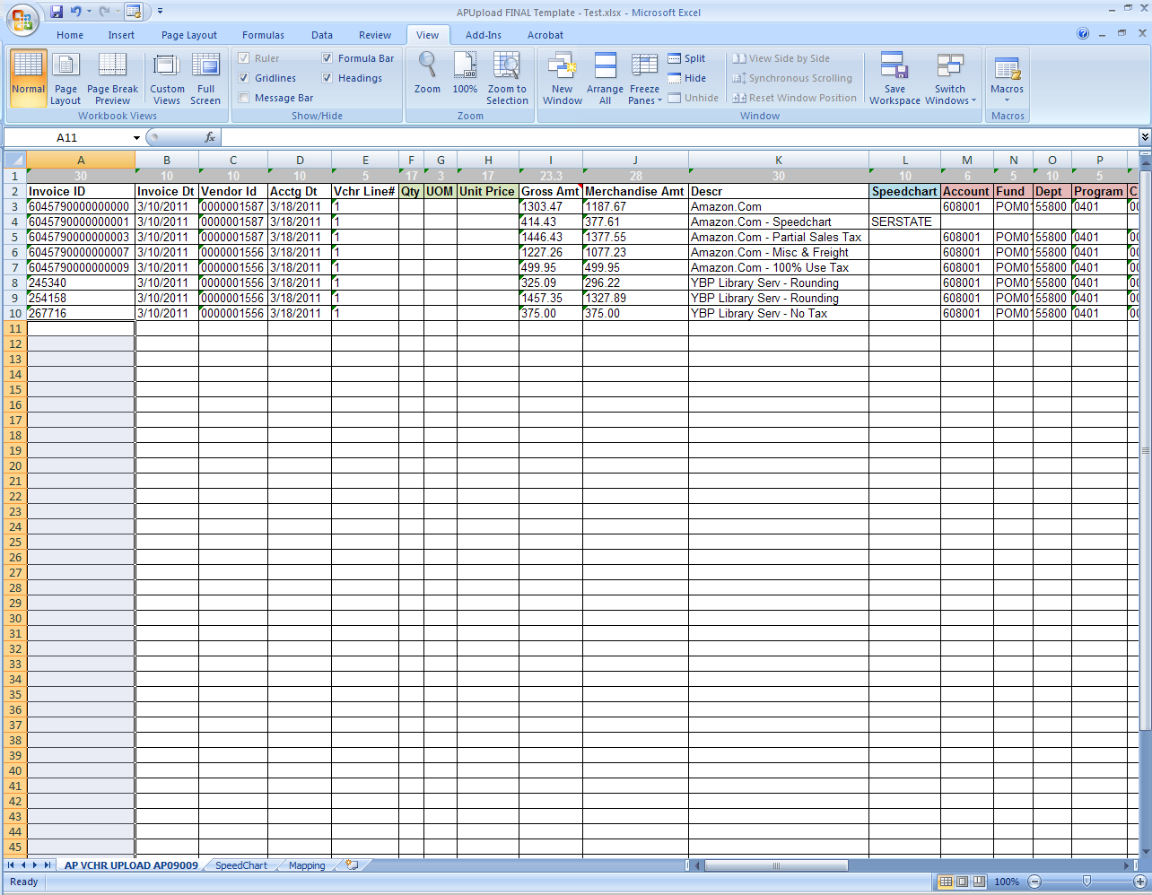
Open the CSV file in either Notepad or other Text Editor application to review. | 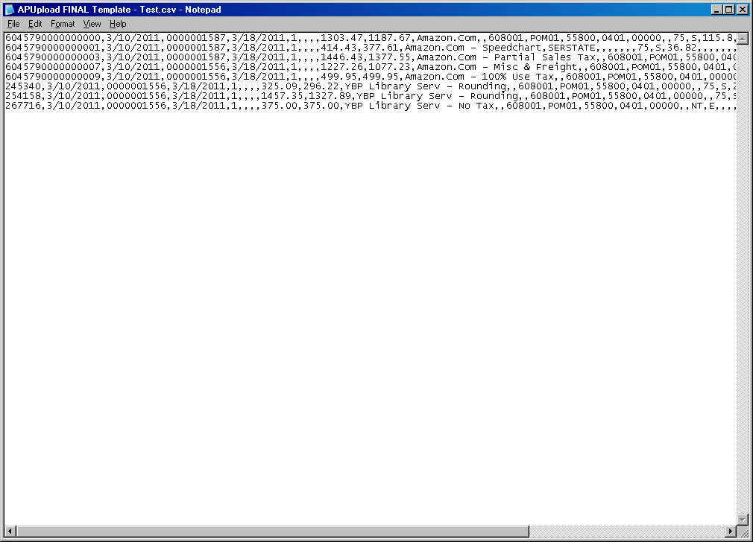
Make sure there are 10 extra comma at the end of each data line after the numeric number (Add Seq # for mailing the payment).  If the data does not appears to be correct, contact either Library or Accounts Payable for correction. | 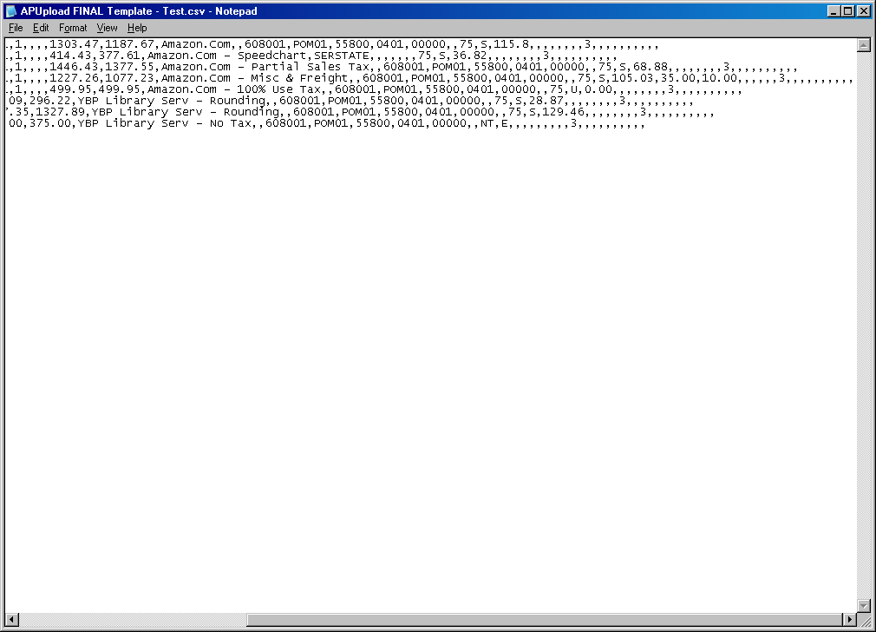

Below describe the steps to upload the spreadsheet data:

Navigation | Screen Shots
Menu > CSU Administer Integration > AP Voucher Upload  Select existing run control or create new  Enter correct Business Unit and Voucher Origin information  System will enter the Processor’s User ID as default  DO NOT enter Path and File name information as the information will be populated when the Upload Voucher File button is clicked  Click on the Upload Voucher File push button to select the CSV data file | 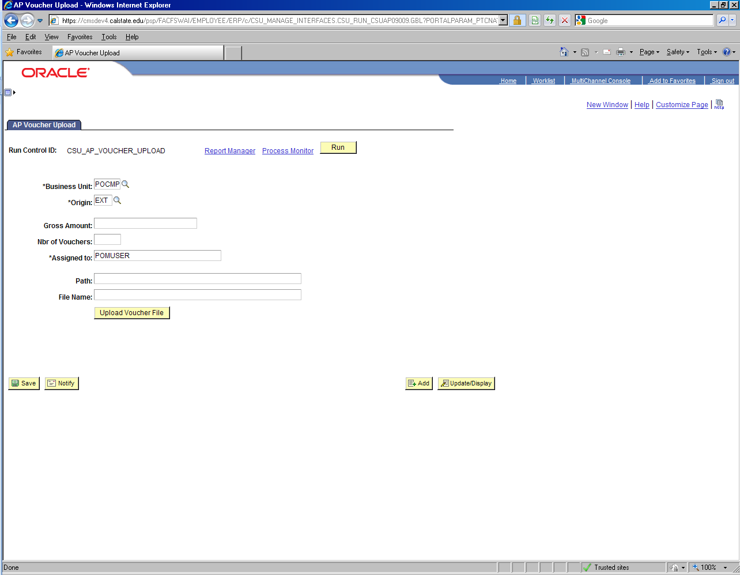
Click on Browse to select the CSV data file

Click on Upload push button to return to the main run control page
Verify the Path and File Name information is entered  Click on Run | 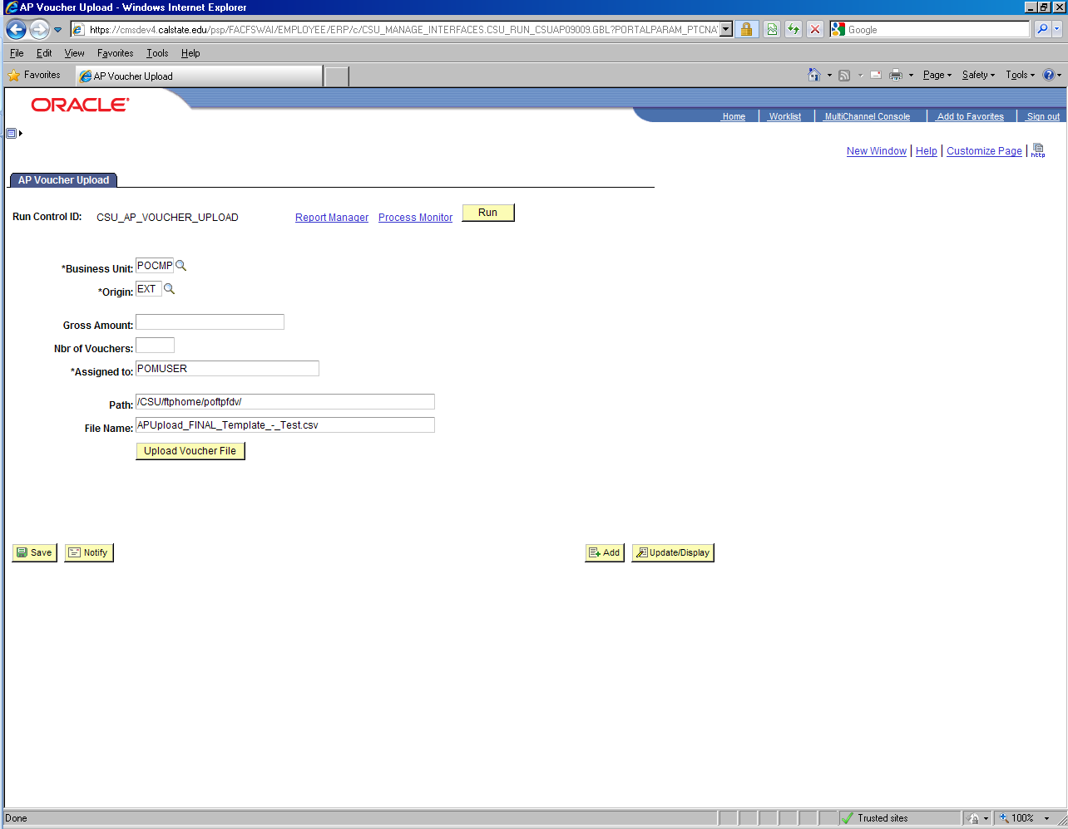
Click on OK to submit the job | 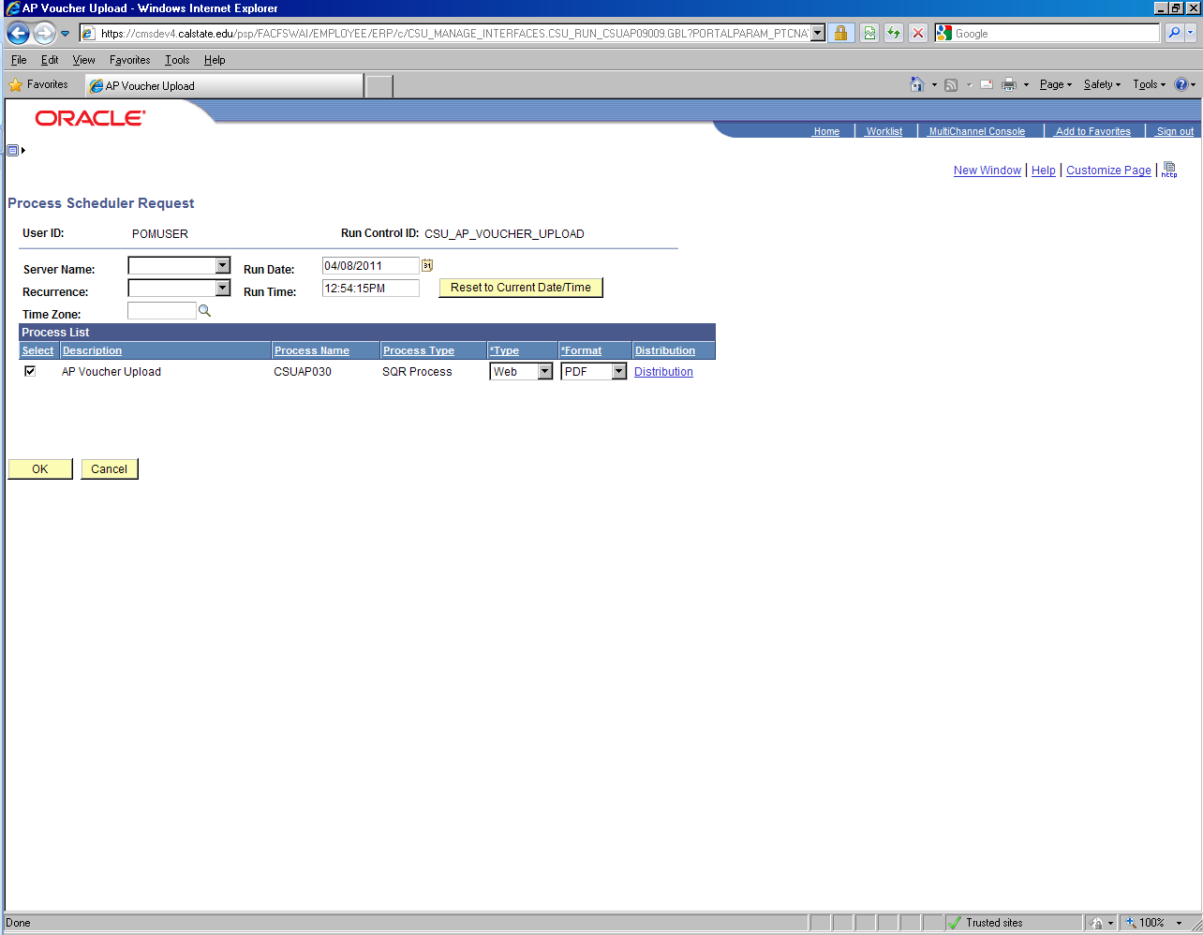
Review the file output in Process Monitor when the job is completed

Once the voucher data file has been successfully uploaded into PeopleSoft/Oracle and validated by either Library or Accounts Payable, proceed with running the Voucher Build process.

Navigation | Screen Shots
Menu > Accounts Payables > Batch Processes > Voucher Build  Select existing run control or create new  Enter the required run control parameter  Process Option must be set to either:  ~ Business Unit  ~ Process Group  ~ Process Origin  ~ Process Vendor  ~ Process Voucher  Enter the Selection Parameters for the selected Process Option  Click Run | 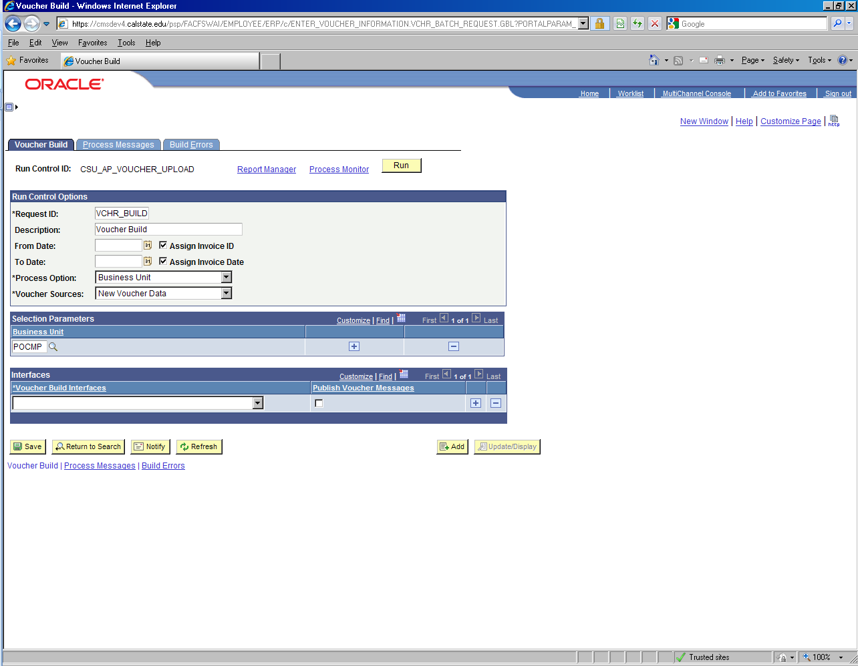
Click OK to submit the job | 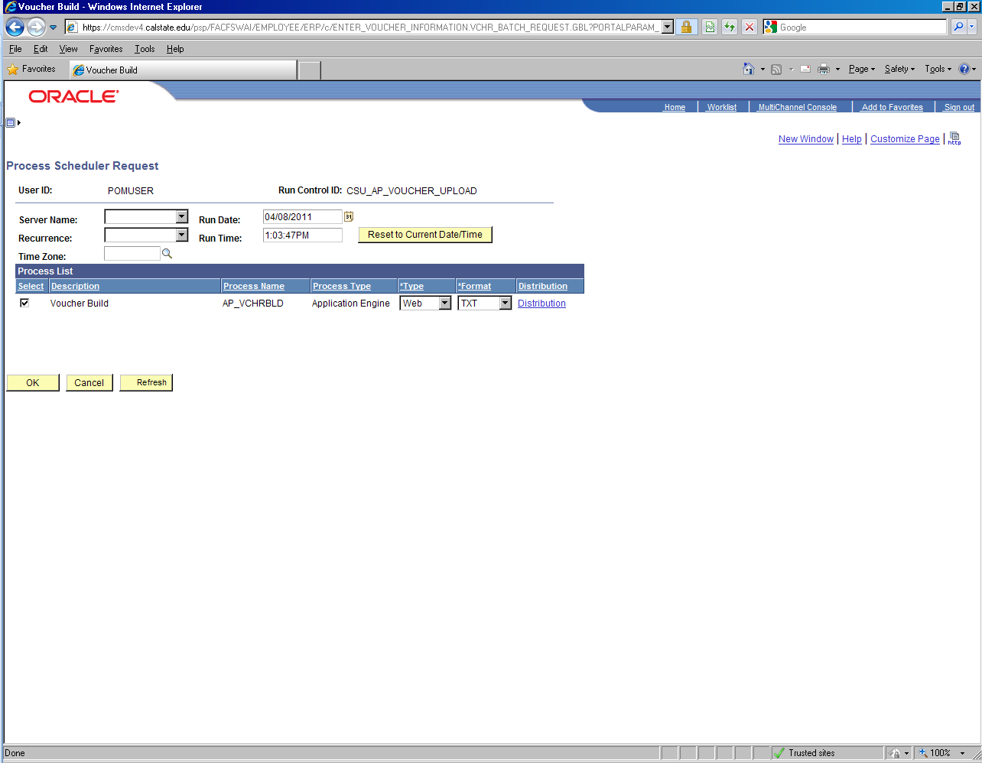
Review the file output in Process Monitor when the job is completed and proceed with regular Voucher Processing  ~ Matching  ~ Budget Checking (BCM)  ~ Voucher Post | 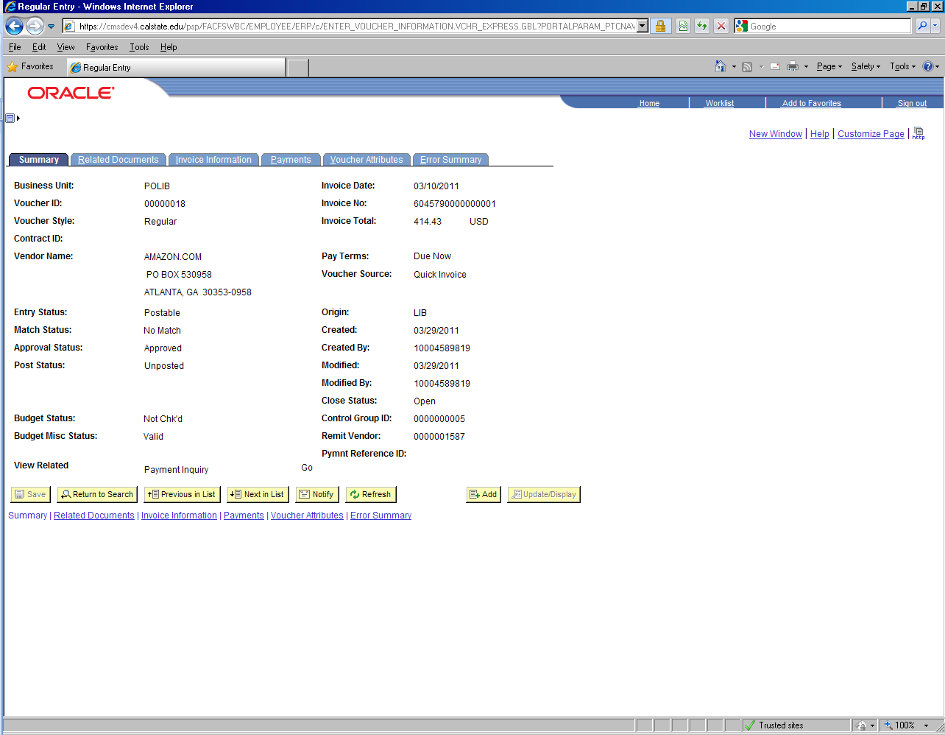
Run the AP Control Group Query to extract voucher data for review  Menu > Reporting Tools > Query > Query Viewer | 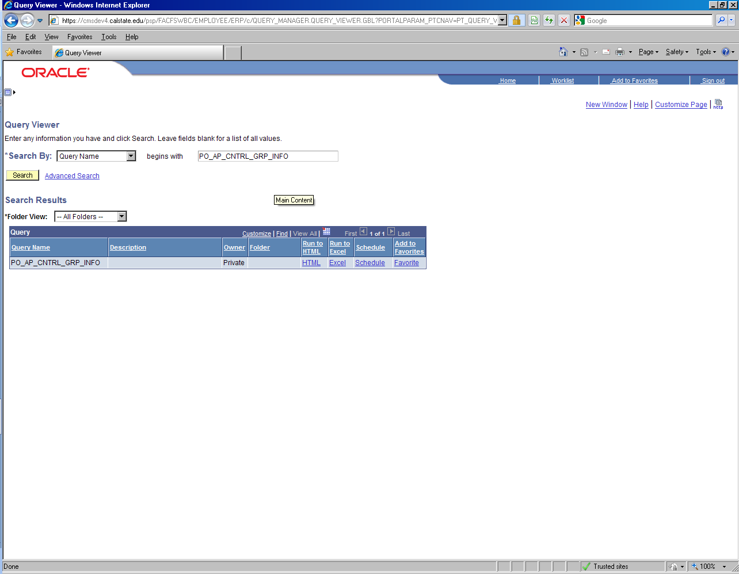
Export the query result to Excel for review
In additional to querying the data, CSU Control Group Report should also be run to review the mailing address for the checks  Accounts Payable > Reports > Vouchers > CSU Control Group Report  Select existing run control or create new  Enter the required run control parameters  Click Run | 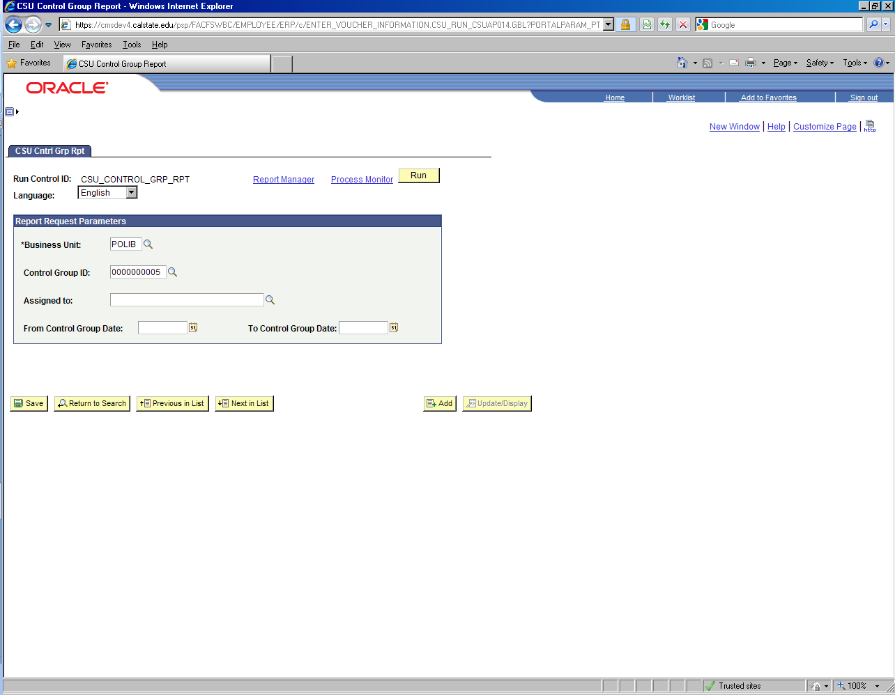
Click OK to submit the job | 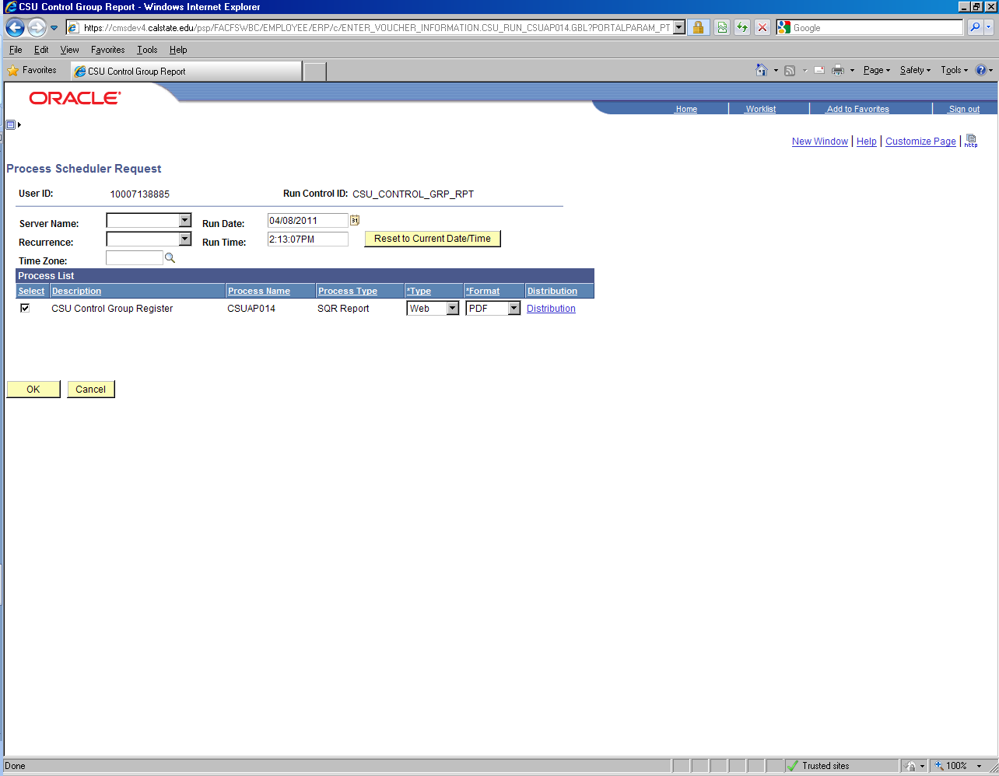
Review the file output in Process Monitor when the job is completed

This file will contain the invoice information and the mailing address for the check
Appendix A

Below listed the required data fields for the spreadsheet upload processes:

Column | Column Name | Max Length | Notes
A | Invoice ID | 30 | Enter in MM/DD/YYYY format:  07/01/2011
B | Invoice Dt | 10 | Enter in MM/DD/YYYY format:  07/01/2011
C | Vendor Id | 10
D | Acctg Dt | 10 | Enter in MM/DD/YYYY format:  07/01/2011
E | Vchr Line# | 5
F | Qty | 17 | Value works in conjunction with columns G and H to derive to I
G | UOM | 3
H | Unit Price | 17
I | Gross Amt | 23.3 | Total Invoice Amount, including Sales Tax, Freight, and Misc Charges; No $ sign or comma separator allowed:  1023.34
J | Merchandise Amt | 28
K | Descr | 30
L | Speedchart | 10 | If Speedchart value is provided, skip columns M ~ R
M | Account | 6 | If Speedchart value is not provided, enter required chartfield values in columns M ~ R
N | Fund | 5
O | Dept | 10
P | Program | 5
Q | Class | 5
R | Project | 15
S | Ship to Location | 10 | Value works in conjunction with column T:  75 = Sales Tax or Used Tax  NT = Exempt / No Tax
T | SUT | 1 | Value works in conjunction with column S:  S = Sales Tax (full / partial Sales Tax on Invoice)  U = Used Tax ($0 Sales Tax on Invoice)  E = Exempt / No Tax
U | Sales Tax | 23.3 | Enter value from Invoice
V | Freight Amt | 23.3 | Enter value from Invoice
W | Misc Amt | 23.3 | Enter value from Invoice
AC | Addr Seq # | 5 | Enter the Address Sequence where the check will be mailed. Contact Accounts Payable for address verification if needed.

