Analytics Webinar – ACRL reporting

Note regarding which system to use:
- For 2015-16 (September 2016 survey): Use your old systems and test in Alma for practice
- For 2016-17 (current year, September 2017 survey): Use your old systems and practice in Alma
  - Exceptions:
    - Combine circulation data from old system (July 1 – cutover) + Alma (cutover – June 30)
    - UStat users: use Alma for questions requiring COUNTER usage data
    - 360 Counter users: use whichever system has the most complete data
  - Recommendation: gather data for 2016-17 FY ACRL/IPEDS questions during technical freeze
- For 2017-18 (September 2018 survey): Use Alma

Alma Analytics
Role required: Design Analytics
How to get there:
- Click the Alma button and choose Design Analytics in the far right-hand column
- Click on Catalog in the menu bar at the top
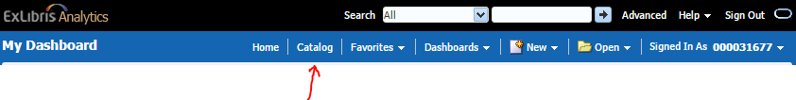
THEN FOLLOW THIS SPECIFIC PATH:
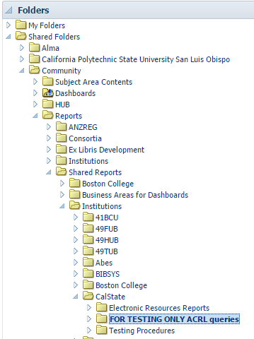
Shared Folders > Community > Reports > Shared Reports > Institutions > CalState >
FOR TESTING ONLY ACRL queries
Note: The Community area contains many duplicate and outdated folders. This folder has the most current versions.

Notes
- Reports are currently set with a filter already in place for 2016
  - This can be manually adjusted for the desired fiscal year
  - If you didn’t migrate acquisitions data, expenditure reports will produce zero results when you run it for 2016
    - To test these reports, change your fiscal year to 2017 and it will report expenditures in Alma during your test period
  - Hopefully later iterations of this report will prompt for fiscal year
- Reports using data from Alma generally use the Alma fiscal year
  - Each campus can configure fiscal year individually
    - For best results, ALWAYS check and correct any fiscal year filter
  - Fiscal year dates starting with letters (e.g. FY-2016) are at the end of the list of dates
  - COUNTER usage fiscal year matches the institution fiscal year but isn’t labeled the same way
    - Usage Date fields are the same as Loan Date
    - e.g. 2016 = July 2015 – June 2016
- ACRL questions where you will need to follow up or can’t easily use Alma
  - Line 20-21 Expenditures
    - Alma will report what you spent during the fiscal year
      - If you need to divide a single expenditure over multiple years, you must manually correct for this
  - Line 41 Number of Databases
    - Alma can give you a count of Electronic Collections, but…
      - It probably won’t conform to the ACRL definition
      - It probably will over-count if multiple packages are activated from the same provider
        - e.g. Springer Engineering eBooks 2014, Springer Engineering eBooks 2015, etc.
    - Better bet: use some combination of your library’s Databases A-Z list and an Alma repository search for Electronic Collections available to you in the NZ and IZ
  - Line 60 column 1 Initial Circulation Physical
    - Very Important: This query technique will only work accurately for circulation that happens AFTER go-live. Item data that is migrated into Alma from Millennium (and probably Sierra–needs testing) will only contain the most recent circulation action, so titles will show as having circulated during a given fiscal year, but will only show as circulating ONCE.
    - Use your OLD ILS for ACRL/IPEDS circ stats for FY 15-16 AND FY 16-17 (use Alma to count any loans/renewals between cutover and the end of the fiscal year).
    - Use Alma for ACRL/IPEDS circ stats beginning FY 17-18 (the first full year in production).
  - Line 60 column 2 Initial Circulation Digital/Electronic
    - ACRL and IPEDS want streaming media usage as well as e-journals and e-books
    - Alma does not yet support COUNTER MR1 and MR2
    - Streaming media platforms haven’t widely adopted COUNTER in any case
    - You’ll need to start with the Alma Analytics report and add whatever e-media usage you have to the total

