Analytics Webinar – Usage Data in Vendor record
- Vendor search
- Usage Data tab
- SUSHI Vendor checkbox
- Add
- SUSHI Account autopopulates + url
- Enter details
- Test Connection (Test Connection with Response is used for troubleshooting)
- Save
- Upload files: Actions, View
- 1 day lag for Analytics
- Results in Analytics, under Usage Data Details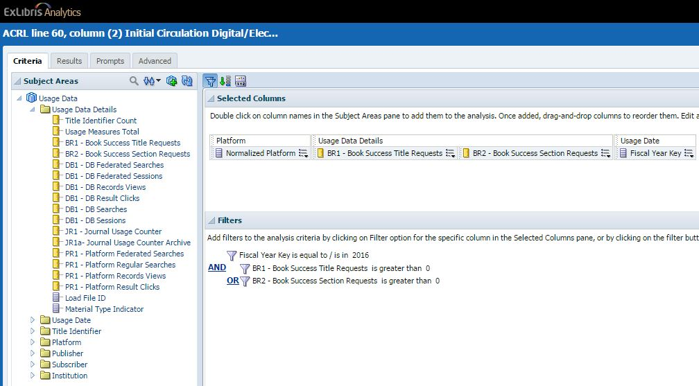
- Acq – Import - Usage Data Loader
- Acq Config – General - Subscribers configuration
- Vendor Interface, Statistics Information tab
ExLibris documentation https://knowledge.exlibrisgroup.com/Alma/Product_Documentation/Alma_Online_Help_(English)/Acquisitions/090Acquisitions_Infrastructure/010Managing_Vendors/Managing_COUNTER-Compliant_Usage_Data
Lisa Bartle’s tutorials https://calstate.atlassian.net/wiki/display/ULMSR/Video+Tutorials
July 6, 2016 Analytics Functional Call with Connie Braun https://calstate.atlassian.net/wiki/display/ULMS/Functional+Call+Via+Webex+with+Ex+Libris

