*Book Title Counts
(CSUSM Book count does NOT include material types: pamphlet/document/report)
Physical Books – Title Count
New Analysis using Physical Items Subject Areas
- Bib Title (edit column properties to re-name header to No. of Title)
- Bib Level (filter for is monograph)
- Bib not suppressed (filter Suppress from discovery = No)
- Physical Item Life Cycle (filter for is Active)
- Physical Item material type (filter = Book/Manuscript/Master Thesis/Music Score)
Delete columns 2, 3, 4, & 5 after filters have been added. Should look like this:
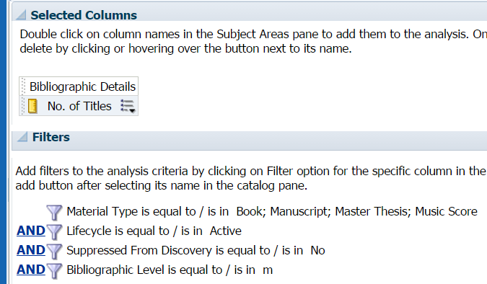

Click on the drop down menu for No. of Title column and choose Edit Formula
Click “f(…)” at the bottom of the column formula box
Expand the Aggregate Folder
Double click CountDistinct then click OK

Electronic Books – Title Count
New Analysis using E-Inventory Subject Areas
- Bib Title (edit column properties to re-name header to No. of Title)
- Bib Level (filter for is monograph)
- Bib not suppressed (filter Suppress from discovery= No)
- Portfolio Life Cycle in Repository (filter In Repository= Yes)
- Portfolio is available (filter Is available= Yes)
- Portfolio material type (filter = Book/Dissertation/Manuscript)

Delete columns 2, 3, 4, & 5 after filters have been added. Should look like this:
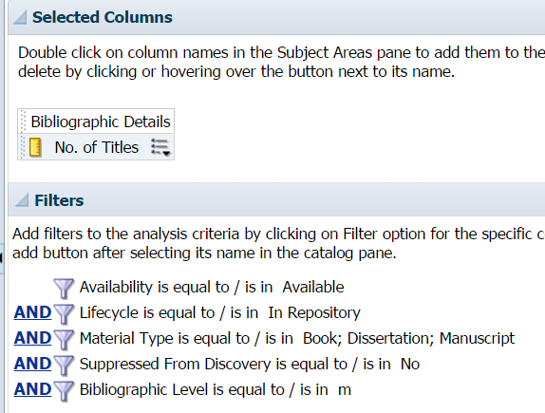

Click on the drop down menu for No. of Title column and choose Edit Formula
Click “f(…)” at the bottom of the column formula box
Expand the Aggregate Folder
Double click CountDistinct then click OK
Book Volume Count (Physical Items)
(This will not include unbound periodical counts as there are no item records to count)
New Analysis using Physical Items Subject Areas

- Physical Item Material type (filter = Book/Manuscript/Master Thesis/Music Score) (Now edit column properties to rename as No. of Volumes)
- Physical Item Lifecycle (filter is in Active)
- Bib suppressed from discovery (filter to NO)

Delete columns 2, 3, 4, & 5 after filters have been added. Should look like this:
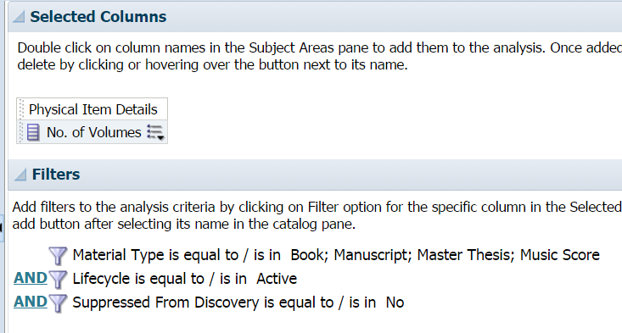

Click on the drop down menu for No. of Volumes column and choose Edit Formula
Click “f(…)” at the bottom of the column formula box
Expand the Aggregate Folder
Double click Count then click OK

*Media Title Count
Includes microfiche set Early American Imprints over 35,000 titles

Physical Media – Title Count
New Analysis using Physical Items Subject Areas

- Bib Title (edit column properties to re-name header to No. of Title)
- Bib Level (filter for is monograph)
- Bib not suppressed (filter Suppress from discovery = No)
- Physical Item Life Cycle (filter for is Active)
- Physical Item material type (filter Does NOT = Book/Manuscript/Master Thesis/Music Score/Pamphlet/Equipment/Headphones/Keys/Calculatoor/Camera)

Delete columns 2, 3, 4, & 5 after filters have been added. Should look like this:
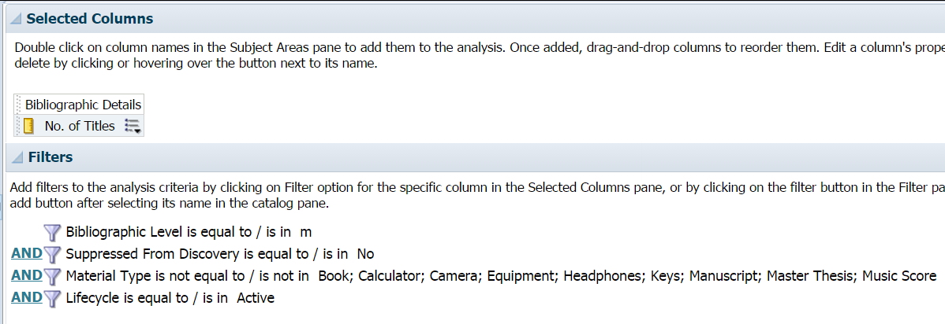

Click on the drop down menu for No. of Title column and choose Edit Formula
Click “f(…)” at the bottom of the column formula box
Expand the Aggregate Folder
Double click CountDistinct then click OK

Electronic Media – Title Count
New Analysis using E-Inventory Subject Areas
- Bib Title (edit column properties to re-name header to No. of Title)
- Bib Level (filter for is monograph)
- Bib not suppressed (filter Suppress from discovery = No)
- Portfolio Availability (filter is Available)
- Portfolio Lifecycle (filter is in Repository)
- Portfolio material type (filter = Map/Sound Recording/Streaming Audio/Streaming Video/Video)

Delete columns 2, 3, 4, & 5 after filters have been added. Should look like this:
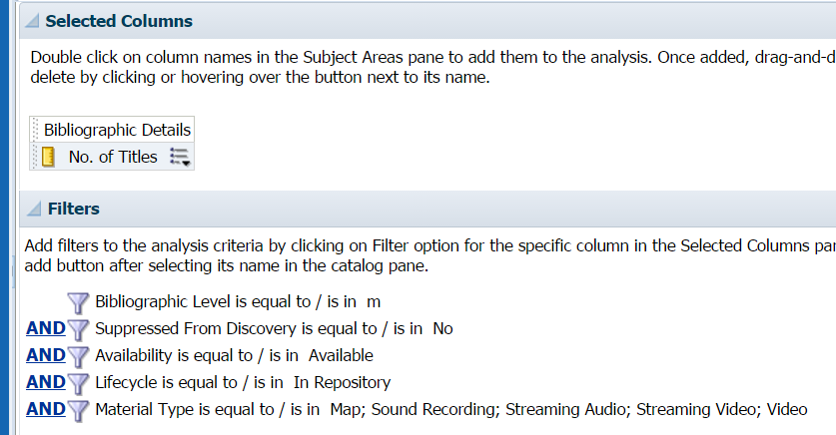

Click on the drop down menu for No. of Title column and choose Edit Formula
Click “f(…)” at the bottom of the column formula box
Expand the Aggregate Folder
Double click CountDistinct then click OK

*Serial Title Count
Physical Serial – Title Count
New Analysis using Physical Item Subject Areas
- Bib Title (edit column properties to re-name header to No. of Title)
- Bib level (filter is Serial)
- Bib (filter Suppress from discovery = NO)
- Bib Lifecycle (filter is on Repository)
- Item material type (filter is not null)

Delete columns 2, 3, 4, & 5 after filters have been added. Should look like this:
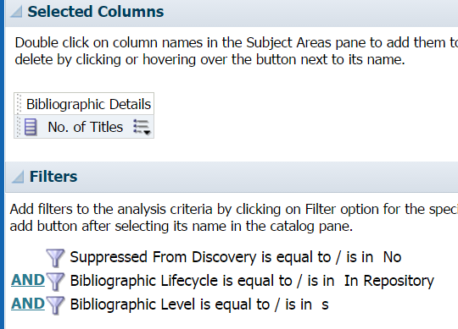

Click on the drop down menu for No. of Title column and choose Edit Formula
Click “f(…)” at the bottom of the column formula box
Expand the Aggregate Folder
Double click CountDistinct then click OK

Electronic Serial – Title Count
New Analysis using E-Inventory Subject Areas
- Bib Title (edit column properties to re-name header to No. of Title)
- Bib level (filter is Serial)
- Bib (filter Suppress from discovery = NO)
- Bib Lifecycle (filter is on Repository)
- Portfolio Material Type (filter is not null)
Delete columns 2, 3, 4, & 5 after filters have been added. Should look like this:
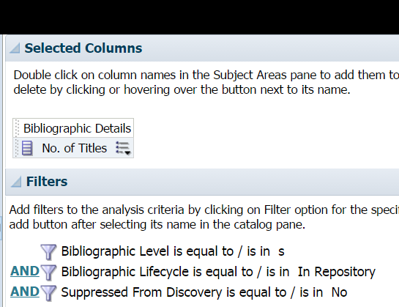

Click on the drop down menu for No. of Title column and choose Edit Formula
Click “f(…)” at the bottom of the column formula box
Expand the Aggregate Folder
Double click CountDistinct then click OK

***THERE IS AN ALMA DASHBOARD CONTAINING all of the above analytic reports. It can be viewed at anytime and is named ‘Annual Collection Counts’
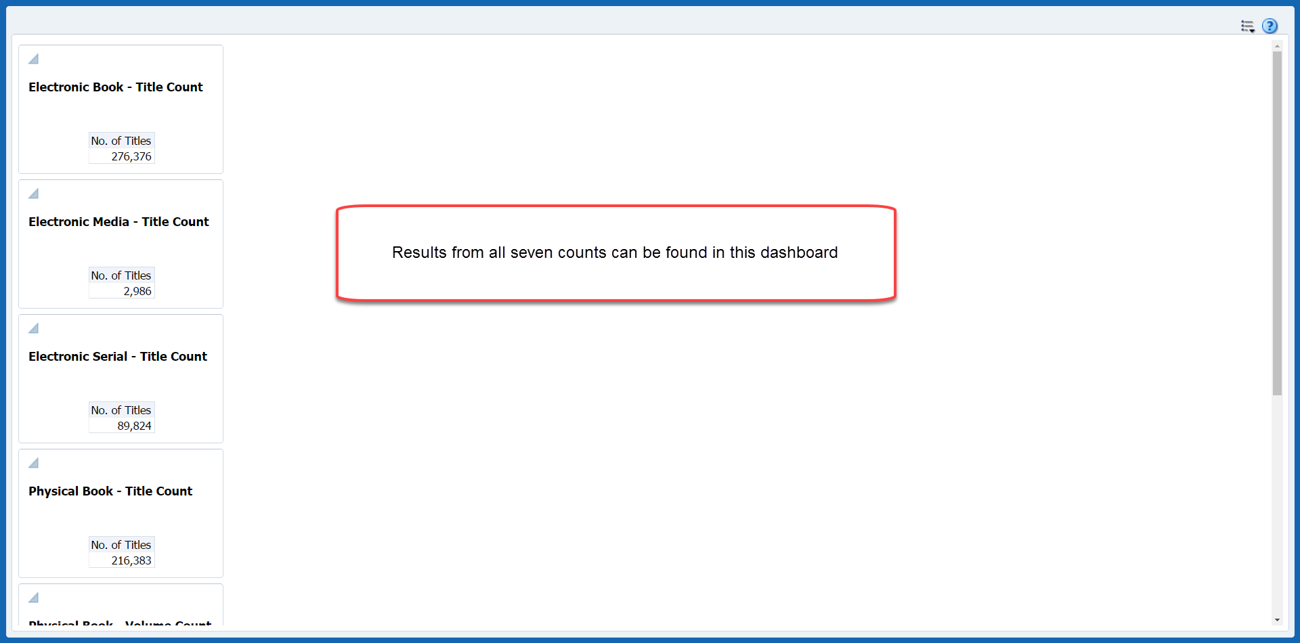

The Analytic Reports can be found in the Analytics catalog under Shared Folders—California State University San Marcos—Reports--/2015/2016 Collection Statistics.
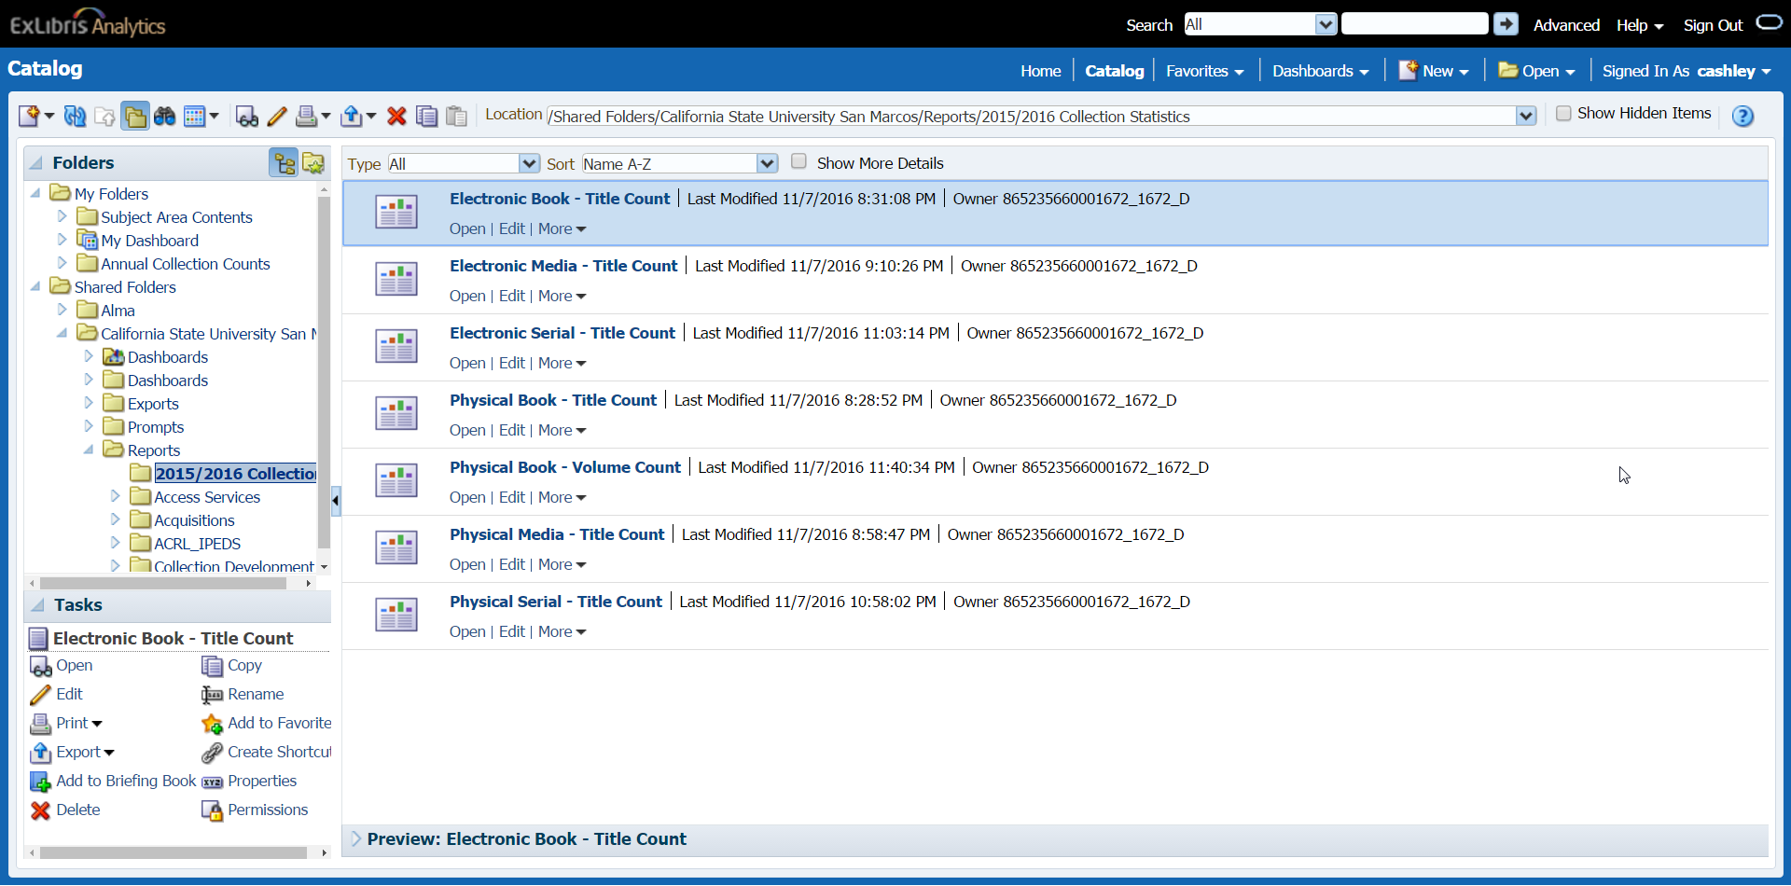

Databases
(CSUSM interprets this as purchased/ECC databases)
Work backward this year – get list of RDP entries. Determine which ones are purchases and make sure each one has an electronic collection/bib record representing a database with Creater Note= CSUSM Database.

Results can be found in an Alma Logical repository search set named “Annual Collection Statistics DATABASE count”
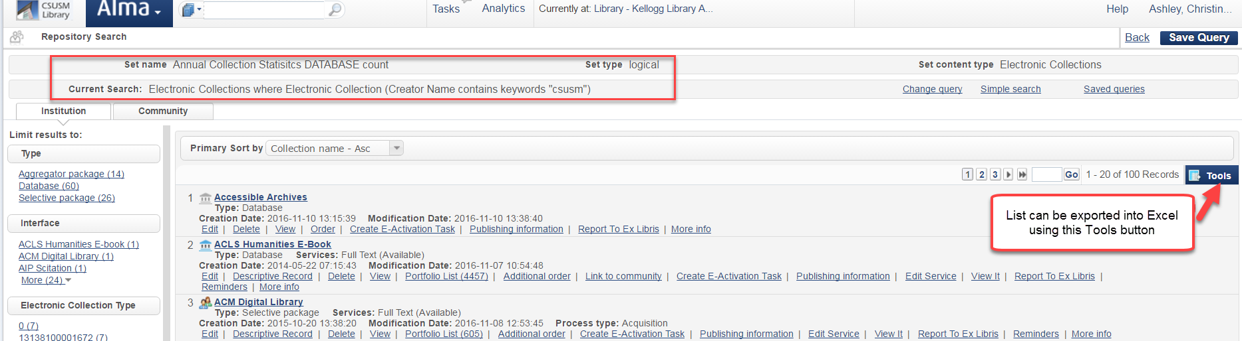ExLibris SalesForce case# 00359952 - they recommend using this method to count our databases as there is not a viable analytic report option at this time.

