Creating a local electronic collection in Alma

For additional information see “Adding a Local Electronic Collection” in the Alma documentation here.

To get started, select “Add Local Electronic Collection” under Create Inventory in the RESOURCE MANAGEMENT menu.

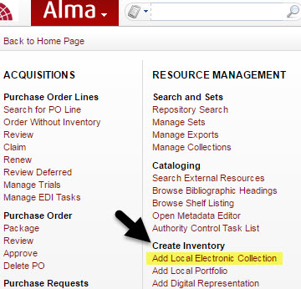

Next, select a name for your collection (the more descriptive the better as this will help you find your collection more easily when searching for it).

You may also enter a description of your database here.

Select “Collection type.”

- Select “Selective Package” if this is a collection where only select titles from a package have been subscribed to or purchased.
- Select “Aggregator Package” if this is an aggregator package and you subscribe to the entire package.
- Select “Database” if this is a database that does not contain individual electronic portfolios.

Select “Service Type.”
- You may choose between “Full Text” and “Selected Full Text.” You may also select “None” if creating a standalone database.

“Library” refers to the owning library associated with the collection, it does not determine who can access the collection and is not required.

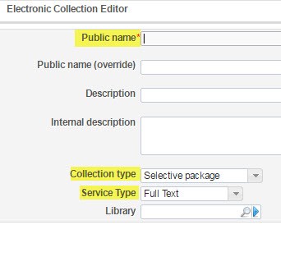
Click on save and continue.

Please note that the following instructions apply only to creating Selective or Aggregator packages. Additional information on creating Databases can be found here.

You will be redirected to the Activation Information tab. You will see a note at the top of the screen informing you that your collection has been successfully created.

Under the Activation Information tab you can:

- Select the “Service activation status” (Not Available or Available).
- Decide whether or not to activate new portfolios associated with this service automatically (this is useful when creating aggregator packages).
- Enter an “Active From Date” and an “Active Until Date.” Note that if no date is entered the default will be set for the date on which you created the collection.
- Note whether or not the service will be temporarily unavailable and provide a date and reason for the unavailability.

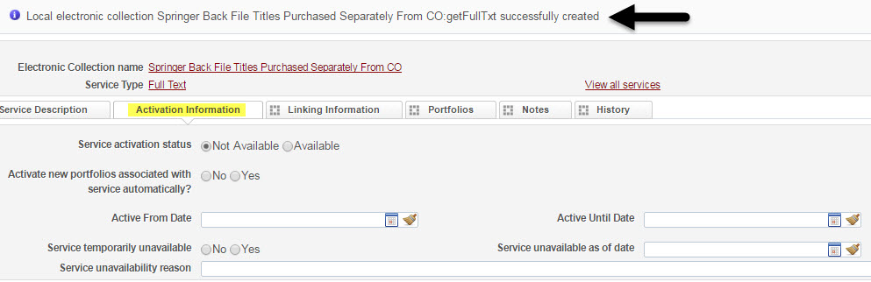

Click on save once you have entered all of the pertinent information for your collection.

You will be redirected to the Additional Information tab.

Under the Additional Information tab you can:

- Here is where you can enter information regarding your new collection including source, creator, alternative title, collection URL, etc. Please note that if you are creating a database and not a full-text or selective full-text collection you will need to enter at least an “Electronic Collection Level URL,” and additional descriptive information (the bibliographic record) in order for your resource to display in Primo.
- You can also select whether or not this is a free collection.
- You may enter proxy information here, but remember proxy information must be selected at the service level in order to provide accurate linking to the resources in your collection. If you do not specify a proxy from the “Electronic Collection Proxy Selected” menu, your default proxy will be used.
  - Note the service you selected now displays at the bottom the Additional Information screen. You can edit the service settings from this tab any time.

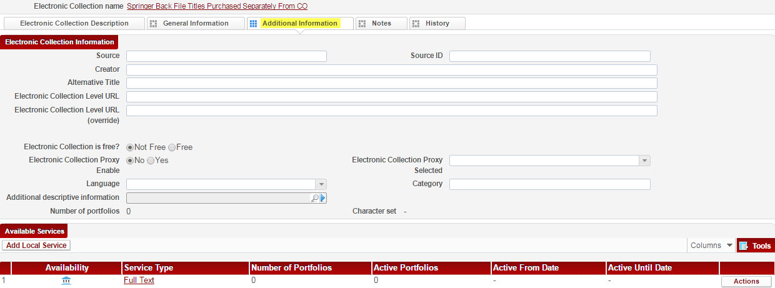
Click save and you will be redirected to your new electronic collection in the IZ. Notice your collection has not been activated yet and the IZ icon is still grayed out.

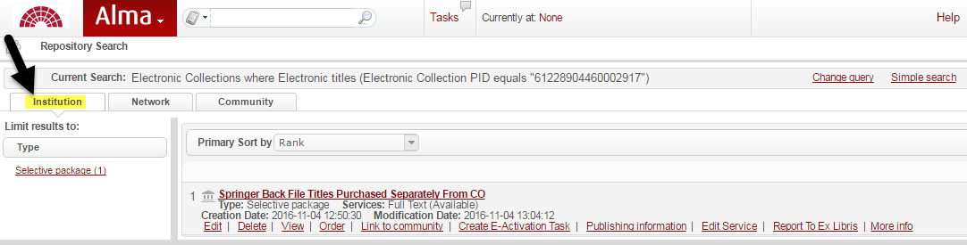

To add portfolios to your collection:

From the IZ, click on edit under your newly created electronic collection.

By default you will be redirected to the General Information tab.

- Here you can also enter some additional information about your collection.
  - You can select the “Access type”: you may choose between current and perpetual based on the content of your collection.
  - “Interface Name” will allow you to attach a vendor to your collection.
  - You may also enter Acquisitions (such as PO Line) and License information here.
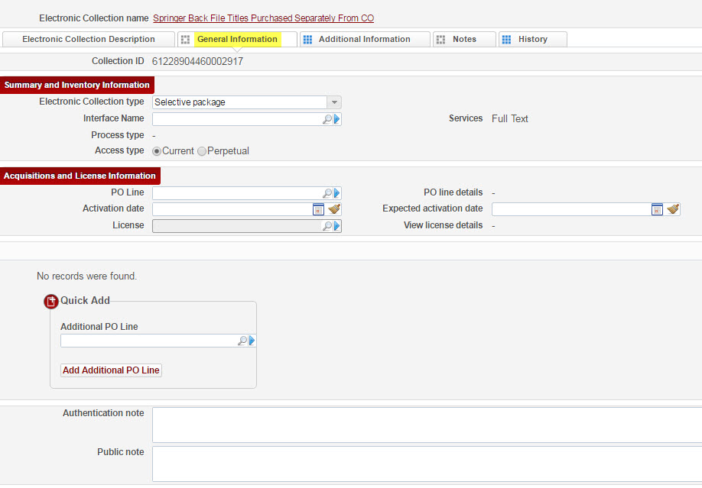

Click on the Additional Information tab to be redirected to the Available Services section.

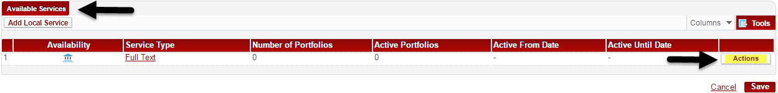

Under Available Services click on the box that says “Actions.”

Select “edit” from the drop down menu.

You will be automatically redirected the Activation Information tab.

From here you can navigate to the Linking Information tab if you have already entered your activation information; if you need to edit the activation information you may do so before clicking on the Linking Information tab.

The Linking Information tab is where you will:

- Set parser, parser parameters, URL, crossref, proxy, and linking level. A more detailed explanation of these fields, and which ones may apply to your collection, can be found here. For additional information on crossref participants, see the crossref website here.
- Remember to set your proxy under Linking Information at the service level in order to provide electronic access to the portfolios in your collection.

You are now ready to add portfolios to your new collection.

Click on the Portfolios tab.

Here you will see options to “Add Local Portfolio,” “Load Portfolios,” or “Add from set.”

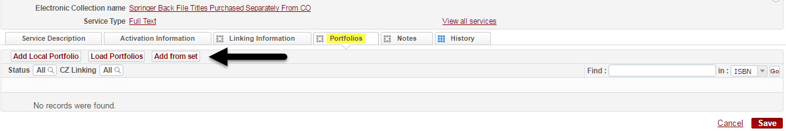

Please note that the following instructions apply to batch loading portfolios from an Excel spreadsheet. Additional information on adding portfolios from a set can be found here.

Before you can batch upload/update portfolios via Excel, you must enter the necessary information for each portfolio into the Portfolio Loader spreadsheet format required by Alma. You can find a copy of the template here.

After you’ve edited your Excel file and saved it to your computer, select “Load Portfolios” in order to perform a batch upload from your spreadsheet.

You will be redirected to the Activation Wizard: File Upload page.

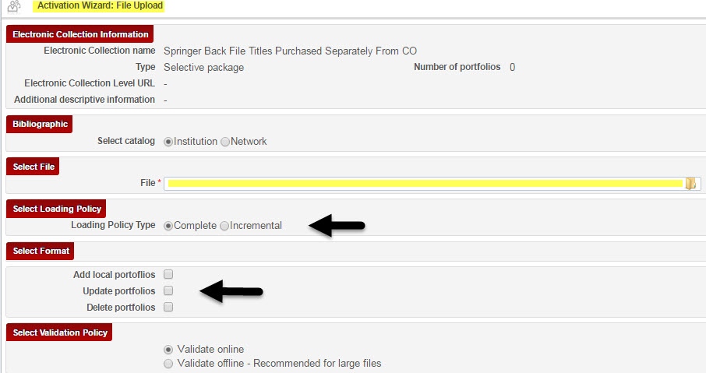

From here you can:

- Choose whether or not to add your collection to the IZ or NZ.
- Upload your Excel spreadsheet of portfolios to upload to your collection.
- Select “Loading Policy Type”: “Complete” indicates your entire set of portfolios will be uploaded and any portfolio information already in the collection will be overwritten; incremental includes only the incremental changes you’ve made to a portfolio list (e.g. changes you’ve made to only a certain number of portfolios in your collection).
O “Loading Policy Type” is also determined by the information you select in the “Select Format” section. For more detailed information on whether to choose “add,” “update,” and/or “delete,” see the Alma Manual for Updating or Removing Portfolio Information in Bulk Using an Excel File.
- Select your “Validation Policy” depending on your file size.

Click next.

You will be redirected to the next page in the Activation Wizard: the Activation Summary. If your Excel spreadsheet contained any errors, the Activation Summary will provide you with this information. It will also tell you how many portfolios will be activated from your list.

- If your file did contain errors, clicking on “Download Excel file to view information and warnings” will provide you with a copy of your spreadsheet that includes these errors.

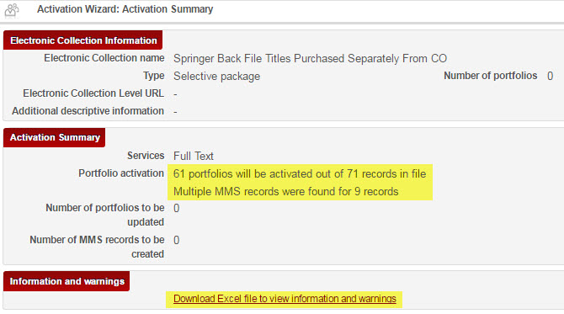

Once you have corrected your data and are ready to proceed, click on “load.” You will see a notification at the top of the screen alerting your activation job’s submission.

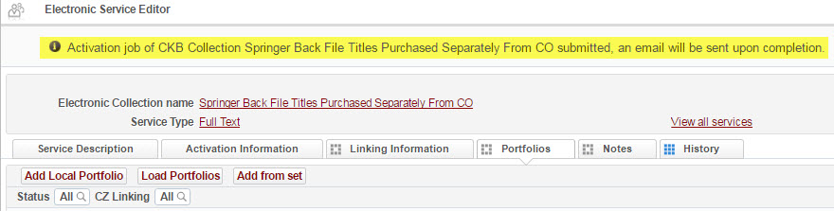

Your upload may take some time depending on the size of your file. You will receive an e-mail once the upload is complete.
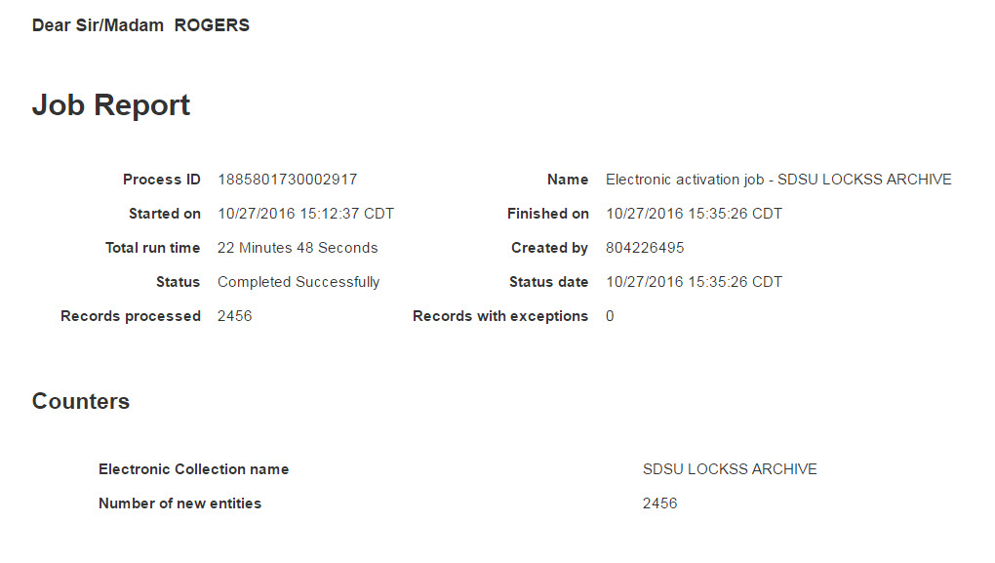

You can return to the electronic collection Additional Information tab in order to check the status of your upload by clicking on save.

Once complete, you will see the number of portfolios added to your collection under “Available Services.” You will also see a note stating that the data for your collection has been successfully updated.

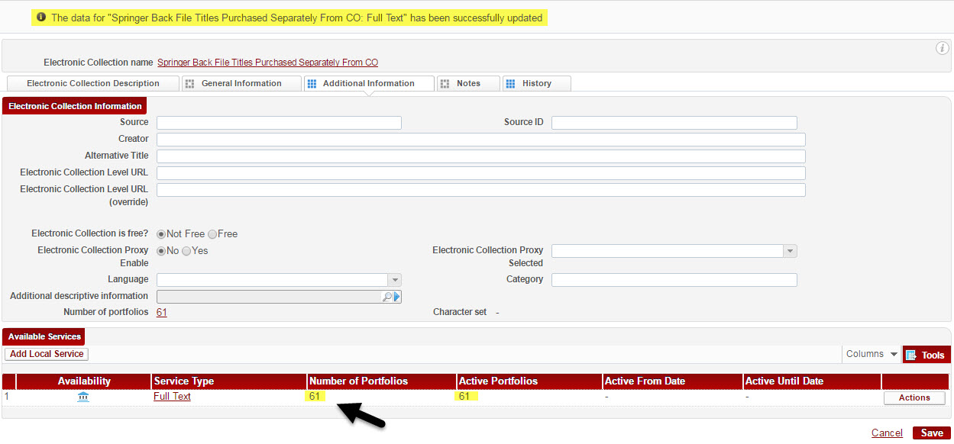
You are now ready to test access to your portfolios:

- Click on the “Actions” link under “Available Services” to: edit or view the service, view the portfolio list for your collection, deactivate or delete portfolios within your collection.
- To test access, click on “Portfolio List” and list of portfolios in your collection will be displayed, each with its own “Actions” option.
  - Note you can also activate and/or deactivate selected, or all titles from the portfolio list screen by checking the box next to each portfolio you wish to edit.

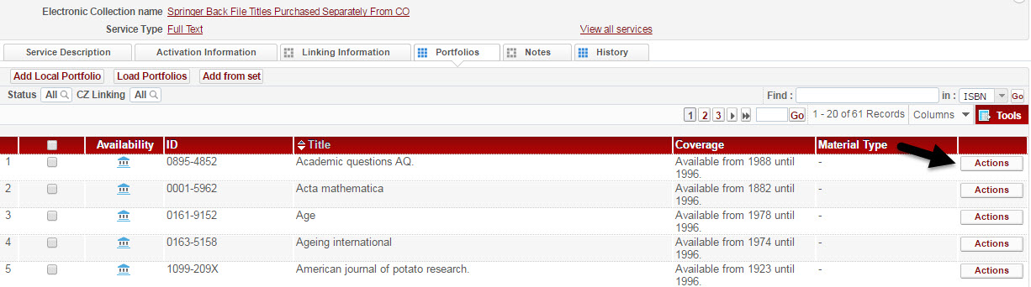

- Click on the “Actions” link for a particular title and select “Test Access.” Note you can also edit, delete, view, remove, deactivate and duplicate the title from this menu.
- If you have configured all of the settings in your collection correctly, your resource will display in the Online Services Window. You will also be given a link to display the title in a new window.
  - If your linking isn’t working, you may need to update the parser, parser parameters, or URL under the Linking Information tab. For additional information, see:
Modifying, Deactivating, or Deleting an Electronic Collection
SFX Target and Alma E-Collection Configuration Guide

Created by: J. Rogers 11/2016

