**IZ POL for Opt-in resource:**

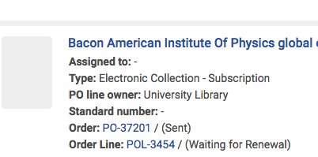

Click on **View License** to see new FY negotiated price for Opt-in NZ resource.

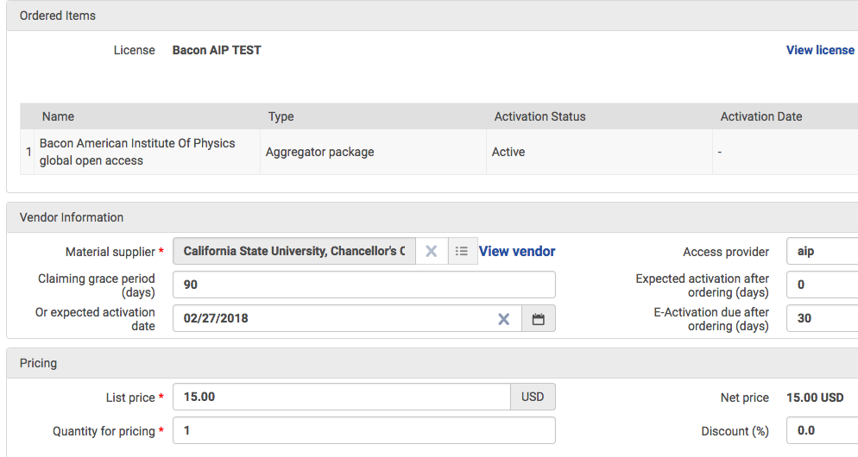

Click View License to see updated amount for new FY

Previous FY amount



Previous amount that needs updating in the POL

New amount listed under License Terms link.

New amount ($200) listed here under License Terms