GOBI API with OCLC Bib Record and Alma ebook single title workflow

Search for the portfolio. Notice that it is inactive unavailable local portfolio icon. Review the order to find which provider / collection to use.

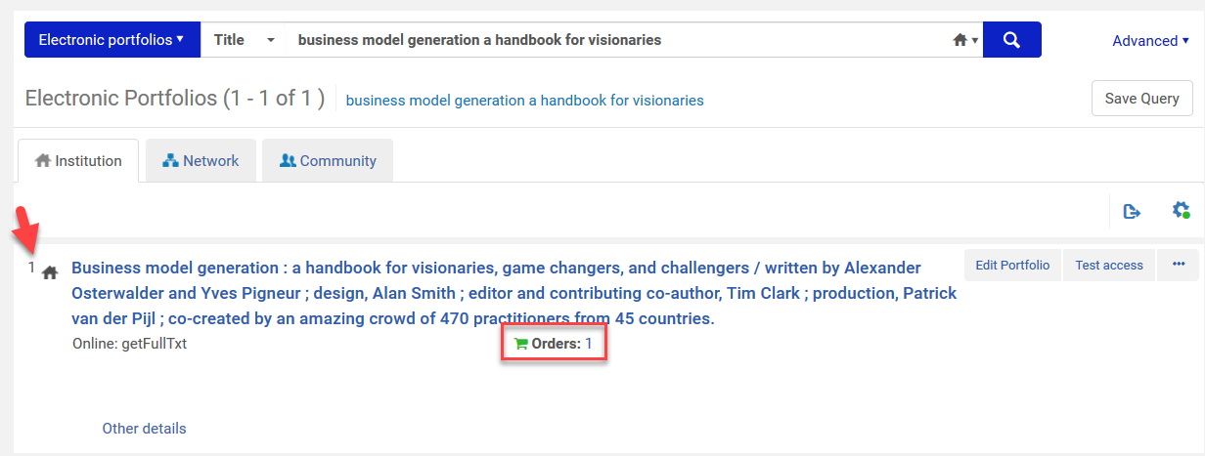

Confirm the OCLC bib record is satisfactory.

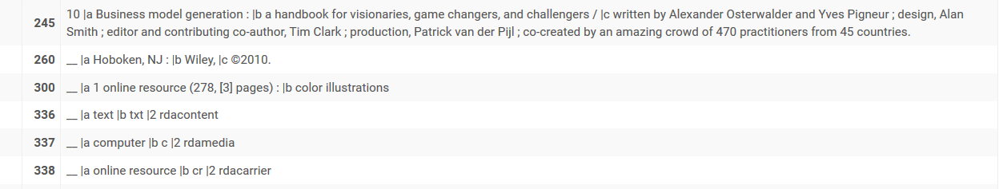

Additional fields confirming the OCLC bib record is satisfactory.

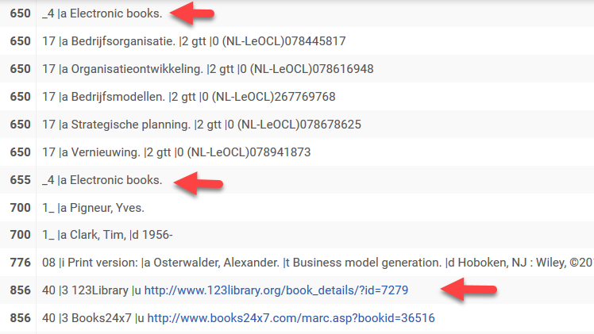

Next, in the “… menu”, select the “Link to Community”

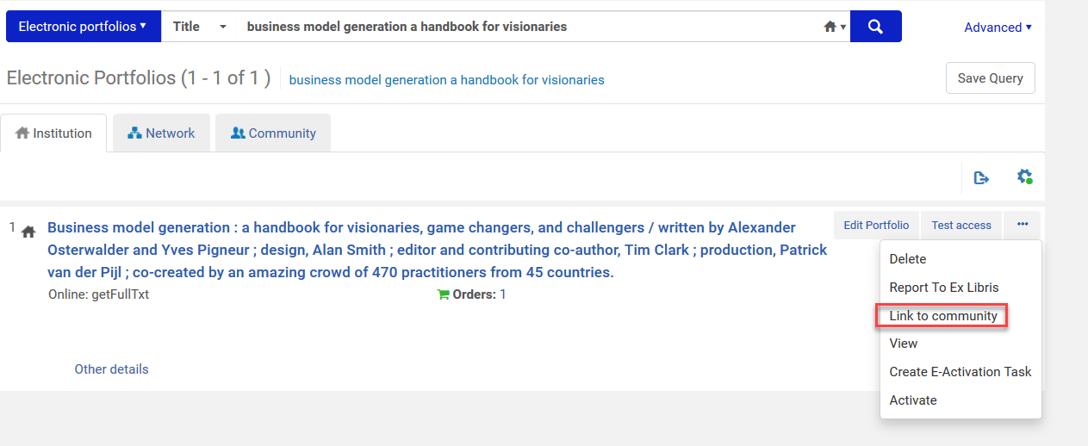

Select the CZ collection

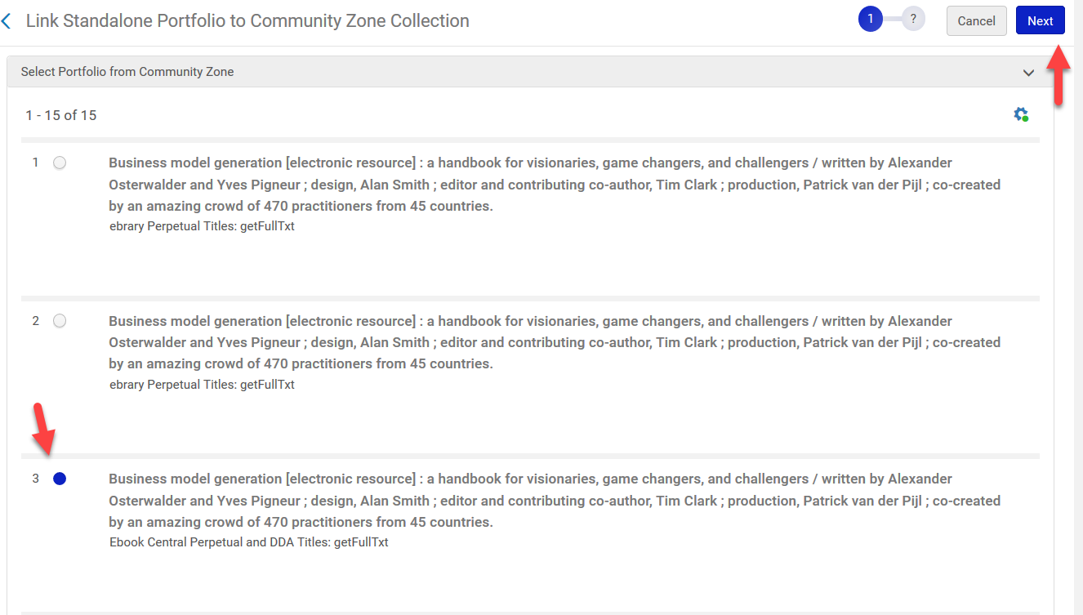

Confirming you selected the correct CZ collection

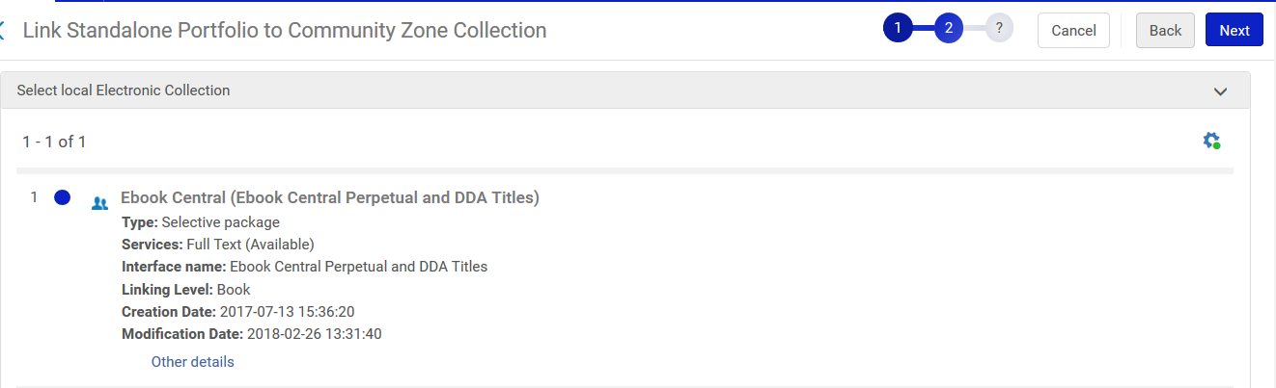

Finish linking to the CZ

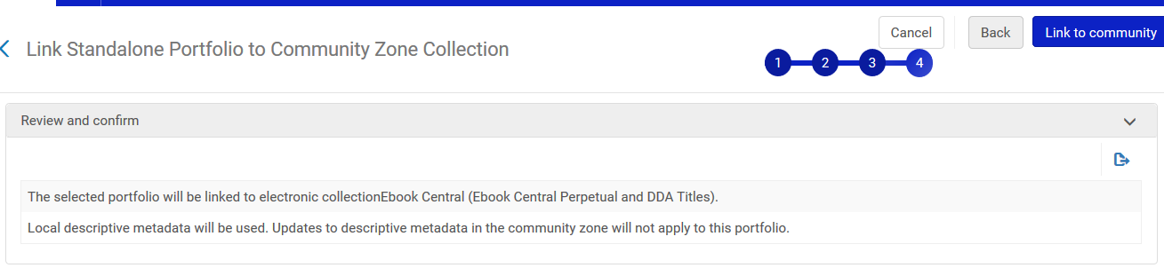

Notice the local icon is now a CZ icon. Search again for the portfolio.

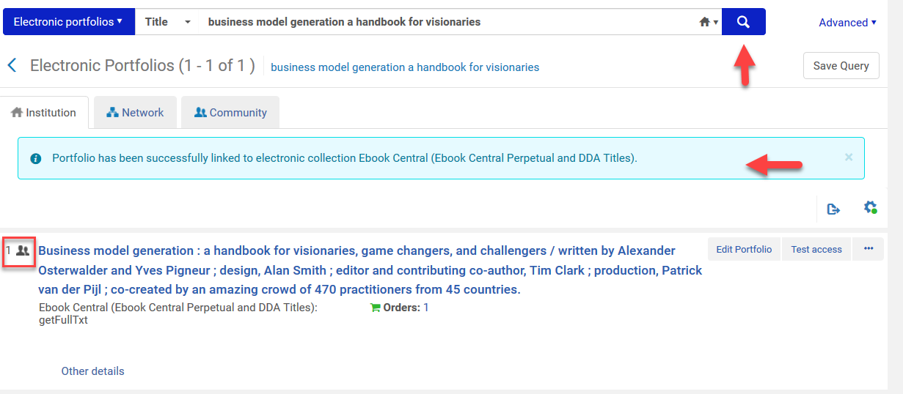

Activate the portfolio

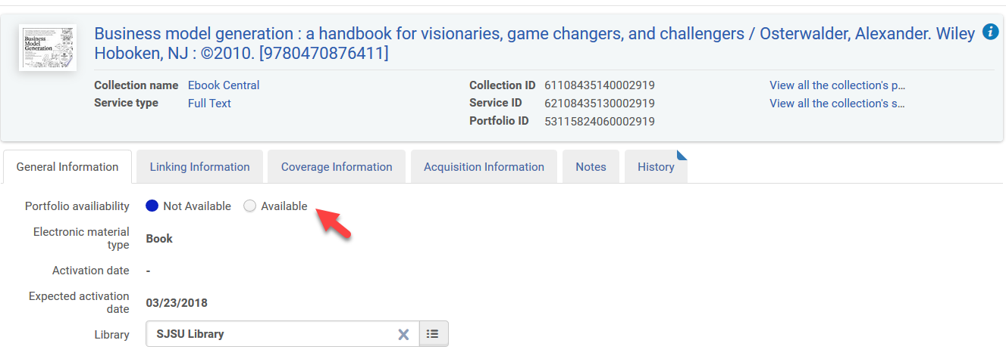

Test access.

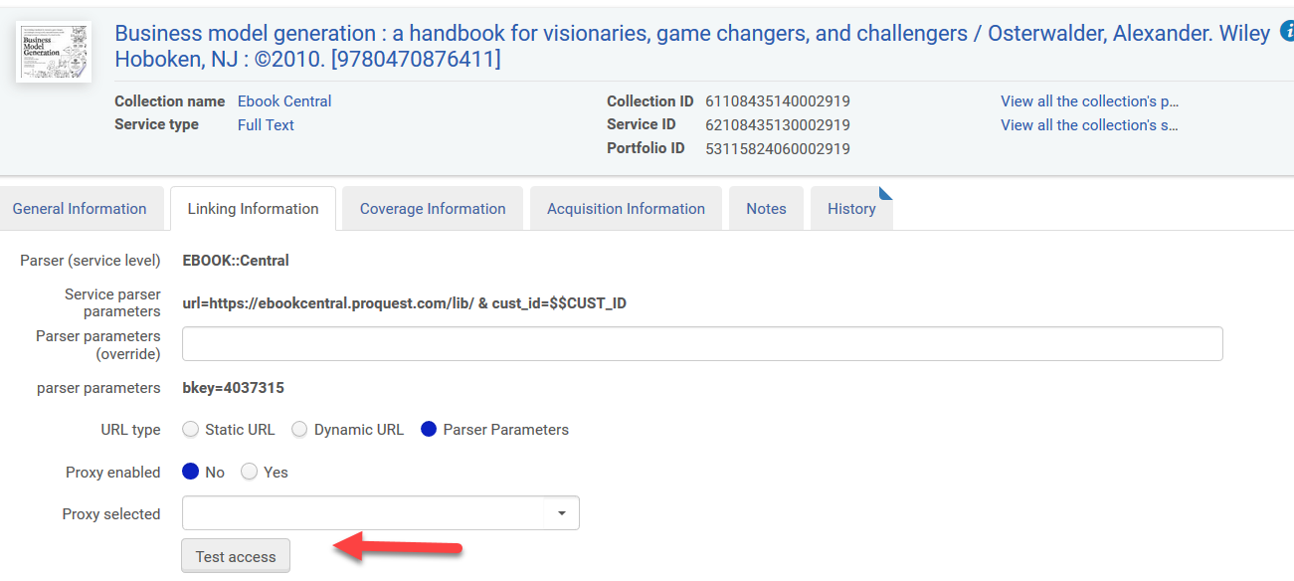

Be sure to select DONE from the Electronic Resource Activation Task List.

