CSUN: Gobi title-by-title ebook workflow

1. Ebook ordered through Gobi

Gobi API imports brief bibliographic record to Network Zone.
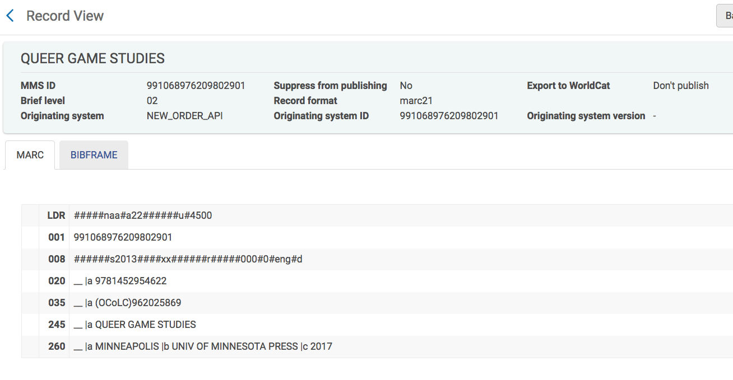
E-portfolio and PO line are also created and linked to Institution Zone bibliographic record.
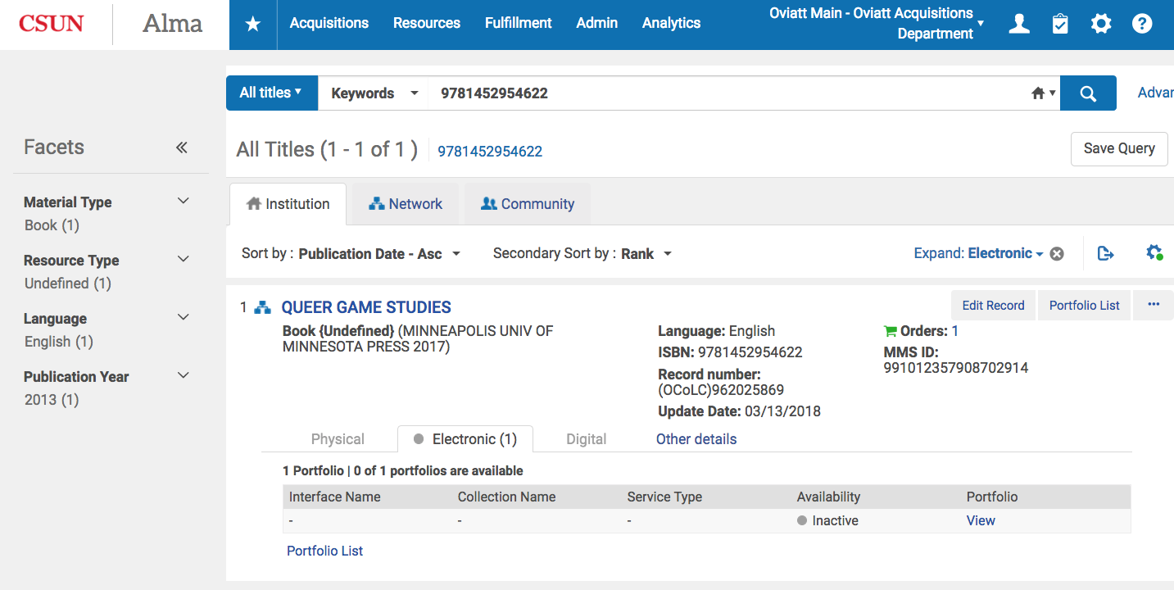

PO line contains vendor reference number which is Gobi’s order number.

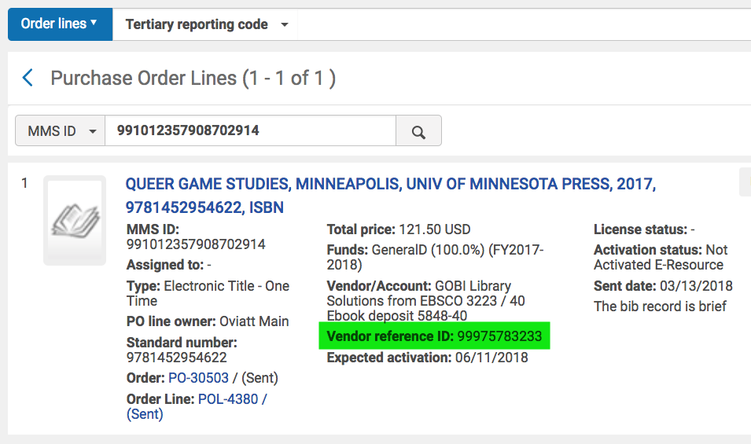

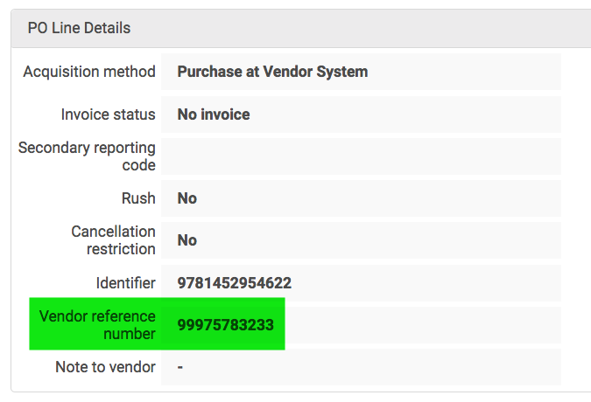

2. Update inventory import profile

CSUN set up a Update Inventory import profile that retrieves data by ftp daily at 1am.
This import profile does not make any changes to bibliographic records.
It only adds url’s from Gobi to the eportfolios.

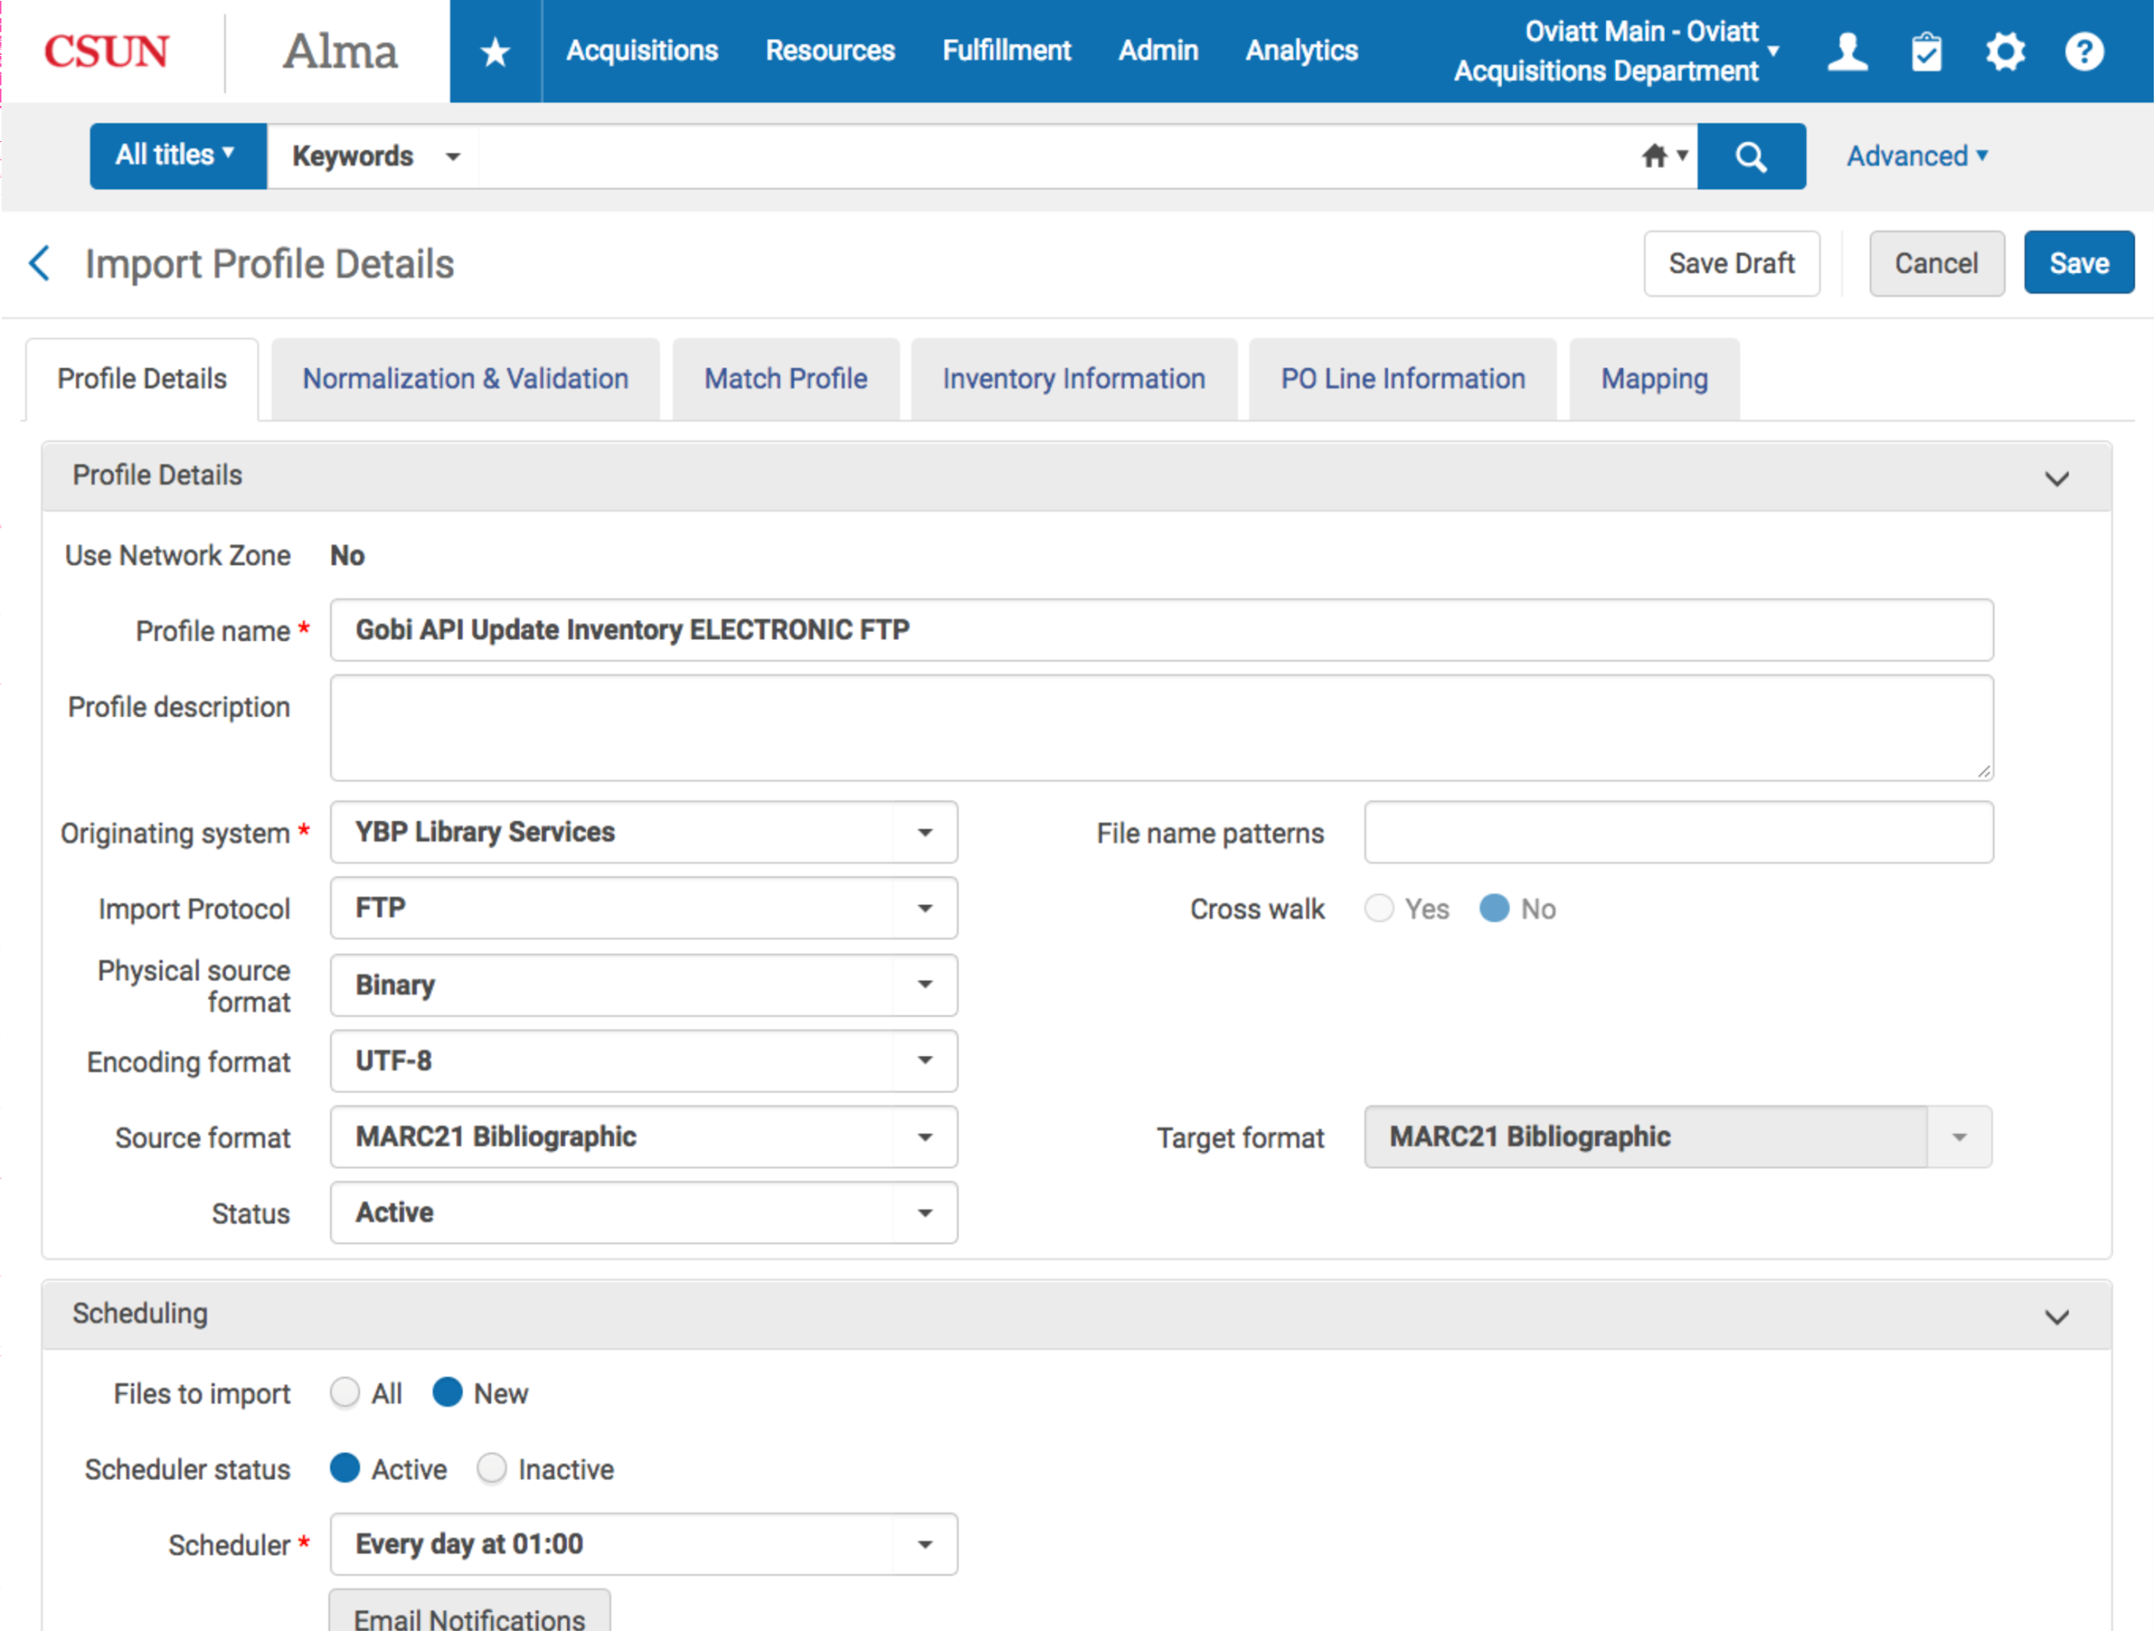
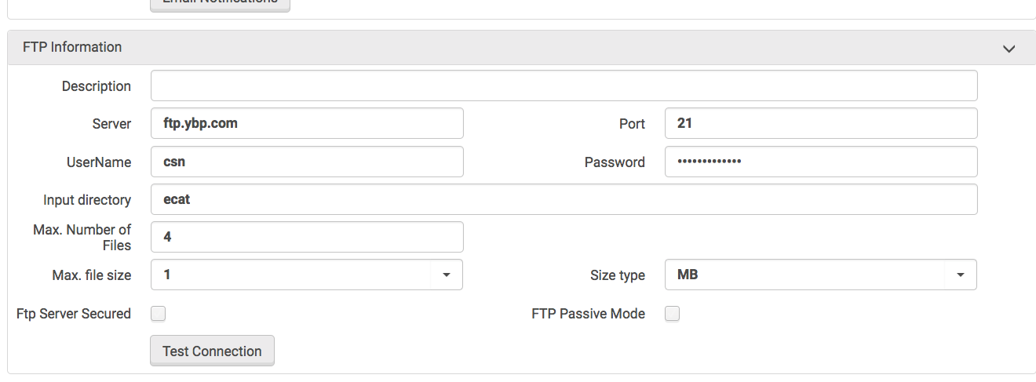

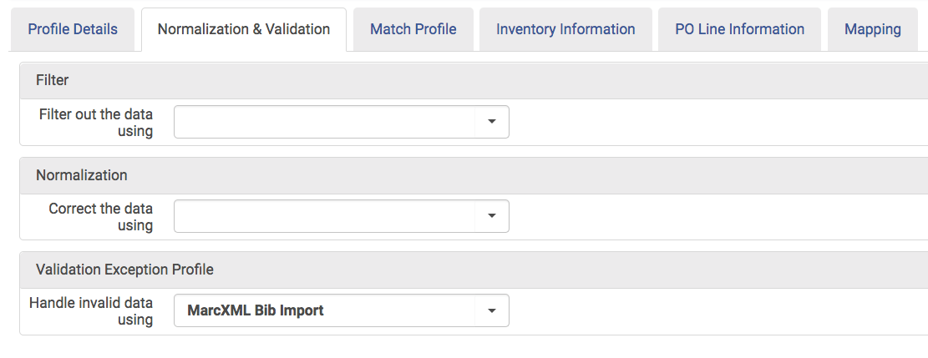

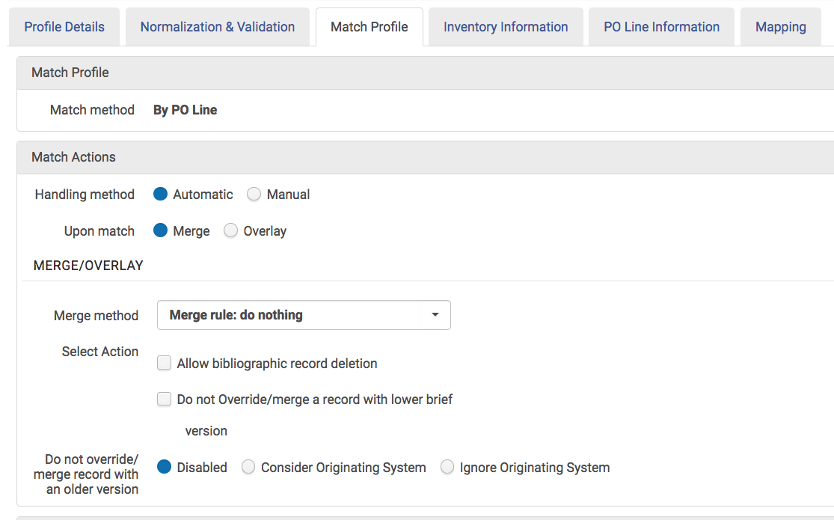
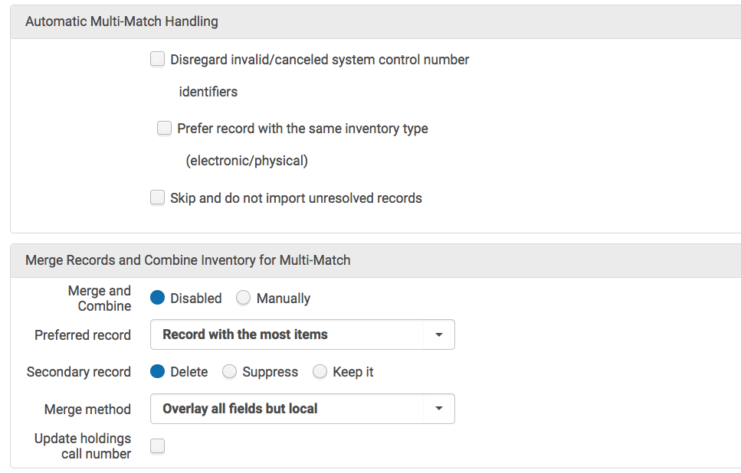

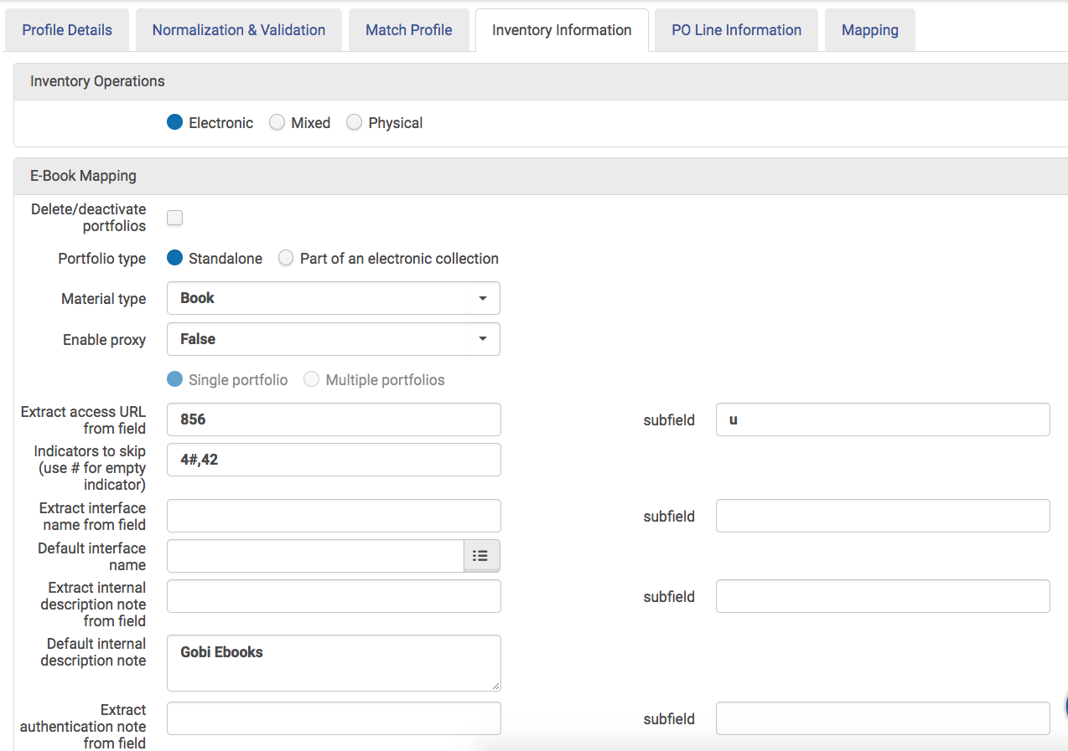

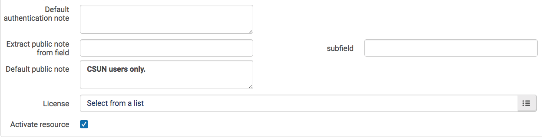

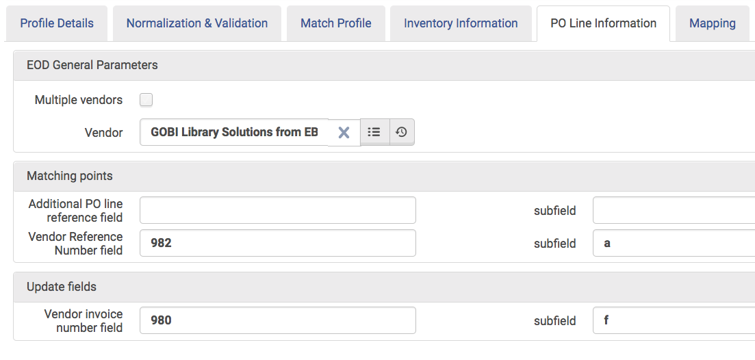

Snippet of Marc file provided by Gobi
...
=856 40$uhttp://libproxy.csun.edu/login?url=http://search.ebscohost.com/login.aspx?direct=true&scope=site&db=nlebk&db=nlabk&AN=1257575$zConnect to online resource. CSUN users only.
=980 \\$a180301$b5688$d000$e5688$f469728$g1
=981 \\$b0815D$cUNASSIGNED
=982 \\$a99975587194

After the update inventory import profile runs, url’s are added to the eportfolio and the portfolio is activated.

ISBN: 9781573876896
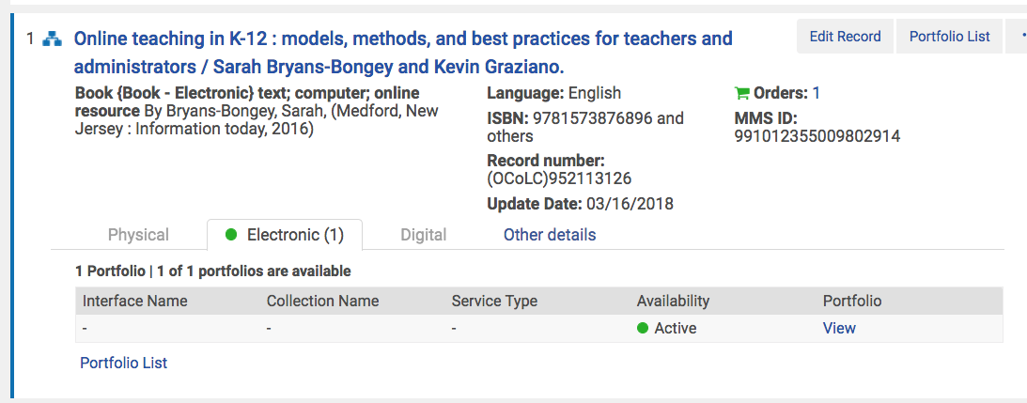

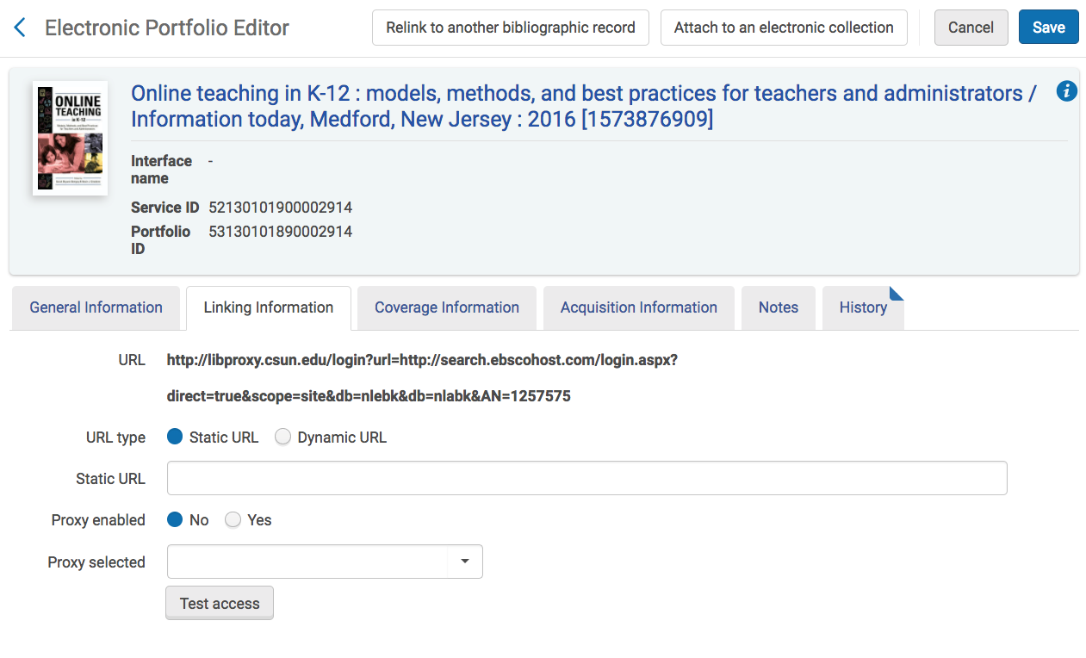

3. Analytics report
The Analytics report retrieves portfolios that have been activated recently and includes the bibliographic record’s MMS ID, title and OCLC number and the eportfolio’s ID number.

Subject area: E-Inventory
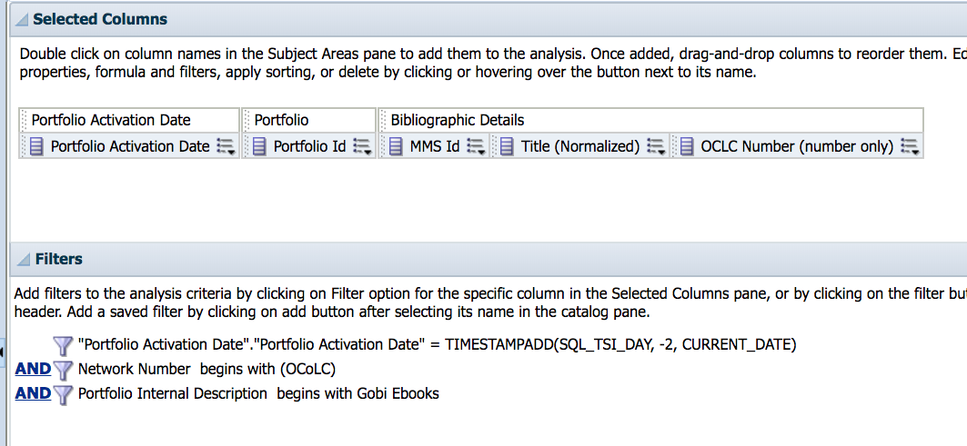

Portfolio activation date

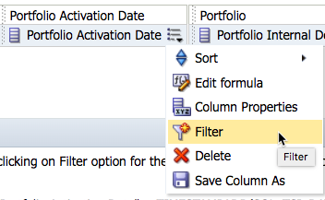
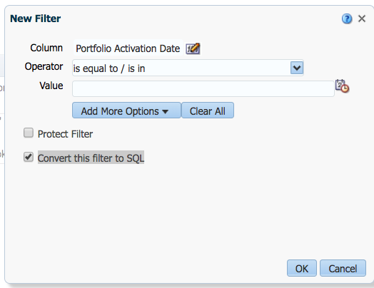

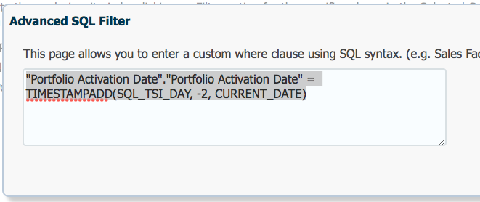
"Portfolio Activation Date"."Portfolio Activation Date" = TIMESTAMPADD(SQL_TSI_DAY, -2, CURRENT_DATE)

OCLC Number
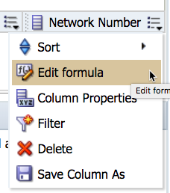
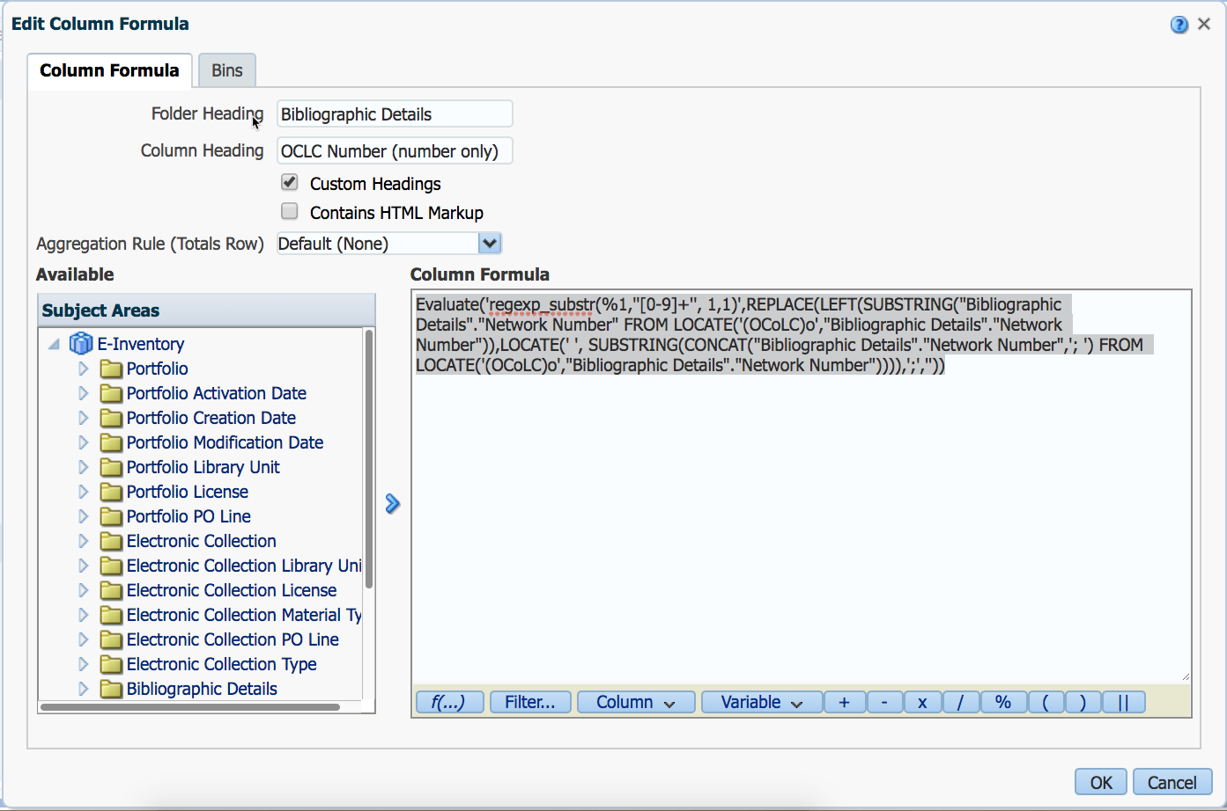

Evaluate('regexp_substr(%1,''[0-9]+'', 1,1)',REPLACE(LEFT(SUBSTRING("Bibliographic Details"."Network Number" FROM LOCATE('(OCoLC)o',"Bibliographic Details"."Network Number")),LOCATE(' ', SUBSTRING(CONCAT("Bibliographic Details"."Network Number",'; ') FROM LOCATE('(OCoLC)o',"Bibliographic Details"."Network Number")))),';',''))

This analytics report is scheduled to run daily at 4am and emails an Excel spreadsheet.
There is Exlibris documentation on scheduling and subscribing to analytics reports in Alma. https://knowledge.exlibrisgroup.com/Alma/Product_Documentation/010Alma_Online_Help_(English)/080Analytics/040Scheduling?uxp=true

Sample report

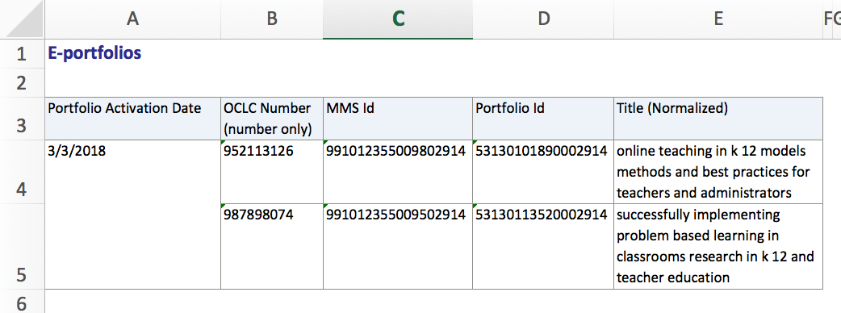

Portfolio Activation Date | OCLC Number (number only) | MMS Id | Portfolio Id | Title (Normalized)
3/3/2018 | 952113126 | 991012355009802914 | 53130101890002914 | online teaching in k 12 models methods and best practices for teachers and administrators
 | 987898074 | 991012355009502914 | 53130113520002914 | successfully implementing problem based learning in classrooms research in k 12 and teacher education

4. Electronic Resource Activation Task List
Resources, Manage Inventory, Manage Electronic Resource Activation

Unassigned tab

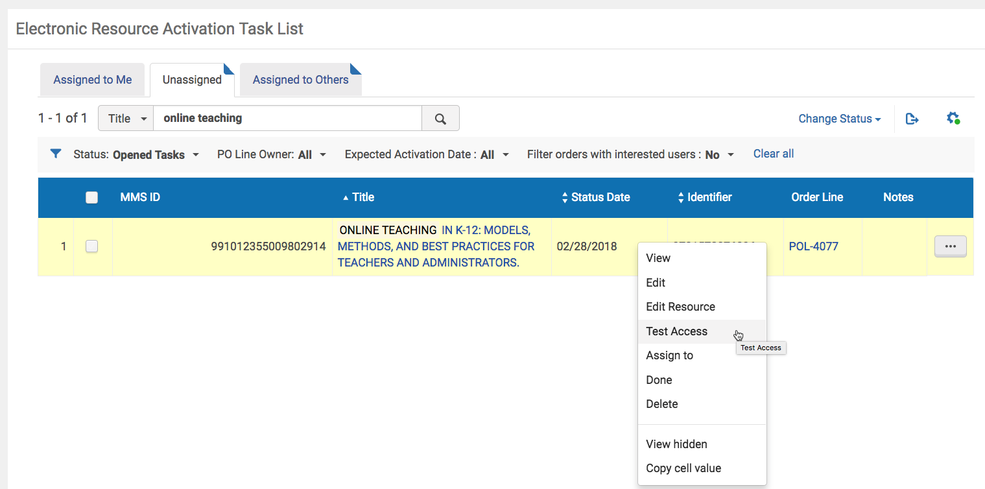

Based on the analytics report, the staff member locates the title in the task list. They verify that the eportfolio’s url provides access to the resource. If not, they can follow up with acquisitions staff who will contact the vendor.

At this step, a cataloger may wish to check that the bibliographic record accurately describes the resource. If not, they can search OCLC for a better record and relink the PO line and eportfolio to the better record. The cataloger may also update holdings in OCLC Worldcat at this step.

Then mark the item as Done which removes the title from the task list and sends notices to interested users (if applicable).

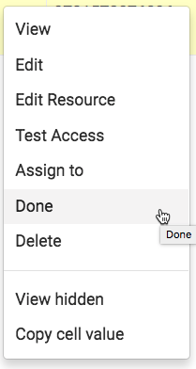

5. Link standalone eportfolios to CZ collection
Exlibris documentation on linking an IZ standalone portfolio to a Community Zone collection:
“in order to enable automatic updates (linking, coverage, activation) - but yet keep the preferred local bibliographic information”
https://knowledge.exlibrisgroup.com/Alma/Knowledge_Articles/How_to_link_local_portfolios_(standalones)_to_the_Community_Zone

Linking a standalone, IZ portfolio to a CZ collection will facilitate centralized analysis because the portfolio will inherit the collection’s (more standardized and widespread) public name and interface name. This will help with determining “who owns what”, gathering CSU-wide analytics and shared collection development.

The public name displays in Primo which may assist user/librarians in ascertaining the access provider and troubleshooting access issues.

Example:
local collection’s public name: Gobi ebooks interface name: None.
vs.
CZ collections public name: EBSCOhost Ebooks interface name: Ebscohost.

Procedures

Search for eportfolio by portfolio ID number. Then Link to community.

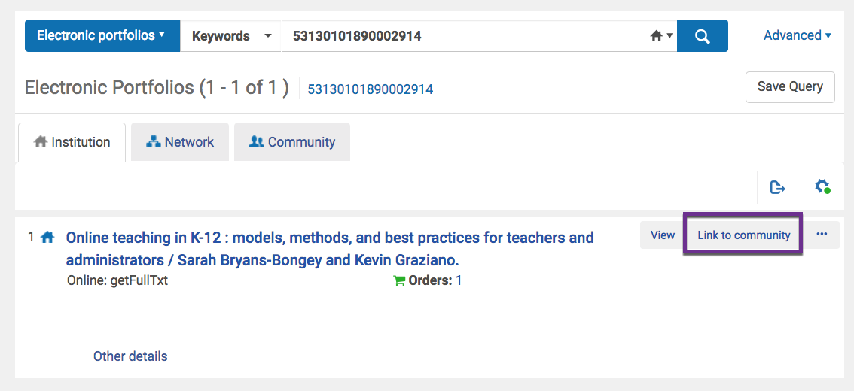

Select the appropriate CZ collection.

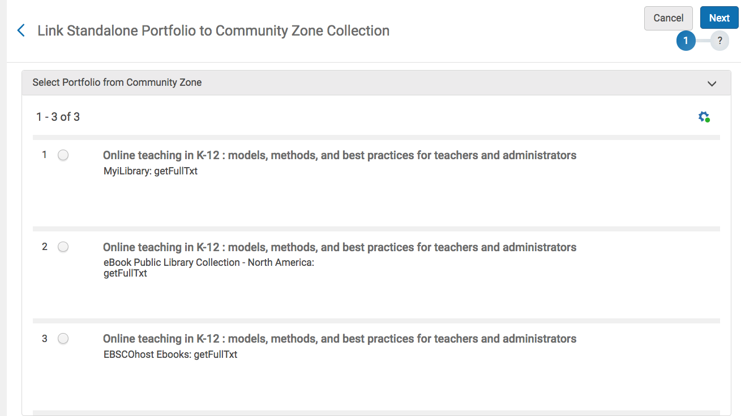

Choose whether to use descriptive record from CZ or to use the OCLC record.

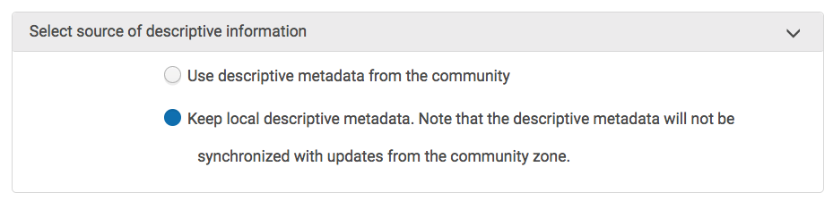
Review and confirm. Link to Community.
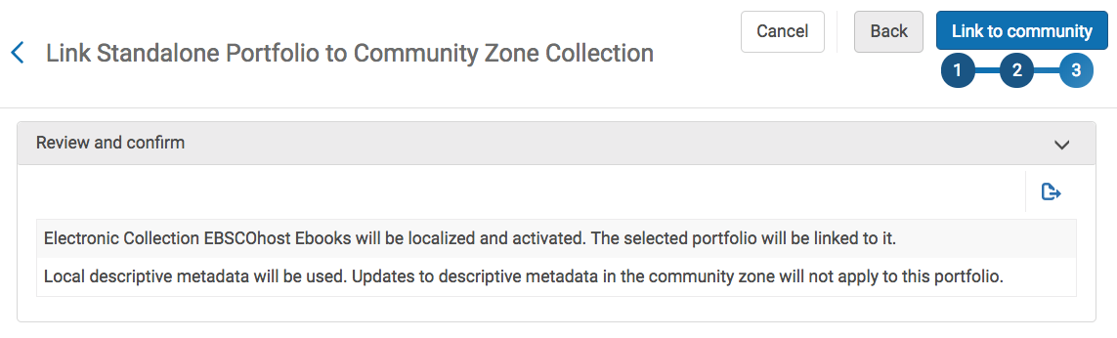
The end.

