Loading Brief Order Records: Creating Import Profiles to Load Vendor Order Records into NZ
Last updated 9/26/2016; Created by the YBP EOCR Record Loads in Alms Group
It’s important to be careful when adding records to the NZ. There are two principle ways to add records to the NZ: 1) directly from Connexion and 2) using brief or full records from a vendor. This document discusses how to use brief/full records from YBP and minimize errors when adding new NZ records.
There are several ways of adding YBP records to the NZ. This document will specifically discuss using YBP EOCR and YBP EOCR+. The considerations and setup will apply to other vendors.
This document covers
- General Considerations
- Vendor Communication and Setup
  - YBP
- Import Profile Settings for Brief Bibs
  - Profile details
  - Normalization and Validation
  - Match profile
    - Single phase - manual handling
    - Single phase - automatic handling
    - Multi-phase process
    - Other considerations
  - Set Management Tags
  - Inventory Information
  - POL Information
  - Mapping
General Considerations
- When loading order records in the NZ, the goal is to avoid adding or creating a duplicate record.
- In order to support the use of a single bib in the NZ, it is important to have multiple match points in the 035 field, including the OCLC number and vendor ID numbers.
- The YBP Unique Identifier (UID) number is the manifestation-level number assigned to each title in GOBI. For example, hardback and paperback editions have different YBP UID numbers.
- The YBP Order Key is the unique ID for each order transaction, unique to each library's order.

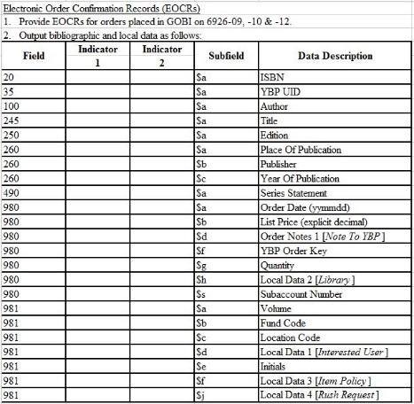
The following are instructions for setup with YBP and for creating Alma Import Profiles.
Vendor Communication and Setup
YBP
If you plan to load EOCR (Electronic Order Confirmation Records) or EOD (Encoded Order Data) records from YBP:
- have YBP put the YBP UID in field 035 $a
- have YBP include the YBP Order Key in a library-chosen field (e.g. 980) for mapping to the Vendor Reference Number. (See: Local Bibliographic Fields)
- work with YBP to include the desired POL data options in the EOCR file (Tech Specs) →→

Import Profile Settings for Brief Records
Navigation:
- Alma → Acquisitions → Acquisitions Configuration → Configuration Menu → Purchase Orders → Import Profiles
- Alma → Resource Management → Resource Configuration → Configuration Menu → Record Import → Import Profiles

When vendor records do not have OCLC numbers (or only occasionally have OCLC numbers)
The following screenshots detail the Import Profile settings libraries should use when loading brief vendor records into the Network Zone when the records don’t have OCLC numbers in the records.
Note: If you receive OCLC#s in all brief order records, you will need to change your match profile setup to match using Unique OCLC Identifier Match Method.
Profile Details: Use the “New Order” profile type, and make sure to select “Use Network Zone” on the first screen when you create your import profile. You cannot change this setting after the first time you save the import profile.
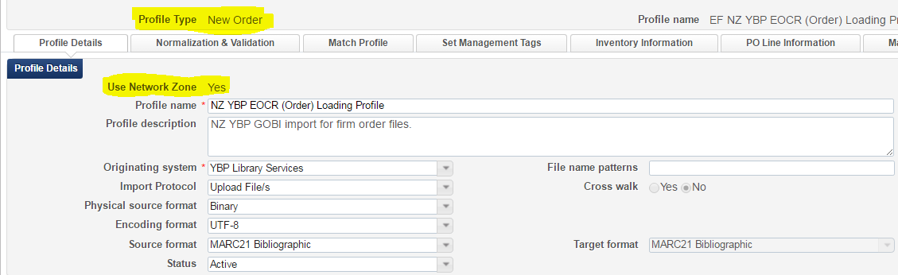

Normalization and Validation:
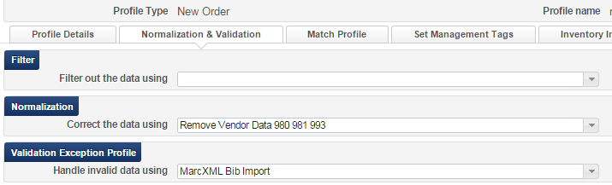
NOTE: To remove institution specific order data from the 980 and 981 fields in the bibliographic record, use the “out of the box” Normalization Rule: Remove Vendor Data 980 981 993. The order will still be created in Alma, but the local data will not be stored in the NZ record.

Match Profile:

This is the most problematic part of the Import Profile, particularly for brief order records like YBP EOCRs, because improper match settings and processes can result in duplicate records which impede smooth imports due to multi-matching. The YBP EOCR will have the Vendor UID in the $035|a and ISBN in $020|a. YBP EOCR+ records will also have an OCLC in the $035|a. Depending on the size of your record downloads, the size of your acquisitions staff, and the expertise in using Import Profiles and Alma records, decide which process/match points and handling settings listed below are best for your library.

Process Options:
- Single-phase import process with one import profile, matching on ISxN/024/035 with automatic or manual handling.
- Multi-phase import process with two or three import profiles, first matching on 035 with automatic handling and a profile that doesn’t load any non matches, and then matching on ISxN/024/035 with automatic or manual handling.
  - EOCR+:Multi-phase import process with three import profiles, the first matching on OCLC Unique Identifier with automatic handling and a profile that doesn’t load any non matches, the second import profile matching on the vendor 035 with automatic handling and a profile that doesn’t load any non matches, the third import profile matching on ISxN/024/035 with automatic or manual handling.
  - EOCR: (not EOCR+) Multi-phase import process with two import profiles, the first matching on the vendor 035 with automatic handling and a profile that doesn’t load any non matches, the second import profile matching on ISxN/024/035 with automatic or manual handling.

Handling options:
- Manual handling: every single and multi-match found will need to be resolved at the time of import (i.e. the library chooses the correct record or chooses to import EOCR if the correct record isn’t in the NZ). Records without matches will be added to the NZ.
- Automatic handling: every multi-match found will need to be resolved. (i.e. the library chooses the correct record or chooses to import EOCR if the correct record isn’t in the NZ). Records without matches will be added to the NZ.
- For both options, use the import report to determine if any matches were linked to incorrect bib records and relink as necessary. See Import Profile Reports: Troubleshooting Tips.

Single phase - Manual handling

Create a New Order Import Profile with a Manual handling method that uses the ISSN/024/035 Match Method and upon no match Adds to NZ. Because you will use the NZ record upon match, you need to disable the ”Do not override/merge record with an older version” option.
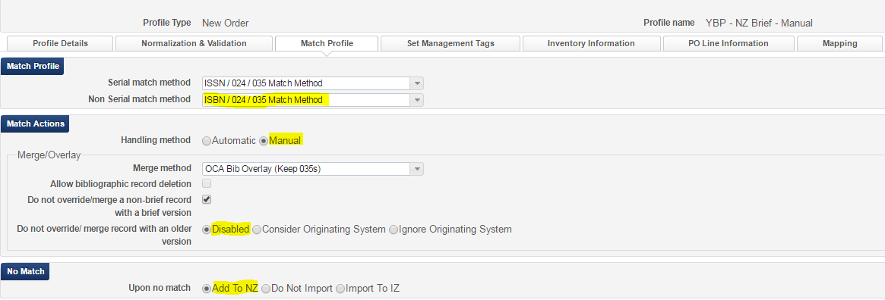
With Manual handling, you will need to choose which record to match to. If there is no match, then the record is added to the NZ. If your records match with a lot of NZ records, this could be time consuming.

Single phase - Automatic handling

Create an Import Profile with an Automatic handling method that uses the ISxN/024/035 Match Method and upon no match Adds to NZ.

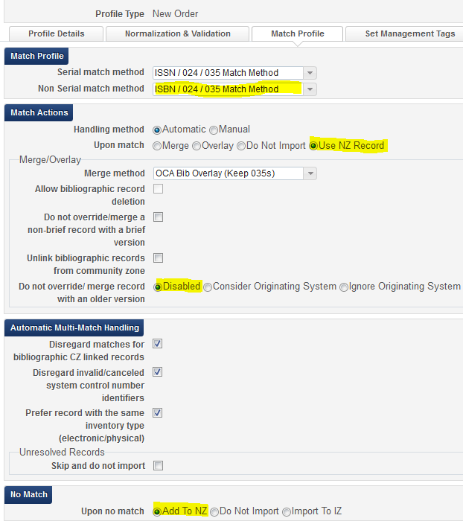

This Match Method is not hierarchical, and it can match on any of these match points. Also, it has potential for improper matches with ISBNs for electronic resources and with ISBNs for a different OCLC record than you will receive in your WCP file, in which case you would then need to transfer your holdings to the proper bib record in the NZ. Use only if you are comfortable in doing this. See Import Profile Reports: Troubleshooting Tips for examples on how to identify incorrect bib matches.

Multi-phase process:

This involves creating 2-3 different Import Profiles which are used in a tiered fashion.

#1: If you are using EOCR+ or some other method that would put an OCLC number in the brief record, create a New Order Import Profile with an Automatic handling method that uses the Unique OCLC Identifier Match Method and does not Import upon no match.

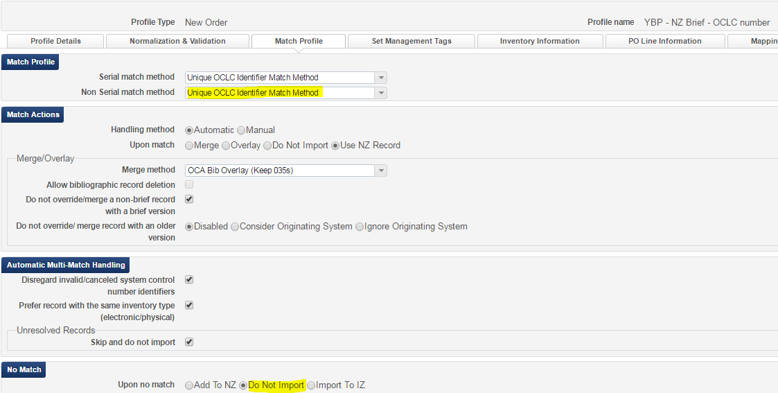

Next, go to Monitor and View Import under either Acquisitions or Resource Management.
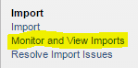

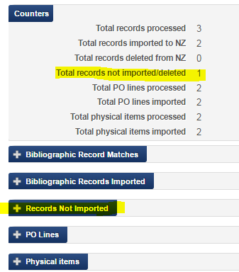
Find the job you just ran for the OCLC match profile and choose Action – Report. In the report, open the Records Not Imported tab and go to the Action button for Total records no imported/deleted.

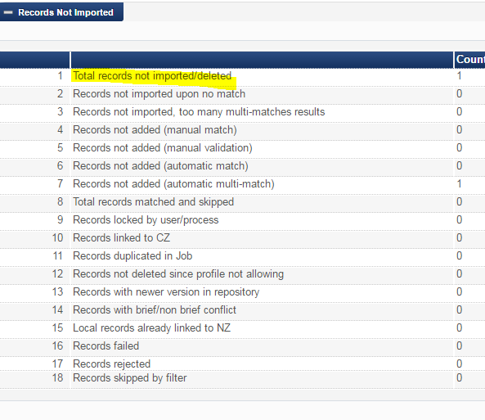

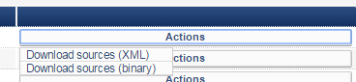

Choose the source that matches the Physical source format under the Profile Details tab (usually Binary) and download the Zip file. The Zip file will have the Process ID number in its name. The actual MARC file will be called “file_0.mrc” so you may want to rename it. Be sure to move this file from the Zip folder and to know where to find it.

#2: Create a New Order Import Profile with an Automatic handling method that uses the 035 (Other System Identifier) Match Method and does not Import upon no match.
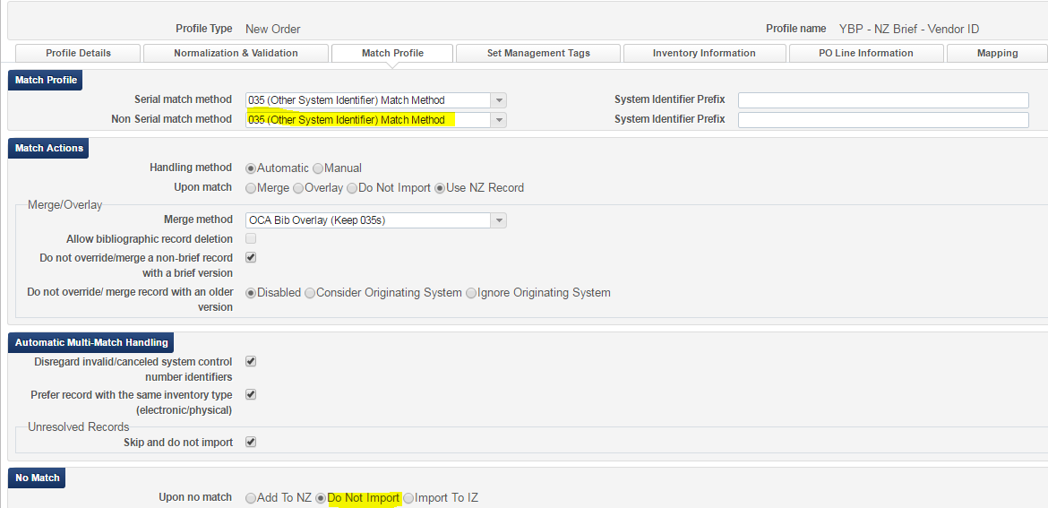

Choose the file from the previous run (or your YBP file if you don’t have brief records with OCLC numbers) and run the Import Profile.

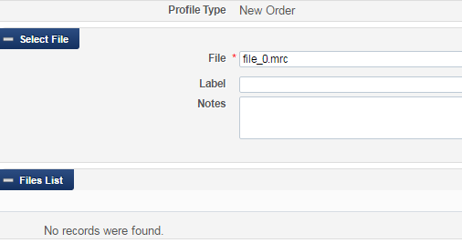

#3: Create a New Order Import Profile with a Manual handling method that uses the ISSN/024/035 Match Method and upon no match Adds to NZ. (See above).

This process reduces the potential for improper matching by using specific match points in separate import profiles. The ISxN/024/035 Match Method will match all the possible match points – whether that is an OCLC number, a vendor number, or an ISxN. By using multiple Import Profiles, you assure matching on just the OCLC number or just the 035 field if there is such a match.

Other considerations:

- Handling Method: If you choose “Automatic,” you will only have to manually handle multi-matches (i.e. the imported record matches two or more NZ records). If you choose “Manual”, you will have to manually handle all matches (i.e. the imported record matches one or more NZ records). It’s useful to choose “Manual” when you are first learning to load records.
- Do NOT use:
  - “Allow bibliographic record deletion” feature in any import profiles at this time.
  - “Do not override/merge a non-brief record with a brief version” option at this time.
  - “Do not override/merge record with an older version” for any New Record Import Profile. Keep at Disabled.
- OPTIONAL SETTINGS (Automatic Multi-Match Handling):
  - “Unlink bibliographic records from the Community Zone” (you will only see this if your “ignore_cz_records” option in Resource Management > Resource Configuration > Configuration Menu > Other Settings is set to false): Applies only when Merge and Overlay is the Upon Match setting, so it isn’t necessary to select in a New Order import profile.
  - “Disregard Matches for Bibliographic CZ linked records” (you will only see this if your “ignore_cz_records” option in Resource Management > Resource Configuration > Configuration Menu > Other Settings is set to false; notice the option is in the first screenshot but not the second.): If this option is selected, Alma will not consider Community Zone records that match your incoming record. So if a record you are loading is a multi-match situation, but one of the records is a CZ record, it will automatically choose the non-CZ record. This is a good option to choose to cut down on manual handling for multi-matches.
  - “Disregard invalid/canceled system control number identifiers”: If this option is selected, Alma will ignore the incoming record’s 035$z and only use the incoming record’s 035$a against the repository’s 035$a and 035$z. This is a useful setting if your order records have OCLC#s.
  - “Prefer record with the same inventory type (electronic/physical)”: This setting has some problems and can cause incorrect matches when there are NZ records without the inventory you are loading (e.g. usually when you are loading a print record and there is only an electronic bib in the NZ) or when there are two or more print bibs, but there is inventory on the wrong bib (i.e. the brief bib or the wrong OCLC full bib). Using this setting causes more relinking at the point of loading full bibs from WCP or when using Connexion. See this document for an explanation of how this option works.
  - “Unresolved records, skip and do not import”: With this option, any records in the file that result in multi-matches will not be loaded and you will not have the option to manually handle them during the load. If this option is selected, you will need to download the records from the Job Report as .mrc or .xml files and load them with 1) an import profile that has Manual Handling selected or 2) an import profile that has the Automatic Handling option selected and the Skip and Do not Import option unchecked. If your records are scheduled to load automatically or if you’re loading very large files of records, this might be a good option.
Set Management Tags:
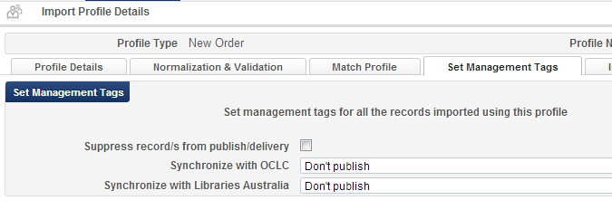

When downloading records to the NZ, do NOT choose the Suppress records/s from publish/delivery. See policy: Suppression of Records for Physical Inventory.
Inventory Information:
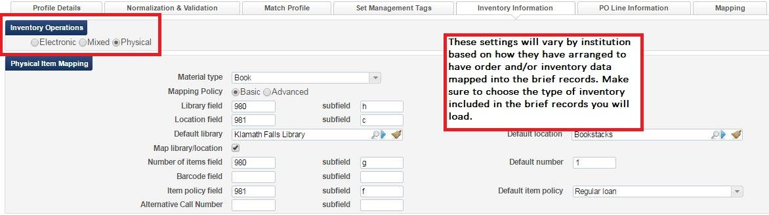
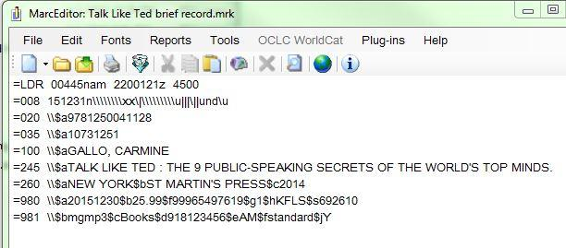

POL Information
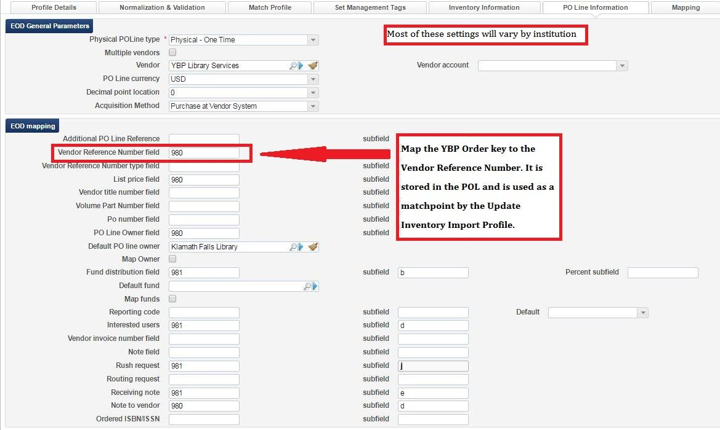
Required
- Vendor Reference Number field
- List Price field
- PO Line Owner field
- Fund Distribution field
Optional
Rush - If you want to map Rush orders to the checkbox in the POL, you need to include any of the following values in a field in your EOCR: y, Y, true, True, affirmative. You can use one of the note fields in the GOBI order details to enter that field and then work with YBP to map that field to the EOCRs.
Reporting Code - The Reporting code is not used uniformly across the Alliance. Alma lets you define reporting codes that can be used for analyzing acquisitions in subsequent reporting. Libraries need to make sure the data they are trying to map to the Reporting Code field exists in the Reporting Code table in Alma, as well as in the EOCR data they are loading. Reminder: the data is case sensitive, so if RR is the code in your table, your data will not map as rr.
Interested users - If you want to map an interested user, you will need the ID number of the patron. Please note that while in the POL itself you can place holds for interested users, if you use this feature in your EOCR record you can only notify the patron. You will have to work with YBP to configure your fields in GOBI to support this.
Receiving note - Anything mapped to this field will be included in the receiving note on the Summary tab of the POL

Mapping
There are no Alliance recommendations for mapping setup. This mapping feature is useful when you need to map incoming values from vendors that might not exist in Alma. It is especially useful during migration when you might still be receiving one code that represents both library and location information from a vendor (e.g. mlstk). You can then map that code to the corresponding fields in Alma. The screenshot below shows how the single code “mlstk” is mapped to “Klamath Falls” library and the “Books” location.
Another example might be during switching of fund codes. You can map old fund codes in YBP records to the new Alma fund codes.

