**Proxy Questions**

1. For electronic collections in IZ, we can enable proxy at the collection level as shown below.

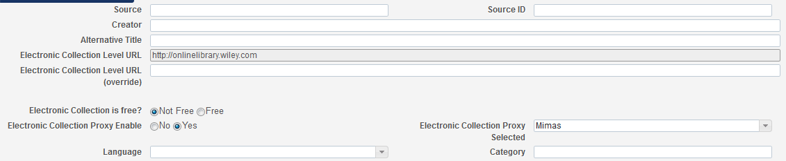

The document Resolver Proxies (<https://knowledge.exlibrisgroup.com/Alma/Product_Documentation/Alma_Online_Help_(English)/Integrations_with_External_Systems/030Resource_Management/220Resolver_Proxies)> includes the following:

Portfolios inherit the proxy-enabled setting from the service-level, proxy-enabled setting to which they are attached. As a result, you do not need to set a portfolio-level proxy-enabled setting…

The electronic collection proxy-enabled settings are not inherited by portfolios.

Question: I am totally confused by these descriptions. What does “the service-level” mean here? Can you illustrate this using screenshots from a real setting, so I can understand? Does “the service-level” mean the same as collection level as the service provides linking and full-text?

Does this mean we don’t need to turn on proxy for all portfolios within Wiley in this particular case?

Answer:

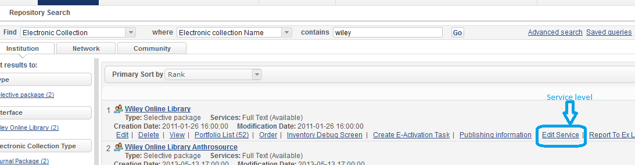

SeArch for collection and click on Edit Service – Go to ‘Linking Information’ tab:

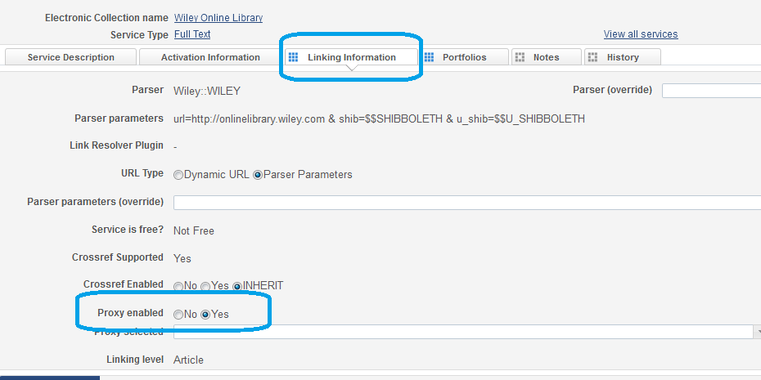

1. In the screenshot below, the Service Parser Parameters including part of proxy string “url=”. I have entered our proxy URL to our campus proxy profile as such: <http://mimas.calstatela.edu/login?url>=.

Question: If the Parser Parameter has already included “url=”, do I still need to include “url=” for the Proxy URL in the Proxy Definitions box (see below) for our proxy profile?

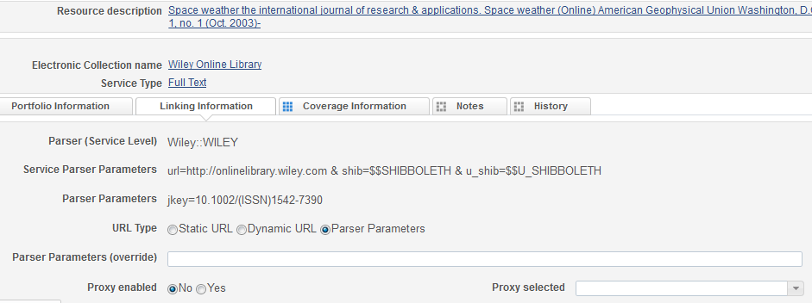

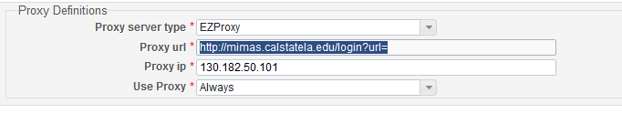

Answer: I think you do not need it “url=” string.

1. The document Resolver Proxies (<https://knowledge.exlibrisgroup.com/Alma/Product_Documentation/Alma_Online_Help_(English)/Integrations_with_External_Systems/030Resource_Management/220Resolver_Proxies)> indicates that If the proxy is set as the default, and Actions is set to Always, then this proxy is used for resolving any resource, even resources that do not ProxyEnabled=Yes.  
     
   Selective – This proxy is used for resources where EnableProxy=Yes and this proxy is selected (this is equivalent to selecting Always for a non-default proxy).

Question: Based on these two definitions, if I don’t need the proxy to resolve free resources, what should I select?

Answer: Selective.