Functional call – June 30

Agenda:
- Activate CZ collections of type aggregator, selective
- Activate individual portfolio – CZ, local
- Add local collection
- All portfolio/set of portfolios to local collection
- Link to CZ
- Batch activation/update of portfolios
- Unlink bibliographic record from CZ, contribute bib record to NZ
- PDA

http://knowledge.exlibrisgroup.com/Alma/Product_Documentation/Alma_Online_Help_%28English%29/Resource_Management/050Inventory/020Managing_Electronic_Resources#Adding_a_Standalone_Portfolio

- Please demonstrate the addition of an Electronic Collection where we subscribe to whole Aggregator packages - via linking to the Community Zone/ via linking to the Network Zone/ as a local collection
- Please demonstrate the addition of an Electronic Collection via linking to the Community Zone when you only subscribe to a Selective Package.

Workflow – Activating Aggregator electronic collection
Example:
EBSCOhost Business Source Elite

- Search IZ/NZ/CZ (Avoid duplication, do not activate the same titles in the same collection both in the CZ AND by using a local collection with NZ bibs or local portfolios).
- Click on Activate (for free); click on Order (when ordering a resource)
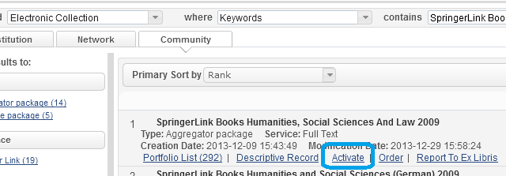
- Fill in activation form
- Activate all portfolios for an aggregator package
- Activate new portfolios associated with service automatically? => select Yes

When selected ‘Order’ workflow – fill in order form (select proper Order type).
When order is ‘Sent’, system creates ‘Activation task’ for the resource.
Manage Electronic resources activation task list (Electronic Resource Operator, Repository Manager):

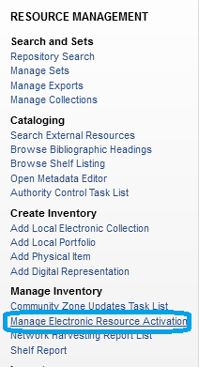
There is an option to assign activation task to an operator. 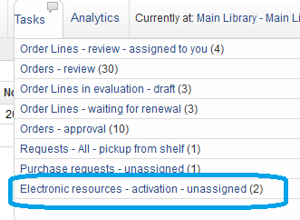
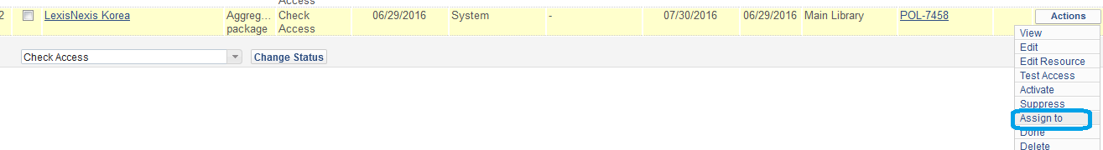
Activation task has a due date when activation has to be complete. There is a process that sends notification “Notify E-Activation due task”. Notice about task due date passed sent to operator to whom the task was assigned.
Resource Management Configuration Menu – other Settings – activation_due – default value.
Due date comes from POL –
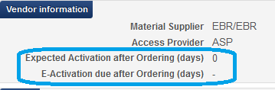
If not defined – system takes default value from Acquisition Configuration menu – Other settings – activation_due
To create e-activation task manually – search electronic resource – click on ‘Create e-activation task
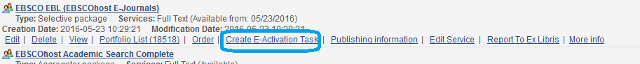
Workflow – Activating Selective electronic collection
Example - JSTOR Music Collection
- Search CZ for collection
- Click Activate
- Follow the wizard
- activate selectively – all/upload a list/add manually
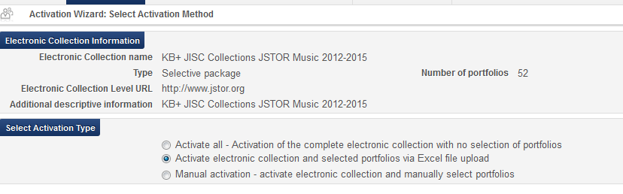
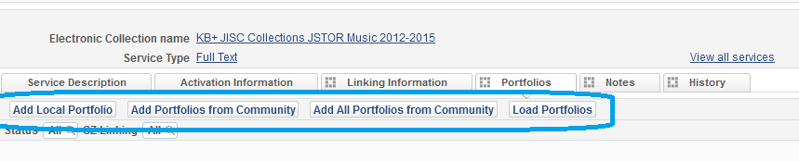
- Load portfolios using Excel
- From the CZ search screen click on ‘portfolio list’
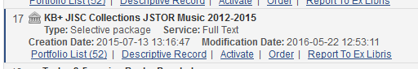
- From ‘Tools’ – select ‘Extended Export’
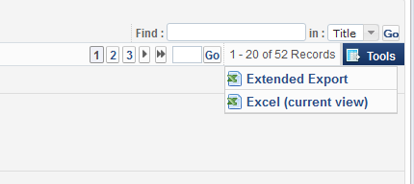
- Modify Excel – remove titles you do not purchased.
- Go to e-Collection – upload the list of portfolios (click on temple icon to view resource in IZ)
- Click on Edit Service – Portfolios tab
- Select ‘Load Portfolios’
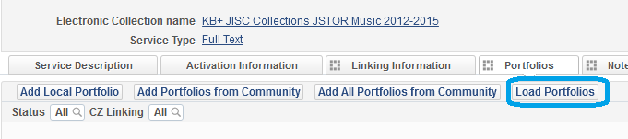
- Activation wizard:
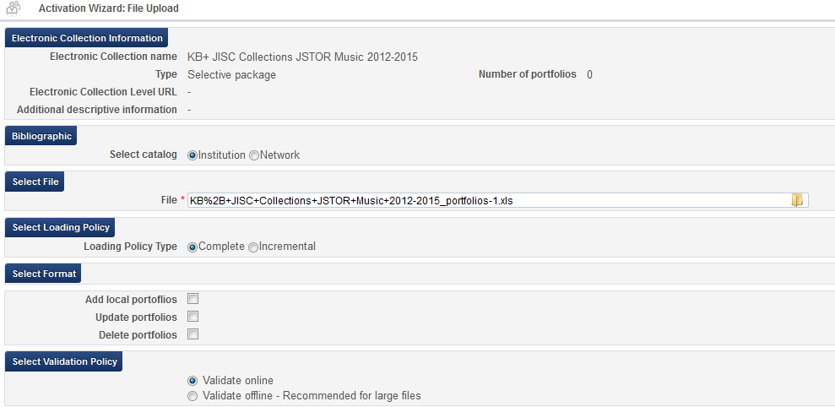
Load policy Type – Complete/Incremental
For this use case, select Complete and Add local portfolios.
Complete - overwriting any existing portfolios.
Select ‘Add Local portfolios’ (no portfolios under collection yet) –
  - If a match is found in the Community Zone for the portfolio, the portfolio is added and linked to the Community Zone.
  - If a match is not found in the Community Zone for the portfolio (based on the identifier), a new local portfolio record is created and added to the electronic collection.

- Update portfolios – use when need to update existing portfolios. If portfolios linked to the Community Zone, only the override information in the portfolio is updated when this option is selected.
- Delete portfolios – action done on portfolios that are not in the Excel:
  - Portfolios that are CZ-linked will be unlinked from CZ/ deactivated.
  - If portfolios are in the Excel file but not linked to CZ electronic collection, they will be activated from the CZ, if they exist in CZ collection.
Note – delete option for Incremental loading policy type is different.
The Delete portfolios option provides the following additional options to specify how you want to handle bibliographic records when deleting portfolios results in bibliographic records without inventory:
  - Delete bibliographic record(s)
  - Suppress bibliographic record(s)
  - Do nothing
Incremental – Loads a file that includes only the incremental changes to the portfolio list of a specific electronic collection. With this option, you can load only the portfolios that have been updated since the last load.

Incremental options:
- Add New –
  - Matching titles in the Excel file with portfolios of the same collection in the CZ, and if found, activates the relevant portfolios. If no match is found, local portfolios are created.
  - When the electronic collection is local and Add New is selected, the portfolio loader adds the titles in the Excel file as local portfolios.
- Update – This option updates the details of all electronic collection portfolios that are listed in the file.
- Delete – When this option is selected, any portfolios that are in the Excel file that match the portfolios in the electronic collection will be removed.
In order to take advantage of CZ updates – inventory should be managed by CZ. If record exists in CZ it is preferable to activate it from CZ and take advantages that system gives:
- Maintenance efficiencies for large and frequently changing collections
  - Collections/portfolis: added and deleted titles managed automatically
  - Automatic updating of URLs in portfolios if URL changes in the collection
  - Weekly list of collection updates
See presentation:
http://knowledge.exlibrisgroup.com/@api/deki/files/39140/Using_the_Alma_Portfolio_Loader_-_Examples.pdf
- Please demonstrate how to add an individual Portfolio - via linking to the Community Zone/ via linking to the Network Zone/as a local stand-alone portfolio

Workflow – Activating individual portfolio
Scenarios:
    - Activate CZ portfolio
- Search CZ for title
- Click Activate

    - Add local portfolio
- From Collection – click Add local portfolio
- From Alma menu – Add local portfolio - Resource Management > Create Inventory > Add Local Portfolio
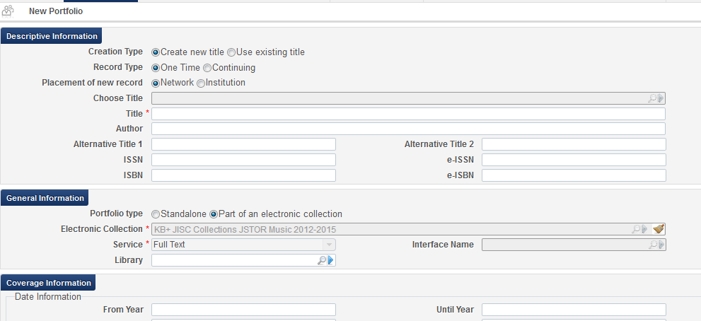
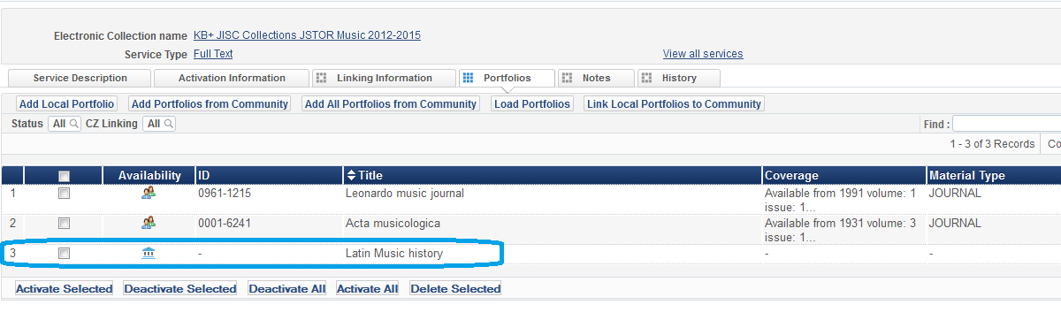
Alma Menu – add local portfolio:
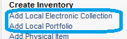

Workflow – add local collection
Use cases:
- Combine standalone portfolios under one collection to enable easy managing of linked portfolios.
- Collection is not in the CZ. Vendor supplies file with portfolios for upload. If collection is not present in CZ – institution will create a local collection and upload titles/portfolios to the collection.

Locally created collection can be linked to the CZ when CZ has a collection.
How to contribute missing collection to the CZ?
Click ‘link to Community’
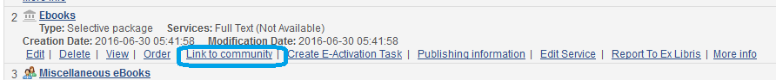

Local Collection can be added from Alma Menu –

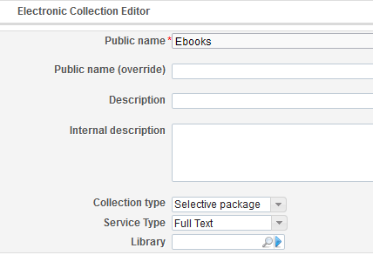
Workflow – add standalone portfolios to local collection
- Add from set
- Add from search
- Add from file

Workflow – link local portfolio to a Community (if matches)
Use case – portfolio was not in the CZ when activated. CZ was updated – portfolio can be linked to be managed from CZ.
- Go to Collection
- Select local portfolio/portfolios
- Click – Link to Community
System will try to find a match.

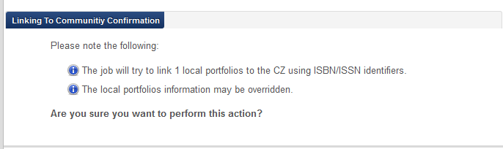

Link to collection from portfolio - https://www.youtube.com/watch?v=_iFsrATEHYs&hd=1

Workflow – unlink bib record from CZ
Use case - CZ record has brief MARC record – institution wants to enrich record and share with NZ.
Note only bib is shared with NZ!
If portfolio is activated from CZ – it remains to be managed by CZ
If portfolio is local – it remains to be managed manually by IZ
Inventory level is not linked to NZ
Check always if resource exists in CZ.
Steps:
- Search for Electronic portfolio in CZ
- Find record in IZ
- Edit record in Metadata editor
- File – Copy to Catalog
- Enrich bibliographic record - Save
- File – Share with Network
Record is now linked to NZ – icon has been changed to -
If another institution wants to use this bibliographic record and order it there will be a step to link local portfolio created to CZ. Be sure not to use CZ bib record – Use the Community bibliographic record – Yes/No.
Icon - will show that portfolio is linked to the CZ
- Please demonstrate the steps involved within the Service Level for setting up connectivity for an Electronic Collection and for a stand-alone portfolio.
http://knowledge.exlibrisgroup.com/Alma/Product_Documentation/Alma_Online_Help_%28English%29/Resource_Management/050Inventory/020Managing_Electronic_Resources
Linking parameter
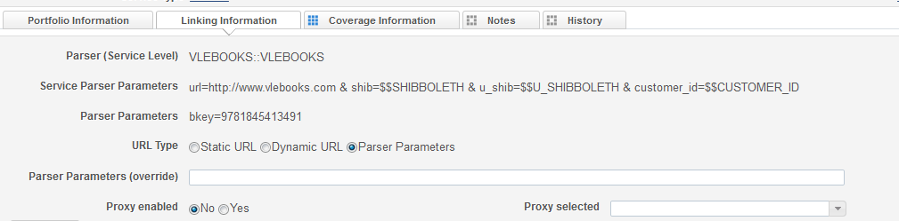
Collection:
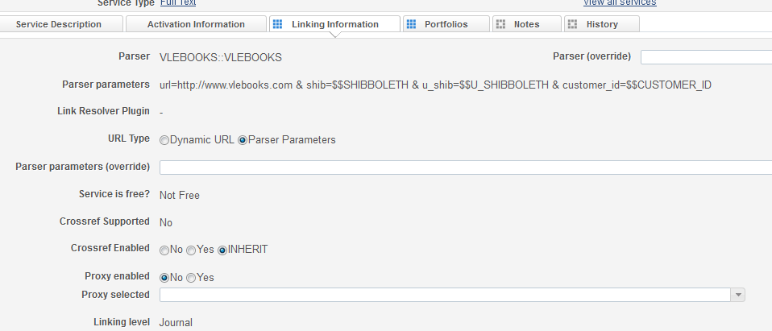
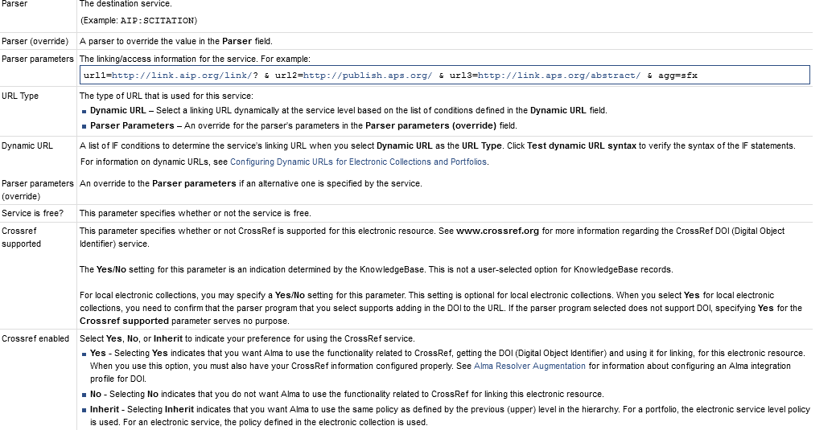
To set Alma to work with DOI go to General Configuration menu – External System – Integration Profiles – add profile – Augmentation
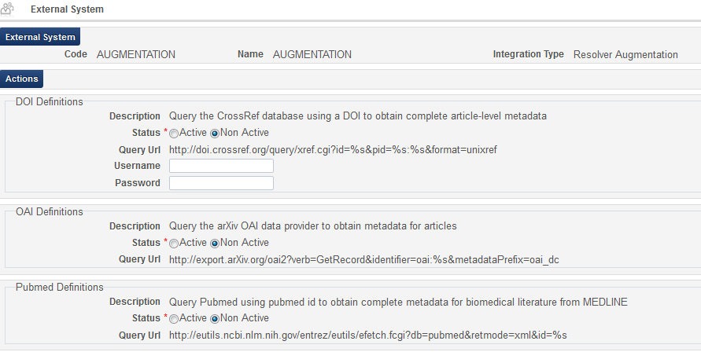

- Can you describe how an electronic collection gets passed from acquisitions to the e-resource librarian for activation? For example: Acquisitions purchases and invoices a database, and needs to notify the e-resources staff to activate and test access to a new collection. How does that task flow from acquisitions to e-resources?
Repository Manager/ E-Inventory Operator roles can assign task to an operator.
- What is the process of activating select titles within an electronic collection? -- batch activation using title list, etc.

- search Collection
- Edit Service
- Portfolios tab
- Load portfolios

http://knowledge.exlibrisgroup.com/@api/deki/files/39140/Using_the_Alma_Portfolio_Loader_-_Examples.pdf
https://www.youtube.com/watch?v=jHbJ2IDLgYs&hd=1
- If we wish to evaluate records in the CZ for quality before deciding to whether or not to link to them, where can we do that?
Workflow – manage evaluation process

Use case - vendor offers new electronic material to the institution for evaluation, or member institution asking to have electronic material evaluated.

Evaluation is the workflow of using a trial as the evaluation workflow.
Roles:
- Trial Operator/Trial Manager — Manages the trial
- Purchasing Operator — Manages the PO
Steps:
  - Search CZ and manually creates a new PO line – click ‘Order’
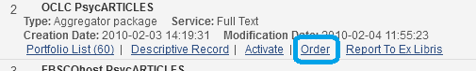
  - Enter all of the PO line information
  - Select one of the following options:
- Save and Request Evaluation – The Purchasing Operator selects this if the user does not also have the Trial Operator role. The PO line’s status changes to Under Evaluation and moves to the Manage Trials page with the status Requested, where the Trial Operator can access it and continue with step 3 below.
- Save and Start Trial – The Purchasing Operator can select this if the user also has the Trial Operator role and wants to start the trial. The PO line’s status changes to Under Evaluation and the Trial Details page open (step 3).
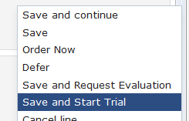
  - Edit trial details
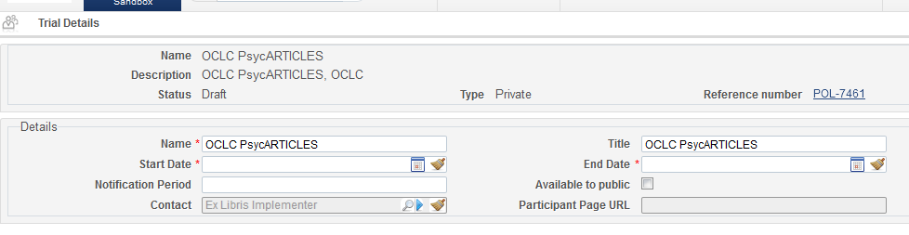
  - Job ‘Trials – Start and Notify Participants’ should be active – system will send notifications to participants
  - There is a letter in Alma.
  - Add participants
  - Add questions
  - Activate resource
  - Activate trial
  - Notify participants
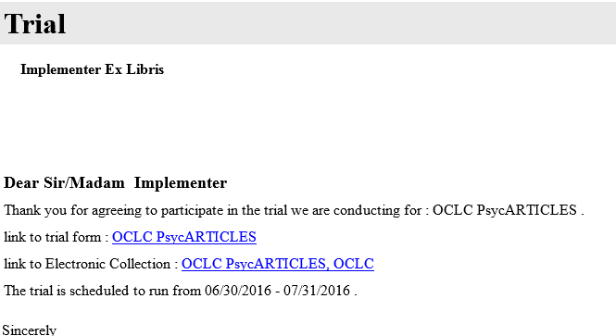
Click on link
Survey form
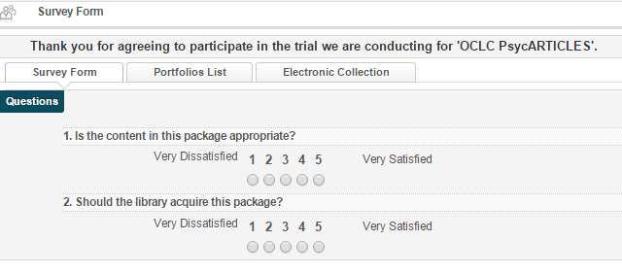
Go to Analysis
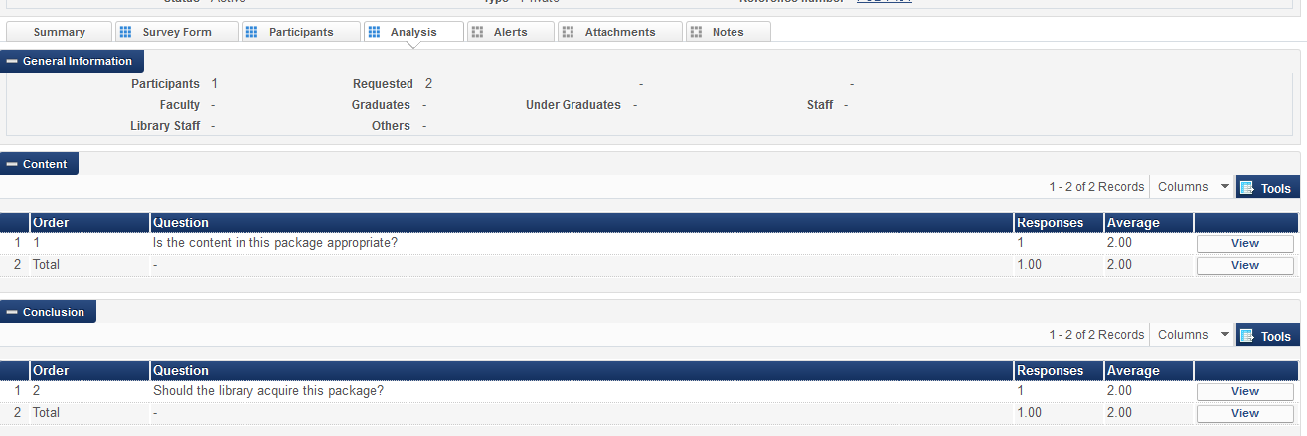

- How will the DDA (demand-driven acquisitions) process change in Alma? Network Zone? Institution Zone?
- Will you get into using the NZ and/or CZ for managing PDA (or DDA) programs easily with groovy workflows for the CSU as a consortium?
Answer:
When PDA profile created in IZ and bib records loaded from IZ – bib records can be linked to NZ (NZ check box). PDA titles can be linked to Network Zone via profile.

PDA profile can be created in the NZ (for shared resources) – resources can be loaded with indication of ‘available for’ group.
https://knowledge.exlibrisgroup.com/Alma/Training/Extended_Training/Alma_Collaborative_Networks/07_PDA_Management_in_Alma_Network_Zone
Many libraries have Patron Driven Acquisition agreements with vendors. Agreement includes a collection of electronic books that will be available for library patrons to access before they are purchased. Once an e-book is accessed (based on agreement) the library will be billed for the e-book
- Vendor candidate e-books records (with URLs) are loaded into Alma repository
- Alma publishes candidates to discovery
- Users discover and use e-books, triggering purchases
- Vendor delivers POLines via EOD & invoice via EDI
- Candidate e-books that are not in use are removed from repository and from discovery
Steps:
- Configure PDA profile
  - General- PDA agreement details with vendor
  - Repository profile - Details for loading candidates e-books to repository
  - EOD profile – Details for creating purchase orders for e-books that were used by users

- What kind of collection services (i.e. "Get ILL in SFX") are provided in electronic resource linking process?
Answer: Need clarification for this question.

- What is the benefit of enabling crossref in the electronic collection service parameters?

Better results.
- We often have portfolios in packages that we consider ‘high priority’ titles, that are being used on course reserves, for example. We’d like to somehow ‘flag’ these portfolios for changes, so that we can be notified easily if a portfolio has been removed from a package. Apart from reviewing all of the entries in the Community Zone Updates Task List, is there a way to be alerted to actions affecting specific portfolios, so that we may order them if they are removed from subscription packages?

Answer: There is no additional notification. If portfolio is deleted in CZ, it is not deleted from IZ. Portfolio becomes local. It is probably deactivated. What is current workflow?
- The training video explained the relationship between the community zone and the institution zone on electronic resources—does the addition of our network zone have any effect on this or give further functionality?
- Where does the Network Zone fit into the chain of electronic resource linking between Institution Zone and Community Zone?

Network Zone ‘All Titles’search - displays which institutions held inventory:
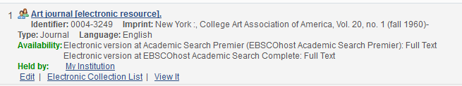

CZ Bibliographic record by default managed by CZ. It can be managed in IZ or NZ, if desired.

Electronic Collections search type – displays ‘Available for’– it shows shared resource activated from NZ for specific institutions.

- Please show how a Service Level change in Alma is reflected in Primo.
Answer: which changes you would like to make? Can we look on this question later when Primo environment is available?

