Agenda

Work orders
- Can you talk about the difference in functionality between the Work Order Types and the Work Order Departments? They seem repetitive.
Answer:
Alma work order hierarchical structure
Work Order Type
Work Order Department 1
Work Order Department 2

Library
Library
Library
Status
Institution
Status
Status
Operator
Operator

Work order is used in Alma to manage different library physical material processes, like binding, repair, cataloging, barcoding, preservation and digitizing.
What is work order type? It is type of process or work that is done in the library and has to be recorded in the system for physical items, for example, some technical processes (cataloging, barcoding).
Department – is a place where processes will be recorded and work will be done. You may add one or more departments for work order type; and those will become units where staff will perform a work. Department can be scoped to libraries that can be served by department, and operators. Department can serve the institution.
Operator will be able to connect to a specific department based on a role that scoped to a specific department. When operator connected to a department he/she can perform a work on specific item and scan it in the department, set to a specific status.
When work order request/process is recorded on an item that item gets status “in process”.
Statuses defined on Work Order type level. Statuses can be used as steps in work order process or to record a specific process itself. There is no sequence to steps or statuses.
Work Orders are requests. They managed very similar to other requests. They can be seen from Monitor Requests screen facet ‘Requests/Process Type’ can be used to filter items based on work order type status. They can generate Transit process to go to destination desk, if work order type is not managed by item location circulation desk.
Configure Work orders
https://knowledge.exlibrisgroup.com/Alma/Product_Documentation/Alma_Online_Help_%28English%29/Administration/050Configuring_General_Alma_Functions/040Work_Orders_and_Departments
http://knowledge.exlibrisgroup.com/Alma/Product_Documentation/Alma_Online_Help_%28English%29/Administration/050Configuring_General_Alma_Functions/040Work_Orders_and_Departments#Configuring_Work_Order_Type_Statuses

Workflow - Create work order type, statuses and department; assign operator.
- Go to Administration – General Configuration Menu – Work Order Types
- Click on ‘Add Work Order Type’
- Give Code/Name/Description – Click Add and Close
- Go to Actions – manage Departments – Add Department
Give unique Code/Name/Description; Work Time (days) - The number of days used to calculate the Expiration Date that appears on the Resource Request Monitoring page for the item being processed. If the field is left blank or set to 0, a default of 7 days is used. Assign library or leave institution level (applies for all libraries); add operator.
- Go to Actions – Manage statuses

What is receiving acquisition department?
After migration into Alma every library gets acquisition department created. Those are out of the box settings. Receiving department linked to this department by default. Library that receives materials just needs to add operators to the acquisition department.

Workflow - default acquisition department; access to acquisition department from Receiving and Manage department items.
- Select your library acquisition department in Currently at
- Go to Acquisition – Post Receiving Processing; Same department accessed from Fulfillment – manage Department items
- This is default acquisition department - There is no option (currently) to use other department as receiving/acq department.
Work order can be managed by circulation desk.
Workflow Demonstration – how to link work order department to circulation desk?
- Go to Fulfillment configuration menu – select library you are configuring
- Click on Circulation Desk
- Select tab Work Order Types
- Select department from drop-down list
- Set Work order time (days)
- How would we use Work Orders to replace Item Statuses from Sierra (such as On Search, Long Missing, Claims Returned, Billed, Inventory Missing, Damaged, Repair, Bindery, and In Process)? Some of these processes must go through more than one department, Access Services and Cataloging, however Work Order departments cannot be repeated. Can you give an example of how this might be configured?
Answer:
Alma process management may not be similar as in your legacy system.
Missing status in Alma is not managed by work orders, but by tightly set in Alma workflows. Item can be manually set to Missing status from item management screen; by lost loan process and in bulk by process.
Claimed Returned – is loan status in Alma. It is set from patron services management screen.
Other statuses can be set in Alma as work order type statuses.
What displays in Primo?
Default – ‘In process’. Label can be changed from Fulfillment configuration – Labels
- We have been doing a variety of weeding projects lately. Oftentimes we are not able to locate an item on the shelf that has been identified for discard. Would you use the work orders function to indicate that an item is identified for discard or is there some other function we should use to flag discards? Please describe that process.
Answer:
Yes. Work order is a request that staff can put on item.
- We still on a limited basis send items out to bindery. I believe I saw 'external bindery' as an option. Would there be a location for the bindery company as an option so we know it is out of house and not in-house waiting to be sent out? Can you demonstrate that process?
Answer:
Two statuses can be added for binding to indicate a binding steps.

- We would like a demonstration of a complete work order process involving the following scenario:
- An item is returned to a circulation desk with obvious damage, and a work order is created for repair
- It is determined that the item cannot be repaired, so a replacement must be ordered
  - Question 1: is a new work order created to process the replacement?
Answer: New order will be created and new item will be attached to the order. Damaged item can be withdrawn from the system… No need to create or keep work order for ever.
  - Question 2: what happens if the replacement ordered is actually an electronic copy instead of a physical copy? Is this dealt with outside of work orders?
Answer: when order is create purchase operator will select which type of order to create – physical or electronic.
Work order processes relevant for physical items, not electronic.
Workflow –
- Connect to circulation desk
- Return item from Alma menu – Fulfillment – Return items
- From Return screen place a work order request from Actions
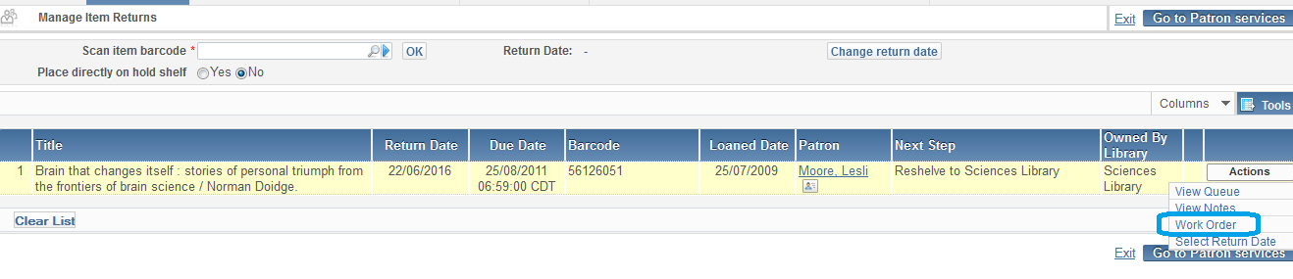
- Select work order type and department or circulation desk where item process will be managed
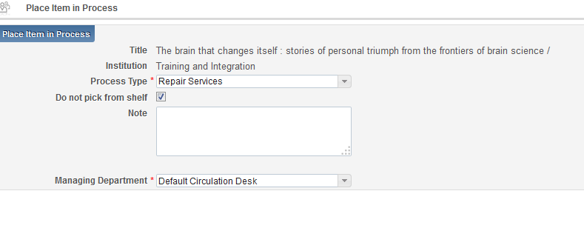
- View process under Circulation desk – Manage in Process items
- Change status as required to reflect repair status
- If item cannot be repaired, library may decide to withdraw item and order a new one.
- To close work order request by selecting Done.
- To keep item in work order – update status accordingly to reflect the step and update expiration date to when item will be withdrawn.
- Place a new order for the title from Repository Search – find title and click Order
Other possible ways to create work order process/request:
- From Alma Repository search on Physical Items
- Item in hand – Scan In item barcode in work order department
- Receiving process – Keep in Department
- From List of items – Actions
- Using process ‘Create physical item work orders’ to put items to work order process in bulk.
- A work order is also created when the “Create Item” button is used when making a loan and then the loan is returned. Work order department is default Technical Acquisition Department.
Documentation:
https://knowledge.exlibrisgroup.com/Alma/Training/Ask_the_Alma_Expert/Work_Orders_and_Item_Process_Management
See Work Order Presentation (includes workflows and configuration details):
https://knowledge.exlibrisgroup.com/@api/deki/files/39115/Work_Orders_and_Managing_Physical_Item_Processes.pdf

E-mail and printing
- How can we test our email printing jobs at Circulation Dept.? Right now we submitted one personal email address (i.e. for testing fulfillment printer jobs)to EL in the migration form.
Answer:
Add additional e-mails for users that you want to test notices. Add printer e-mail that you want to print slips.
General configuration menu – Allowed e-mails

Import process

- "Does ALma provide a test load option when importing bib, inventory and order records in Batch? "
Similar to Sierra's?

Clip from III documentation:
"To help avoid erroneous record loading, you can perform a test load in Data Exchange. When you test load a file of records, the system performs all the functions related to importing the records but does not actually bring the records into the system. This allows you to check for any possible errors before loading the records into the system. This is helpful when you load a file from a new source or if you are unsure about the integrity of the data."

Answer:
No, this feature does not exist in Alma. Suggestions for reducing the risk bad imports can cause:
* It is possible, record by record, to revert to an earlier saved version (Metadata Editor > View Versions).
* You may wish to consider testing records imports from new vendors in your Alma sandbox.
* There is also the Monitor Imports feature, which allows thorough checking of match handling.

