Functional call – June 16th
Fulfillment: Working at the Circulation Desk, Physical Item and Move Requests

Is there a way to disable the “returns display” All? Most libraries consider what a patron has previously borrowed as private information that should not be kept in the system.
- There is not a way to disable this display. However, you can configure Alma to anonymize patron data on a scheduled basis. When this job runs, all identifying information about the borrower is removed from the loan record, leaving only statistical information.
Is patron block overrideable visible to staff user who does not have that permission? In other words will it show overrideable but not have the override button in order to let the staff member notify another staffer who has the permission to override.

- If a patron block cannot be overridden by the logged in staff user, the override button will not display. The user will need to log out so that a staffer with permission can log in and override.

Do the request ids only relate to requests made through Alma? In the video it says patron has not been able to submit a request via Primo? Are the patron requests via Primo handled differently?

- The description of a patron not being able to submit a request via Primo is merely to provide context to the training. These requests are staff-mediated requests placed in Alma by a staff member on behalf of a patron. Request ids are assigned to any request that appears in Alma and the source of the request (Alma or Primo) is not taken into account. The request management workflow is the same as well and both staff-mediated (Alma-originated) and patron (Primo-originated) requests look exactly the same in the workflow.

Can we limit what can be requested? (do not want to be able to request stacks items)

- Yes. You can configure requesting TOU to not allow requesting.

Digitization
The assumption is that Alma can be configured to not show this workflow if service is not offered.

Answer: configure Request TOU rule to disable digitization requests for item
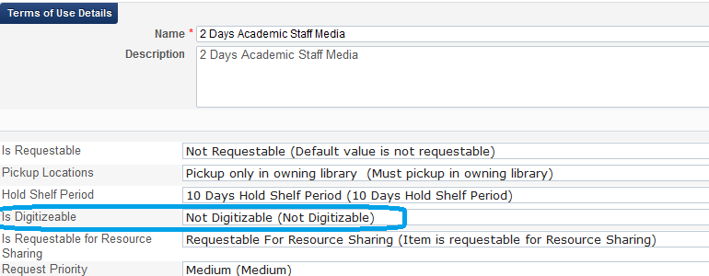
User will not see option to put digitization request in Primo.

In this week’s videos for the Functional Call, there was mention a few times of Physical Item Requests (Holds, Relocates, other times?) that can become Resource Sharing Requests.

Answer: yes, regular request can be switched to RS request

Is this ‘trigger’ (a request becomes a Resource Sharing Request) a default setting in Alma, or does a Library have to configure those Requests to become Resource Sharing when the Physical Item is not available?

Answer:
Jobs –
Recalculate after inventory update
Request handle expiration step

If request recognized as not-fulfilled it can be automatically converted to RS request
TOU – Requests – policy – automatically convert to RS request.
Any request that this TOU is applicable will auto convert to RS when canceled.

Send borrowing request rule – Config menu – Fullfillment – Borrowing request send rule
Create rule – created from hold request = true
Request will be send to Alma/created in Alma.

Jobs – monitor jobs
Scheduled jobs – fulfillment –
2 jobs should be running – they can be running manually
Report will show if requests converted

Conditions for request to be converted
– pickup location is a library and not a circ desk
- RS library can deliver to the library
- RS library has a default location
- Date needed by is not yet passed

Requests – Handle Expiration Step - The job works as follows:
1. Each request step has an expiration date calculated.
2. For 'pickup from shelf' step, if that date has passed and the request has still not passed that step (not been fulfilled) the system assumes that it cannot be fulfilled.
3. The system marks the items that were supposed to be picked up -- but weren’t -- as missing, and tries to move the request to another location where the relevant items also exist; or it cancels the request.

Manually:
http://knowledge.exlibrisgroup.com/Alma/Training/02_What%27s_New_Videos_2015/06_July_2015_Release/Converting_Hold_Requests_to_Resource_Sharing_Borrowing_Requests
Automatically
https://www.youtube.com/watch?v=p3Rx3RjAMTg
Convert to Resource Sharing – Convert the request to a resource sharing borrowing request. This option appears if:
- The request is a Hold or General Hold request (request for holding without item)
- The workflow step is Not Activated, Pickup-From Shelf, or Waiting for Remote Storage.
- The user has the CONVERT_HOLD_TO_BORROWING privilege (see Privileges Report).
This action will succeed if:
- The request's Date Needed By has not passed.
- The requested pickup location is supported for resource sharing requests.

