Functional Call – July 7th 2016

1. **Funds**

When doing an order, the funds are not showing up on this line:

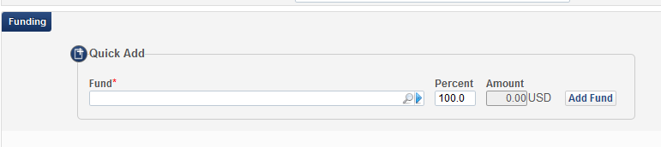

1. Is there a reason they are not showing up (might be outside the scope of the functional call)
2. I was reading through the documentation and it said that if the fund does not have any $ in it, it will not appear on this line. We often overspend funds. How do we get the fund to show up here if there is no money in the account?

Answer:

- Fiscal Year has finished on June 30th 2016.

The following document describes how to rollover for the next fiscal year –

<http://knowledge.exlibrisgroup.com/Alma/Product_Documentation/Alma_Online_Help_%28English%29/Acquisitions/100Advanced_Tools/020Fiscal_Period_Closure>

For detailed explanation and demonstration of the process got to -<https://www.youtube.com/watch?v=seinWQUiBGA&hd=1>

In order to test workflows on production server, you will need to process fiscal year closure and rollover to the next fiscal period.

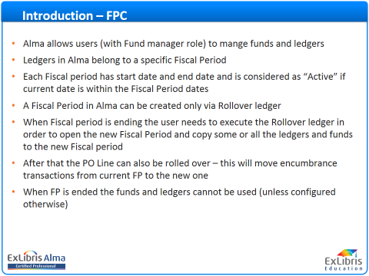

* There is an option under ledger to add grace period in order to allow using funds after fiscal period ended. Go to Acquisitions > Acquisitions Infrastructure > Funds and Ledgers – select Ledger – Edit – Rules (click on ‘plus’)

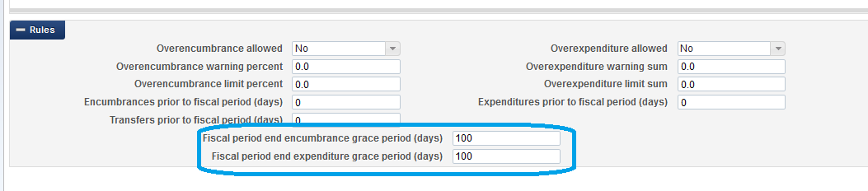

Ledger/Fund rules:

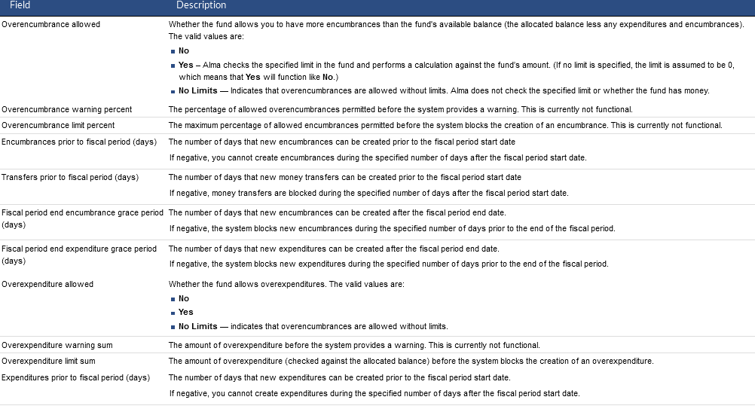

Recommended to check migrated data before rollover. Active POLs are candidate for rollover (not-fully-invoiced)

***Workflow – Create POL from Metadata Editor***

1. Can you demonstrate how to handle both ways the acquisitions process for a unique item that is not in the Alma knowledgebase or in OCLC....for a print one-time order example and an electronic one-time order example?    
   We sometimes order Chicano graphic novels or have university published items that are locally unique.

* Open Metadata Editor

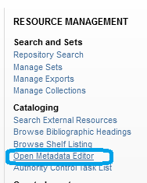

* File – New – MARC21 bibliographic

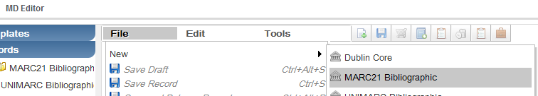

* Catalog – Save/Click on order icon

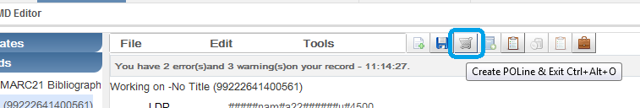

If this is electronic resource, Alma enables to create portfolio with linking information - enter 856 $$u with URL. Multiple fields/portfolios are supported - <https://www.youtube.com/watch?v=b2j_RJPFKRE&hd=1>

* Continue with wizard – fill-in fields

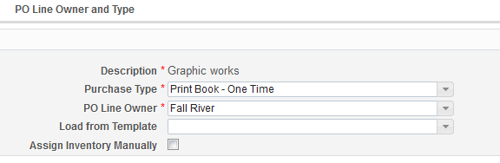

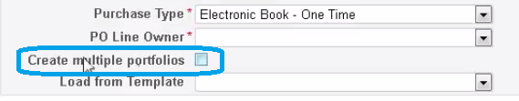

* Click ‘Create PO Line’

<http://knowledge.exlibrisgroup.com/Alma/Product_Documentation/Alma_Online_Help_(English)/Acquisitions/020Purchasing/020Creating_PO_Lines/030Manually_Creating_a_PO_Line>

1. What exactly is the difference between po-prefix (PO) and po-line (POL) prefix and why is it important?

Answer:

PO – prefix indicates that this is Purchase Order

POL – prefix indicates that this is Purchase Order Line

POLs (Purchase order lines) are packaged under PO (purchase order). In another words, POLs combined under one PO when packaged and sent to vendor. PO created by the system.

1. For continuous PO lines, can you explain more about what the Accrual Mode check-box does?

Answer:

Other Settings –

acquisition_accrual_mode – true/false

Institutions that practice accrual accounting set this parameter to ‘true’ > this will enable to accrue invoice expenditures from one fiscal period to another. It enables to have future fiscal period active, instead of one current fiscal period. There must also be two **active** fiscal periods – current and future.



* In Accrual Mode FPC allows the institution to have future FP as active and if the funds and ledgers are configured correctly these funds can accept encumbrance and expenditure transaction even before the FP Starts
* This allows the institution to set up the expenditure in a way that invoice is spread in more than one FP depending on the start and End subscription dates on the invoice.
* In Accrual Accounting expenses are recorded **at the time in which the transaction occurs rather than when payment is made**.
* Accrual accounting takes effect only on expenditures, and not on encumbrances. Encumbrance’s amount recorded in the current fiscal year fund transactions.
* When accrual accounting **is not enabled in Alma**, if an invoice overlaps two different fiscal periods, the entire invoice amount is attributed to the current fiscal period.
* This is related only to invoice lines linking to Continuous PO Lines.
* When accrual mode enabled – invoice line will have check box ‘Accrual Mode’.

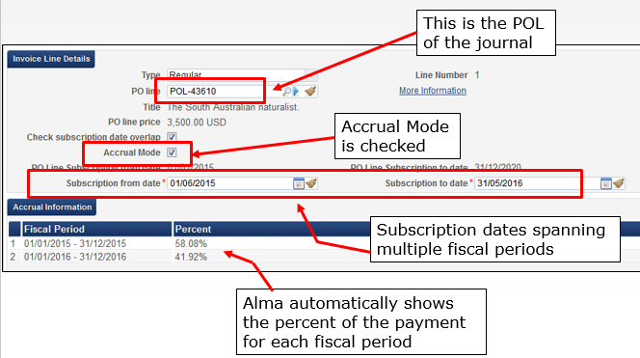

* It is still possible to not use accrual mode on a “one by one” basis on the invoice level even though on the institution level accrual mode is activated. This is done by unchecking the “Accrual Mode” check box.
* If subscription period overlaps current fiscal year period, system will calculate amount of expenditure to transfer to the next fiscal period. Automatically Alma will break down the expenditure from each of the included fiscal years and show the percent of each
* There should be fund configured in the next fiscal period to accept expenditure transactions.
* Fund Rules should be updated to enable transaction - **Expenditures prior to fiscal period (days)** field in the **Rules** section for the specified fund.



For more information see: <http://knowledge.exlibrisgroup.com/Alma/Product_Documentation/Alma_Online_Help_(English)/Acquisitions/030Invoicing/020Creating_Invoices#Working_With_Accrual_Accounting>

1. Does Alma Acquisitions assign voucher numbers for invoices that are posted for payment?   
   In the Alma video for 1.7 Prepaid and Internal Copy, the example showed we can input a voucher number....but we are used to our system assigning voucher numbers upon posting of payment. The assigned voucher number, voucher amounts, and vendor information are then exported to the ERP (Enterprise Resource Planning System - PeopleSoft). We haven't ever had to create a voucher number or had it referred to an external reference number before.

Answer:

Voucher in Alma entered when payment recorded. If payment recorded manually on an invoice, voucher is entered by operator.

If payment uploaded automatically, voucher number is coming from the uploaded data.

Important Other Settings definitions:

invoice_skip_erp – > true – do not export to ERP; false – do export to ERP

handle_invoice_payment – > false – when invoice exported to ERP it is closed; true – enable handle payment in Alma manually or automatic import payment from ERP.

exportPrepaidInv – Enable to export to ERP prepaid invoices - > true – check box ‘Export to ERP’ will display when invoice marked as Prepaid; false – no export to ERP option for prepaid invoices.

What is the difference between "Change Bib Reference" and "Relink" when editing a PO? It seems like both of those have to do with changing the bib record the PO Line is associated with.

<http://knowledge.exlibrisgroup.com/Alma/Product_Documentation/Alma_Online_Help_(English)/Acquisitions/020Purchasing/110Closing%2C_Reopening%2C_and_Relinking_PO_Lines#Relinking_PO_Lines>

Building POLines, how does alma then gather them into a single PO? I guess I'm referring to buying individual books from a vendor, I'm buying various books

Packaging

<http://knowledge.exlibrisgroup.com/Alma/Product_Documentation/Alma_Online_Help_(English)/Acquisitions/020Purchasing/050Packaging_PO_Lines_into_a_PO>

What are the functional implications of the "PO Line Owner"?

When creating a PO line, the PO line owner refers to the library creating the PO line, while the intended locations/access refers to the library for which the order is being placed.

List of libraries appearing in the drop-down depending on Purchase Operator role scope.

Libraries for which ordering library can acquire depends on relationship settings between libraries (Acquire for).

Can you describe some example use cases of PO Line Templates?

PO Line Templates: I don't think every field can be saved/added to the template

See details and fields that can be saved in the document:

<http://knowledge.exlibrisgroup.com/Alma/Product_Documentation/Alma_Online_Help_%28English%29/Acquisitions/020Purchasing/020Creating_PO_Lines/030Manually_Creating_a_PO_Line#Working_with_PO_Line_Templates>

There was a presentation on Fiscal Close done last week or so. Could the link to the recording of this be added to your notes? It may be helpful to this group.

To view a copy of the recording, please click here.

Password: AlmaSupport

from Moon Kim (privately):

<https://vimeo.com/172935214>

Please explain, with examples, more details about how 'use tax' is handled in Alma.

VAT content in OLH > Acquisitions > Invoicing > [Creating Invoices](https://knowledge.exlibrisgroup.com/Alma/Product_Documentation/Alma_Online_Help_(English)/Acquisitions/030Invoicing/020Creating_Invoices)

<https://knowledge.exlibrisgroup.com/Alma/Product_Documentation/Alma_Online_Help_(English)/Acquisitions/030Invoicing/020Creating_Invoices#ww1140706>

* [VAT Calculation – Example](https://knowledge.exlibrisgroup.com/Alma/Product_Documentation/Alma_Online_Help_(English)/Acquisitions/030Invoicing/020Creating_Invoices#VAT_Calculation_.E2.80.93_Example)
* [How Alma Handles VAT Payments](https://knowledge.exlibrisgroup.com/Alma/Product_Documentation/Alma_Online_Help_(English)/Acquisitions/090Acquisitions_Infrastructure/010Managing_Vendors#How_Alma_Handles_VAT_Payments)
* See [Invoicing and Tax](https://knowledge.exlibrisgroup.com/Alma/Training/Extended_Training/Managing_Funds_and_Payments/MF-03__Invoicing_and_Tax) for a detailed Webex training session on using the governmental vendor to handle use tax on an invoice (36 mins).

We want to confirm that all kinds of taxes, including state sales tax, county taxes, etc. are processed through VAT (even though we are not part of the European Union)?

This is correct.

Can you demonstrate how to see all PO lines associated with a particular vendor?

Go to Acquisition – Vendors – search for vendor – open POL tab

Go to Acquisition – Search for POL – search by vendor information:

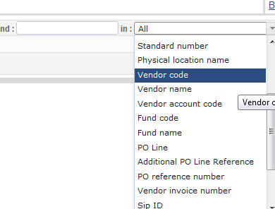

How to select the proper license when ordering an e-resource?

Create licenses under Acquisition –

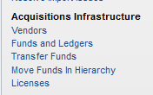

What is the best way to search for all POs and PO Lines, regardless of status?

Go to Acquisition – Search for POL

Can you demonstrate what an emailed order sent to a vendor looks like? We want to be sure that the vendor receives both PO Line numbers and PO numbers.

