Functional call – July 28 2016
- Can you show us an example of the differences in Preferred Record of the two major Merge Methods? That is, how a record loaded via Repository Import or OCLC Connexion Export would look, how a record loaded from an External Source (non-OCLC) would look after load into Alma?

When merging two records, the primary record is the record that will contain all of the merged information. The secondary record is the record that contains information that will be merged into the primary record.
Merge rules either remove lines in the primary record or copy lines from the secondary record to the primary record. Merge rules do not affect the secondary record. There are several possible scenarios for merging records. The primary record in each of these scenarios is as follows:

Process | Primary record
Importing records using a profile | Alma record
Importing records from OCLC Connexion | Alma record
Merging two already existing records | Record on the left (opened first)
Copy cataloging using an external resource | External record

Commands:
Remove ‘field’ - removes all lines with this field from the primary record
Add ‘field’ – adds all lines with the field from the secondary record to the primary record
Replace ‘field’ – 1) removes all lines with the field from the primary record (that exist in the secondary record) and 2) adds all lines with the field from the secondary record to the primary record

Examples

Primary record is a record to which I want to make changes and keep them.

Import via profile - full record should replace fields in a brief Alma record.

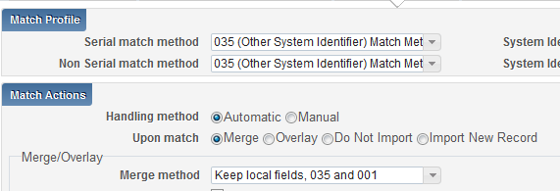

rule "Replace all fields except 59x, 69x, and 9xx. Preserve 035 and add 035 from incoming record."

when
merge
then
remove MARC."0"XX excluding "035"
add MARC."035"
remove MARC."1"XX excluding ""
remove MARC."2"XX excluding ""
remove MARC."3"XX excluding ""
remove MARC."4"XX excluding ""
remove MARC."5"XX excluding "590,591,592,593,594,595,596,597,598,599"
remove MARC."6"XX excluding "690,691,692,693,694,695,696,697,698,699"
remove MARC."7"XX excluding ""
remove MARC."8"XX excluding ""
replace MARC.XXX excluding "035"
end

Copy Cataloging – external record in preferred/primary. Remove from external record 019, 029, 9XX. Add from Alma record to external record (copy from Alma record) local fields 59X, 69X, 9XX.

rule "Merge Search External Resources"
when
merge
then
remove MARC."019"
remove MARC."029"
remove MARC."9XX"
add MARC."59"X
add MARC."690"
add MARC."9XX"
end

- Can you demonstrate the process of exporting and overlaying a record in Alma from OCLC Connexion? Is the record only matched at the NZ level or does it also try to match on the IZ level? If there's no matching record in the NZ, but there is a record that should match in the IZ (using OCLC unique match method) will it overlay in the IZ or create a new record?

Where Connexion record will be created depends on a Connexion profile settings flag ‘Use network zone’. Imported from Connexion record with this configuration will be contributed to NZ. It will be visible to all member institutions.

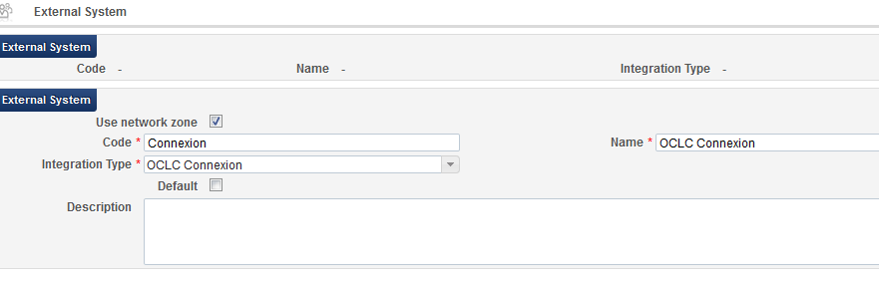
In the OCLC Connexion profile there is a place to define merge rule. If NZ flag ‘Yes’ –> rules drop-down brings NZ merge rules; If NZ flag ‘No’ –> rules drop-down brings IZ merge rules.

Profile defined under - General configuration menu – Integration Profiles – OCLC Connexion

Connexion configuration:
connexion.oclc.org

General > Admin > Preferences > Export Options
Hostname: enter Alma inst host name
Port: 5500
Login ID: 01XXX_INST
Password: enter pwd

Testing Export using connexion browser into IZ
- Click Cataloging (top tab)
- Search for record
- Select on lower screen Action drop-down: Export Record in MARC
- Connexion displays message: Record Exported
- Check for title in Alma
- Change record to see merge process

- When you are applying normalization rules, merging and/or matching records where is all this happening? Does it happen in the IZ, the NZ, community zone or all the zones? The tutorials were not clear on where these actions take place within the system.
It depends to which record you apply it. If record is local, IZ normalization rules will be used.
If record is a NZ record, NZ normalization rules will be used.

- Can you provide a demonstration on merging and matching and when you would use these functions?
Matching routines are predefined. They used in import profiles, OCLC Connexion export.
Merge routines can be configured in Metadata Editor. Those rules used in import profiles, export from Connexion, copy cataloging, merging two records in Metadata editor. In Other setting under Resource Management configuration menu there is merge_method definition for default method if not defined specifically.

- What options are there for loading Marcive MARC records for brief shipping list, full and electronic records for government publications? Would this be centralized, especially for their documents without shelves service?
Use Alma import profiles for loading records. When import profile created there is an options to define where records will be created – NZ, or locally in IZ.
I assume that government publications can be centralized.
- Can you please elaborate on indication rules?
Indication rules –
Example:
rule "856 field contains ebrary"
when
exists "856.a.*ebrary*"
then
set indication."true"
end

- Can you give a few examples of when it is appropriate to use Normalization Rules vs. when Run a Job is more efficient?
Use normalization rule when need to update bibliographic or holdings MARC record data.
Use processes for inventory update.

- For the repository import profile, does it always create new inventory or does it have the option to update existing inventory instead, such as updating URLs for ebook portfolios (assuming these particular records are not linked to the CZ)? Or would this be something we'd accomplish by running a job?

To update electronic portfolio details, like proxy, URL use process ‘Change electronic portfolio information’.

Update inventory import profile is designed as part of shelf ready workflow processing when libraries get from vendors files with resources that are already barcoded. http://knowledge.exlibrisgroup.com/Alma/Product_Documentation/Alma_Online_Help_(English)/Resource_Management/060Importing_Records_Using_Profiles/020Configuring_New_Import_Profiles#Understanding_the_Update_Inventory_Import_Profile

Regarding Repository load of mixed-format records:
- Please illustrate an example of a mixed-format record—the Repository profile’s settings, the source record, the Alma record, and show how Physical and Electronic Workflows will handle/change/update these Mixed-Format records.

Import profile:
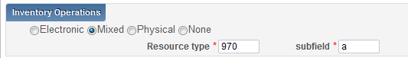
For Mixed inventory, the page displays both electronic and physical inventory.
One import profile can be used to import both types of records physical and electronic in one file.
When imported inventory file has mixed inventory (P, E), input bibliographic record should include tag that identifies type of inventory.
In the Inventory Operations section, enter the values in the Resource type (MARC 21 field number) and subfield fields to indicate the field in the EOD file to be referenced to determine the material type being imported. The specified subfield must reference a field in the EOD file that contains one of the following values:
- E – Indicates that the resource being imported is electronic
- P – Indicates that the resource being imported is physical
These field values are case sensitive.
Example
970 $$a P – physical inventory
970 $$a E – physical inventory
This means that input file can include records of both types and they will be loaded based on profile definitions of each type. This type of file can be loaded using one profile. No need to create two profiles and separate data by record types.
Use case 1:
Input record contains electronic inventory; Alma record is physical.
Import profile matched Alma record and electronic inventory added.
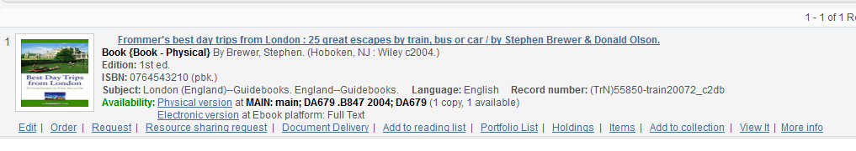

- Am I correct, that I can use a Normalization Rule in a Repository Import Process (also EOD or Update Inventory?), so that the ‘copy to Local Index’ is completed as part of the load, not a later, separate step?
Yes, you can use normalization routine in import profiles. Records should be indexed when they are loaded.

- How do import profiles differ from normalization rules differ from Sierra load tables?
Sierra / Millennium load tables convert MARC records to the proprietary Innovative format used to store records. The transformation process that is run on the records that you configure in the load tables is similar to the normalization rules that you run during the import profile.
- Import profile in Alma is roughly equivalent to the multi-step process of loading files via Data Exchange.
- Alma Normalization Rules are roughly equivalent to the load tables that you select during the file loading process through Data Exchange as they transform the data according to the rules that you determine.

