Functional Call – July 14

Course reserves

Presentations

<https://www.youtube.com/watch?v=leWPKUjfC08&hd=1>

<http://knowledge.exlibrisgroup.com/Alma/Training/Ask_the_Alma_Expert/Course_Reading>

1. Can a reading list be assigned to both faculty to manage themselves and assigned to library staff to work on when updated by faculty?  How would this work?  Will a task/job come to the attention of the library staff person when a reading list is submitted or updated?

Answer: Reading list in Alma assign to one staff operator.

Alma API can be used to enable ‘external’ managing of course related data -

<https://developers.exlibrisgroup.com/alma/apis/courses>

Integration of Courses Management System with Alma -

<https://developers.exlibrisgroup.com/alma/integrations/courses>

1. When adding a reading list the owner field does not show using the sandbox (AlmaCi8c credentials).  How can I see this owner field?  Or did something change?

Answer:

Assign Owner/s –

1. Go to Reading List
2. Actions
3. Work On Reading List
4. Go to Owners tab
5. Add Owner
6. 1)      Under patron service, we have an outstanding loan for a patron (see below image1), can we print this screen or send an email to the patron about this loan?

IMAGE1

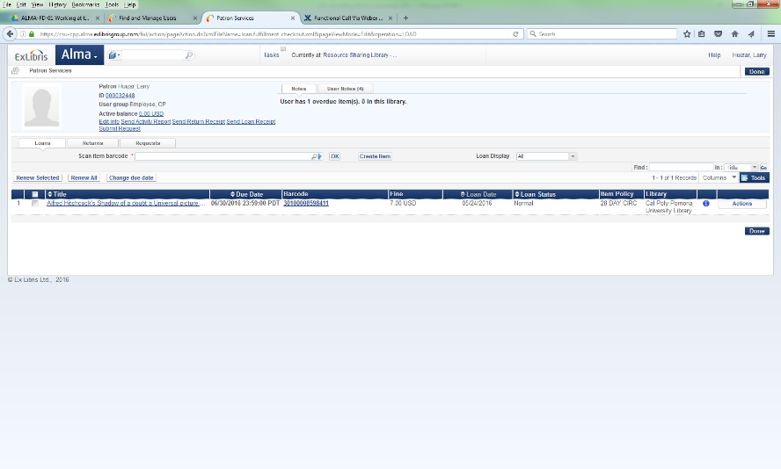

Answer:

* Send Activity letter

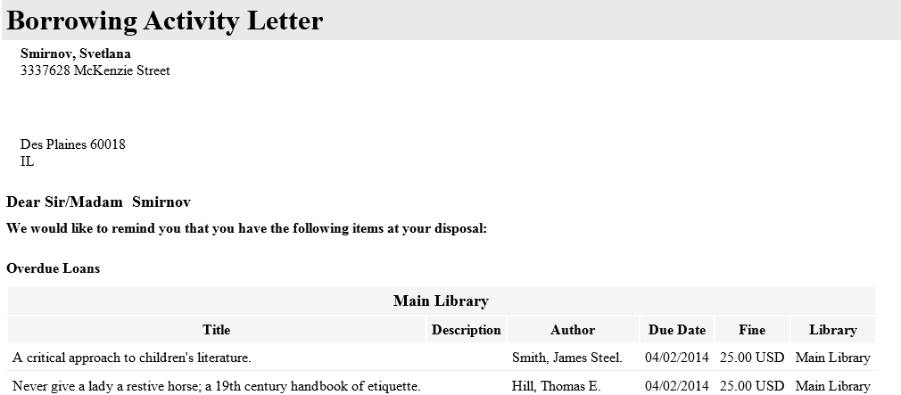

* Alma courtesy notices can be activated to send e-mails automatically.

Notifications - Send Courtesy Notices and Handle Loan Renewals

1. 2)      Our “Pickup At” (see below image) has no values, what should we do and how to fix it:

IMAGE2

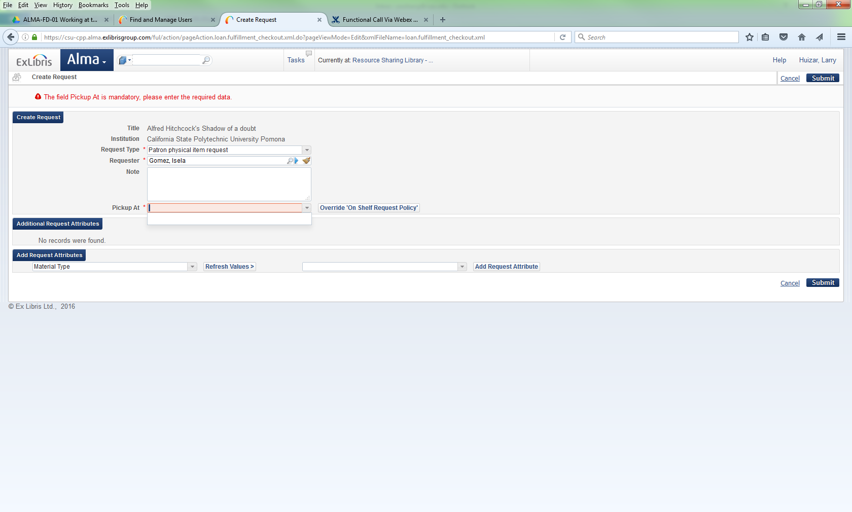

Answer:

Pickup list display depends on configuration.

Fulfillment Unit – On shelf request policy -

TOU – Request/Booking request – Pickup Location/ On shelf request policy

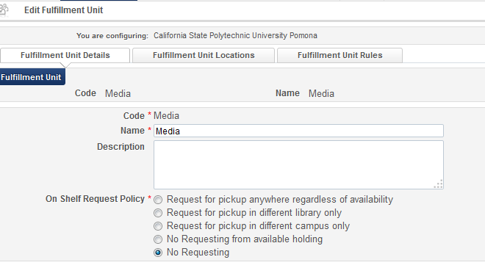

In this case Item is not requestable. If item cannot be requested by policy pickup location will not display.

1. Please demonstrate how to change an item’s item policy to reflect an item policy exception when it goes on reserve.  For example, the default reserve desk location item policy might be 2 hours, but some items have either a 1 hour loan or 2 hour loan policy.  What’s the best way to set the item policy when adding items to reserve?

Answer:

There is a number of options to process reserves workflows.

If library is small, operator may not need to create move request. But, would use Scan In option to put item of reserves.

* Export a report from reading list for all items
* print slip for a specific item
* Operator of Reserves Desk has item barcode

- Go to scan in items

- Change item information

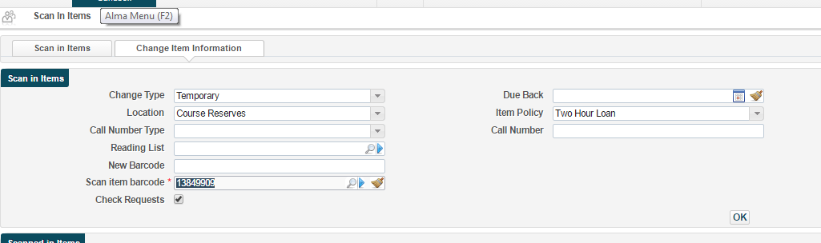

Temporary item policy has been changed

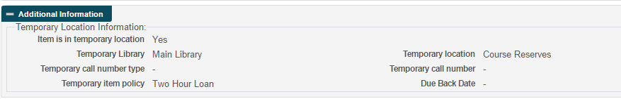

Make sure to update Due Back date

It is used by restore item request process – process will create a request on item to put it back to home location.

1. Please demonstrate how to remove items from reserve before the course period ends.  For example, the course is supposed to end June of 2017, but the instructor has removed an item from the reading list.  How do we remove the item and transit it back to its home location?

Answer:

Detach citation from Reading list

AI: Svetlana to check more on Primo publishing. Check that end users are not seeing the title in Courses tab after publishing.

Restore item to home location - Scan in item – Change item information – select type ‘Restore’ – if destination circulation desk is different system will put item in process type ‘Transit’.

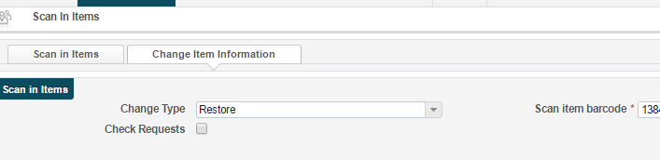

1. Is there a recommended best practice to handle multiple course sections?  For example, English 101 might have 10 course sections, taught by 10 different instructors.  Should we create 10 reading lists within a single course, or 10 courses?

Answer:

Do sections have same start-end dates? Start-end date influences on course status – active/inactive – which influences on course publishing to Primo. If yes, you will need to create separate courses.

How data stored in Courses Management System (CMS)? Will you integrate with CMS?

<https://developers.exlibrisgroup.com/alma/integrations/courses>

If yes, you will keep similar structure in Alma.

1. Is there a way to batch update course end dates – sort of a way to “roll over” course reserves into the next semester / year?

Answer:

API can be used to update course information

<https://developers.exlibrisgroup.com/alma/apis/courses/PUT/gwPcGly021pX8N42Hi9+i0T+CaoZDW6pD1tdxztmofc=/25ede018-da5d-4780-8fda-a8e5d103faba>

1. Under Scan in Items > Change Item Information, there is a check box for “check requests.”  What does this checkbox do?

When check box selected system will check if there is a request for the item and display confirmation message that will require operator to check if change can be applied:

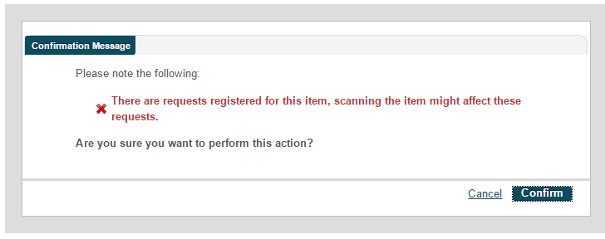

If check box not selected, message will not appear.

If there are not requests, message will not appear.

1. Please confirm that there is no “course password” functionality.  In our current system, when students attempt to access reserves they have to enter a course password, which is set in the course record in our system and usually distributed to students by the faculty member for the course.  I believe there is no such functionality in Alma, but want to confirm.

Answer: there is no password

1. Does there need to be an active course and reading list for faculty to submit citations using the course reserve API? Will the API create the course and reading list?

Answer: API enables to create course, reading list and citations. Course status (active/inactive) doesn’t influence on ability to add citations. Course status controlled by start and end dates.

1. Will staff be notified that a citation has been submitted through the course reserve API? How?

Answer: System will not send notification.

1. When reserves are in processing

Answer: Reading list has its own task list under Fulfillment – Course reserves – Reading Lists.

This task doesn’t appear in Alma Tasks list on Alma Home page.

**Booking Requests**

[**https://knowledge.exlibrisgroup.com/Alma/Training/Extended_Training/Booking_in_Alma**](https://knowledge.exlibrisgroup.com/Alma/Training/Extended_Training/Booking_in_Alma)

1. Is there a way to batch booking requests, or request multiple items in the same booking request?  For example, it is often the case that a patron will book multiple pieces of equipment needed for the same time (for example, they need to book both a camera and a tripod).  Is there a way in Alma to select two items for a booking request and fill out a single request for both items?

Answer:

Answer: multiple request needs to be created on item level.

When the item description field is blank the booking request will be created on the title level. When the item description field is filled in then the booking request will be created on the item level. When a user comes to the desk to check out the item level booking request then only the specific item from this title will fulfill the booking request.

1. Is there a way to set the booking request screen to use a 12-hour clock instead of a 24-hour clock?

Answer: drop-down list of hours is a 24 hour clock, but calendar displays 12-hour clock.

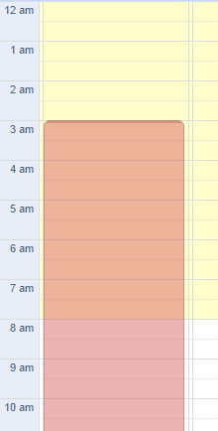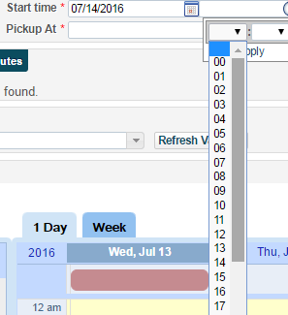

1. Is there a way to set a recurring booking request? (e.g., book this item every Wednesday from 2-3 for the next three Wednesdays)?

Answer: it can be done manually.

‘Future limit’ in TOU rules should enable future requests for the desired period.

**Booking TOU configuration:**

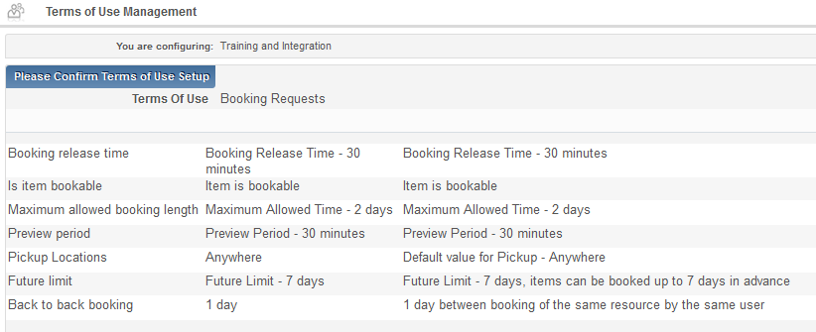

Booking in Alma

* Introduction
  + Similar to patron physical item (‘holdings’) request
  + Difference: bookings reserve use of the item for a specified time frame in the future.
  + Some use cases:
    - Guests/visiting researchers
    - Meeting/conference rooms (requires bib record!)
    - Course Reserves
* Configuration of Booking is similar as for requests and loans – same fulfillment infrastructure:
  + Fulfillment unit, rule, TOU and policies
* Booking TOU policies:
  + **Is item bookable** - Defines whether booking is allowed for the specified item.
  + **Booking release time** - Defines the amount of time after the booking request takes effect that the institution holds the resource for the requesting patron. No other patrons can borrow the resource until after the booking release time passes. If the booking release time passes and the requesting patron does not claim the resource, the booking request is still in effect but the resource can be loaned to another patron.
  + **Maximum allowed booking length** - Defines the maximum permitted duration of the booking request
  + **Preview period** - Defines the amount of time prior to the booking period that the patron can borrow the item.
  + **Pickup Locations** - Defines from where the item can be picked up
  + **Future limit** - Defines how far in advance an item can be reserved through a booking request.
  + **Back to back booking** - Defines the minimum amount of time required between consecutive bookings.
* Override Booking Policies – in the Alma booking request form (not in Primo)
  + future limit
  + maximum allowed booking length
  + back to back bookings by the same user
* Booking APIs
  + Retrieve booking availability for a Title - returns list of periods in which specific title (MMS) is unavailable for booking
  + Retrieve booking availability for an Item - returns list of periods in which specific item is unavailable for booking