Record Types / User Types

- Please clarify the following statement, paraphrased "... ExLibris provided a recommendation for converting external user records for some staff operators to internal during the implementation...to avoid creation of duplicate records for a given user." Should all staff operators (library employees) be an internal user record before cutover?

  - At cutover, all users of record type Public (internal AND external) will be reloaded, but roles will be retained IF the primary identifier is the same. So, you don't have to change user record type Public to Staff as long as primary IDs loaded for cutover will be the same as the data currently existing in Alma at the time of cutover.

- Regarding Public and Staff record types, please demonstrate how to maintain two distinct user import integrations so that "Staff" record types are not overwritten and changed to "public" record types, vice versa.

  - In order to maintain two distinct user imports, you would have to have separate files that come from your Student Information System, one for staff and one for all other users. However, record type has no functional impact in Alma. To streamline workflows and simplify initial and ongoing configuration, I recommend that you maintain only one user import profile set to Public. Public users can be assigned roles to work in Alma.

- The record type, public or staff, of user is updated to the value selected in user profiles. Please demonstrate how to create a user profile so that a record type is not overwritten during synchronization.

  - Any user profiles that are set to external will be overwritten during synchronization. The only way to ensure a profile is not overwritten is to set it to be internal.

User roles:

- Is it possible to set up roles for Alma users to enable “read-only” view of Fulfillment configuration? For example, many of our circulation desk managers and operators who won’t be working directly with configuration would like to be able to review TOU details, library and location configuration, fulfillment units, etc. Is that possible?

  - This is not currently possible in Alma. The role of “Circulation Desk Operator Limited” may give some read-only access to some information.

- Where can I configure what each role can or cannot do? For instance, expanding block override privileges for circ operators at the main desk but not for our IRC circ operators.

  - Role privileges cannot be changed according to scope. If you would like to change the privileges assigned to a role, please file a case and Ex Libris will perform the change.

  - Block override privileges are handled differently. Blocks can be overridden by Circ Desk Managers, Circulation Desk operators, All or No One. This is configured on the institution level in Fulfillment Configuration → Physical Fulfillment → Block Preferences
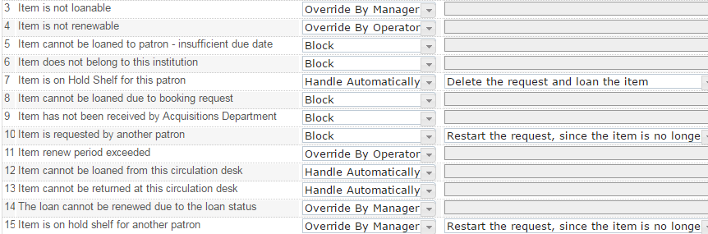

User Import / SIS Load

- The Import mode is used to load a large batch of new users and doesn't update existing records. What happens if there are existing records in the import load - are they just ignored and added in the next synchronization load? The fact they have been pulled once does not mean they will be considered already updated when the next synchronization load runs? (This is how the current integration works for the updates for students from Peoplesoft).

  - The import mode is a one-time load, used to initially create new external users. It is intended to be used only when you have a file of users you know are new, such as during the migration process, when you want to load users from your legacy system into Alma. For ongoing user imports, you should use synchronization.

- Importing/Synchronization of external users (replaces the current patron data load process for students and faculty): If this process will continue to be done for us by a non-library department entity (currently, this is being facilitated by CMS Security here at SJSU), how will their staff be informed of this change? Will this change be coordinated by central operations at Long Beach or will each campus' Alma implementation team need to train these staff at their respective campuses?

  - Question for Chancellor’s Office, will be handled separately.

- Whenever new/existing users are being uploaded, will there need to be 2 jobs run/files downloaded to reflect the new users (using 'import') and updated existing users (using 'synchronize') or can it all be done at once? Here at SJSU we currently run 2 patron data jobs: one for students and one for faculty/staff. Each job run brings over within the same file being uploaded both new users and existing users who have updated some aspect of their data in PeopleSoft. Wondering if this will turn into the running of 4 jobs: 2 for students (1 for new students; 1 for existing students) and 2 for faculty/staff (1 for new faculty/staff; 1 for existing faculty/staff).

  - You will only need to run one Synchronization job. All users can be synchronized at once.

- For the patron data upload to Sierra here at SJSU, it is currently set up via ftp and then manually uploaded to Sierra. It is a very simple process and I am wondering if that upload process will basically remain the same in Alma.

  - It is even simpler in Alma once all the configurations are set up. You will set up your Student Information System to send the user file to your institutional FTP server as a .zip file. Alma is configured to have your institutional FTP server in the allowed connections and goes to the designated user import folder on the server nightly to ingest the new file of users. The file is then changed from .zip to .old so that it is not reloaded. Screenshot of configuration below:

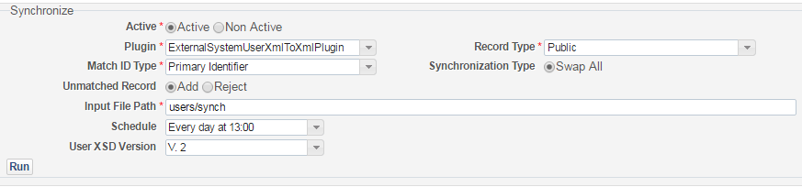

- What mode is more recommended to regularly import external users (students and faculty/staff): import or synchronize?

  - You will want to synchronize users. This will create new users and update existing users with any changes but will not touch users that have had no changes in the external system.

- What are the advantages of using the User Integration as opposed to the API or FTP?
  - FTP is used to transfer the files for User Integration / Importing users from the SIS. APIs are generally used for finite purposes (such as building a website with user information from multiple systems) and are not the best choice for ongoing user synchronization.

  - More info on the User API here: https://developers.exlibrisgroup.com/alma/apis/users

- Is there any plan in place for what we will do in the event a user is not found in the system? (i.e. if they haven’t been loaded in from external system yet) - i.e. can we use the Online Import mode? (is that possible)

  - For users that are not found in Alma when the import profile runs: provided that “unmatched record” in the configuration is set to “Add”, a new user is created in Alma if a user is not found in the system.
  - For users that are not found in Alma when a staff searches for the user: See below scenario

- I'd like a scenario from Ex Libris on when a library would use the Online Import mode. (for loading a single external patron record)

  - If a visiting faculty member walked into the registrar or HR to have their user created in Banner (or other external system) and then immediately walked over to the library to check out books for an upcoming class, their user record will not have been imported yet from the external system. If Online Import is configured, the circ desk operator could import the record immediately by using Online Import so that the visiting faculty member didn’t have to wait a day to be able to check out materials

  - However, the circ desk operator can click on “register new user”. In the form that then appears, the operator selects “Yes” for Patron has Institutional Record and makes sure that the primary identifier is correct. The user will then be updated the next time sync runs.

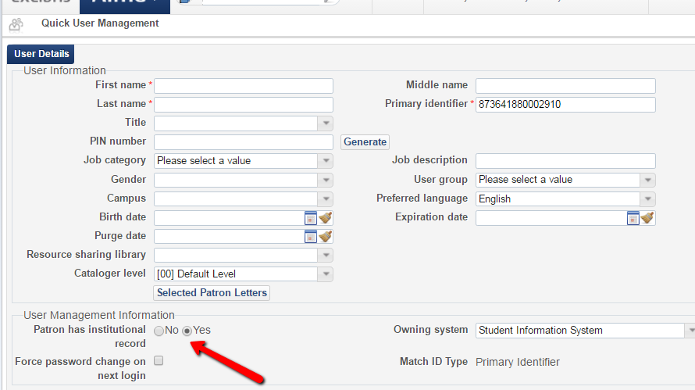

Fulfillment Units

- Does it matter what order the fulfillment units are in?
  - No. While the order of Fulfillment Unit rules (see below) does matter, Fulfillment Units themselves can be in any order whatsoever.

