Functional Call – May 19, 2016

User Management:
- "Scenario: A campus faculty member requests that a graduate student (research assistant) be designated as his/per proxy for checking out materials. In our current system, the faculty member is responsible for notifying the library to remove the proxy when the student's term as research assistant ends. Unfortunately, faculty don't always remember to fulfill this step. Is there a way in Alma to assign an expiry date to a 'proxy as' designation?"

Answer:
Currently it is not possible. There is a road map (no date)
Brief description for the road map: The proxy relation between two users will have an expiration date. After the expiration date, the proxy relation will be considered inactive, and be ignored by the system.
The date of expiry will be updateable in the Proxies tab of the user record.

- In the user management training video it said that it’s possible for some fields in an otherwise external user record to be managed by the library as it they were part of an internal record. For example, our student and faculty user records are external records managed in PeopleSoft, but a faculty member notifies us that his or her address is incorrect in PeopleSoft and asks us to correct it in Alma. How do we indicate in Alma that we want to manage that particular field for that particular user differently? And can you confirm that any data we decide to manage in this way is not overwritten the next time the external data is updated in Alma? ​

Answer:
When working with an external user, the Add as an external check box displays. Select this option to add the contact information as external data which is overwritten during SIS synchronization. If you do not select this check box, the contact information is added as internal data and is not overwritten during SIS synchronization.
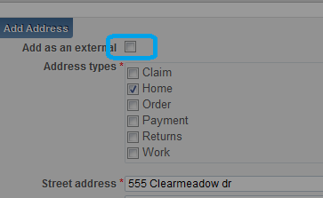 Same option enabled for identifiers, blocks, statistical categories and notes.
It is possible to update an external user’s information manually in Alma, but these updates are overridden by the next synchronization with the user information system (Only the following fields are not replaced if they were updated manually or if they are empty in the incoming user record: User group, Job title, PIN number, User language, Campus, Resource Sharing library)
Open for Update external user record option - >
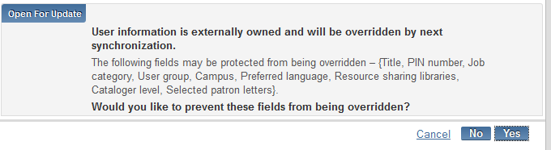

- Please walk through an example of creating role template for acquisitions

Answer:
This is done from User Management Configuration menu
Profiles
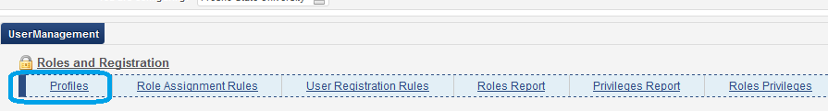
Click on Add profile

Give name to the profile and click Save and Continue
Add Roles to the profile
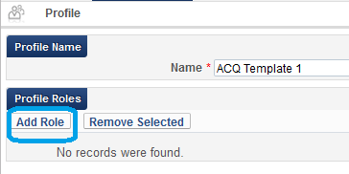
From Acquisition section select roles which acq profile should have
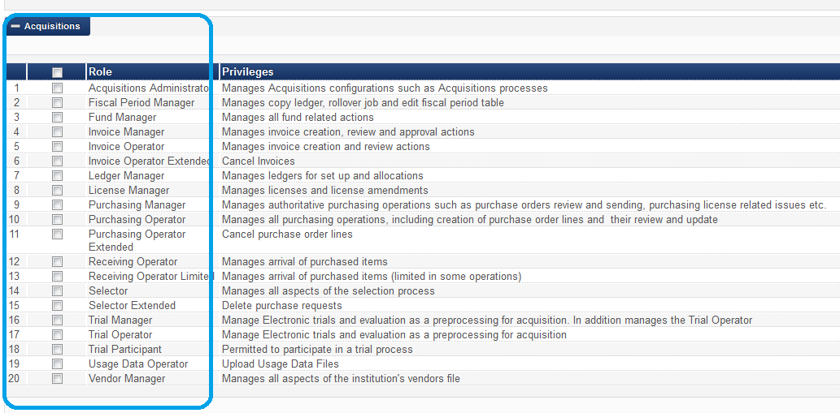

You will assign roles based on functions that user will be doing.

Some roles require scope for receiving/acquisition department. For example receiving operator.
In order to perform receiving an operator has to connect to a specific receiving department.
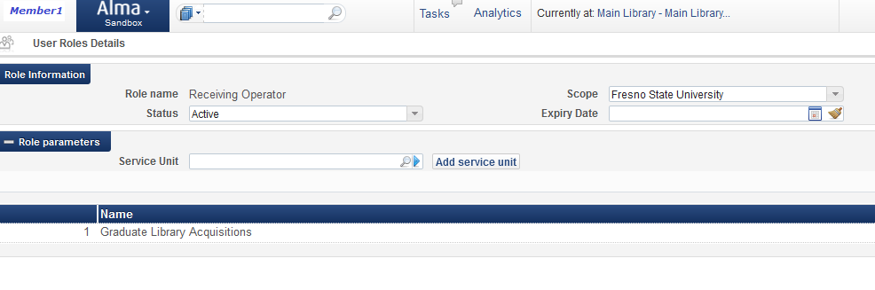
It means that when operator select Receiving function in Alma menu he/she should select receiving/acq department under which materials will be received.
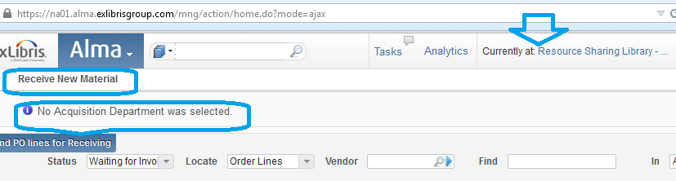

Purchasing operator role with scope for a specific library – POL will be owned by this library. If purchase operator has multiple scopes, they will appear in a drop-down as options to select which library will own the POL.
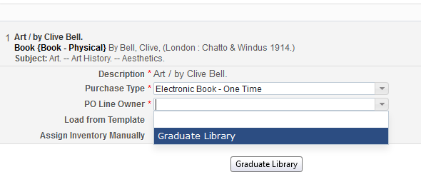

Automatic Role Assignment rules – used only for new users. Doesn’t work retroactively.
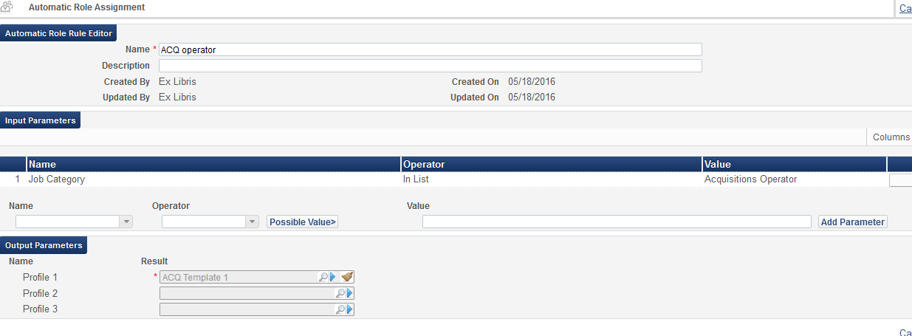

You should always set an automatic rule that will add Patron role to each created user. We have to check that this rule is present in the system.

- Per the user management functions I went in the sandbox to “add user” I select “public” as the type but the system requires I select a “job category” and the only option is student employee. Why would a public user need to have a job category?
Answer:
Staff, Public user type gives you an options for additional filtering. There are some configuration options that you can control which fields are mandatory per user type, which job categories are displayed in the user record type.
If institution manages all users externally they may set all of them to be Public users including external staff users as well.
SIS – user synchronization profile has user type. Using Public for all users (patrons and staff gives option to use one general profile.

Configuration overview - Member 1 server
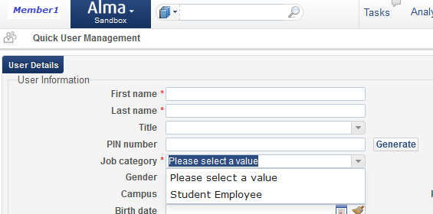

User management Configuration menu
Mandatory fields:
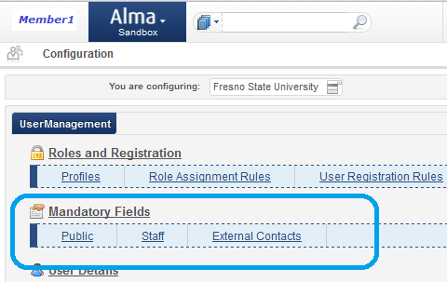

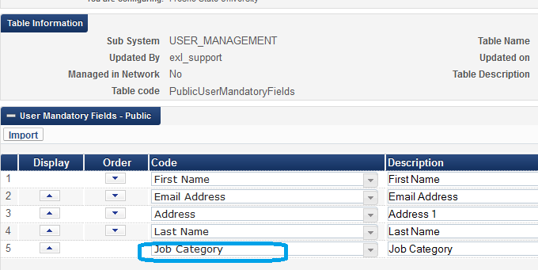

How to define which job category will appear for each user type
User management Configuration menu
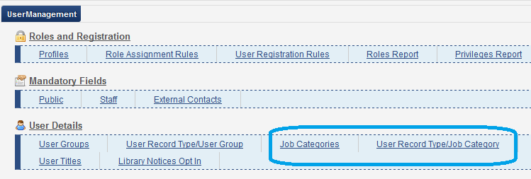
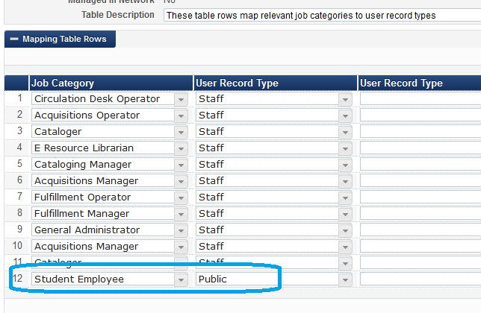

Searching:
- Why does the leading article ( A, The . .) change the search results in Alma? What was the rationale behind that choice? This is not the case in Primo, right?

Answer: Alma search doesn’t strip article in search. Articles are searchable as a words in Alma repository search.

- When searching results in Alma, the default sort is “rank”. What does “rank” mean?

Answer:
Ranking mechanism that is based on Apache Solr; for more information, see http://www.solrtutorial.com/solr-sea...relevancy.html. Ranking factors include:
- Term Frequency - The higher the term frequency in the document, the higher the document score.
- Inverse Document Frequency - The rarer a term is across all documents in the index, the higher its contribution to the score.
- Coordination Factor - The more query terms found in a document, the higher its score.
- Field Length - The more words a field contains, the lower its score. This factor penalizes documents with longer field values.

Additional information:
The Alma repository search is based on the Apache Lucene(TM) search mechanism (http://lucene.apache.org/core/)
Looking at a title search as example:
* A Repository search checks first the 245 (title) field before any other
* It prefers an exact match
* The search calculates the weight, or percentage, of the searched words within the title
For example a search on “history” will retrieve these records, and order them thus:
* The study of history
* History and the study of chemistry

Alma Indexes:
http://knowledge.exlibrisgroup.com/Alma/Product_Documentation/Alma_Online_Help_(English)/Resource_Management/020Using_the_Repository_Search/Search_Indexes

User Management in Alma
User roles
Access to system screens and data is controlled by Alma roles, which are assigned to users in Alma. Each role allows its owner access to specific actions and data in the system. The roles may also be controlled by scope, in a manner that allows its owner access to data and workflows only in the context of the specific libraries.

Role | Description | Scope
General System Administrator | Role acts as overall manager of all of Alma's system configurations. For full effectiveness, all other roles in all functional areas will need to be assigned. | Institution
Acquisitions Administrator | Role is designed to manage overall Acquisitions configurations such as Acquisitions task chains. Other Acquisitions roles need to be assigned so that operators can view and perform all Acquisitions activities. Has Get Access to advanced administration utilities and reports such as the Exchange Rates Report. Create and manage Acquisitions sets. Runs and monitors jobs related to Acquisitions. Searches the repository. | Institution
Fiscal Period Manager | Role can do very little by itself so will likely need to be combined with other roles (such as Fund and Ledger Managers) in order to manage functions such as copying a ledger, performing the rollover jobs and editing the fiscal period table. Searches the repository. | Both
Fund Manager | Role is intended to manage all fund-related actions including entering allocations, performing transfers between funds, creating, updating and closing funds. Likely this role will be combined with Fiscal Period Manager and Ledger Manager roles to be effective. Searches the repository. | Institution
Invoice Manager | Role manages activities related to searching for and creating invoices as well as reviewing and approving invoices. Assigns invoices to other operators. Reconciles Waiting for Payment invoices. May view Vendor records. Searches the repository. | Institution
Ledger Manager | Role creates, edits and updates ledgers. Adds funds and allocations. Performs transfers between funds. May move funds in the hierarchy. Likely this role will be combined with Fiscal Period Manager and Fund Manager role to be effective. Searches the repository. | Institution
License Manager | Role manages activities related to licenses and license amendments. Likely to be combined with Electronic Inventory Operator and electronic Inventory Operator Extended roles to be effective. Searches the repository. | Institution
Purchasing Manager | Role oversees purchasing operations such as reviewing and approving POs. Creates and maintains purchase orders. Assigns POLs to Purchasing Operators for next tasks. Views vendor records, ledgers and funds. Creates sets related to POLs. Run and monitor monitors import jobs related to Acquisitions. Searches the repository. | Both
Trial Manager | Role handles trials and evaluation of electronic resources as part of pre-processing activities related to Acquisitions. Creates and maintains purchase orders. Manages the Trial Operator. Likely this role will be combined with the Trial Operator role. Searches the repository. | Institution
Vendor Manager | Role manages all aspects of the institution's vendor records. May edit, add and delete. Likely this role is combined with other Acquisitions roles to be effective. Searches the repository. | Institution
Catalog Administrator | Role manages administrative aspects of cataloging activities and includes cataloging configuration. Likely includes all Cataloging roles that allow the operator to perform all day-to-day metadata and inventory-related activities to manage collections, physical/electronic/digital inventory to be effective. Manages authority updates. May create and manage sets. Creates, runs and monitors import/export functions. Searches the repository and external resources. | Institution
Catalog Manager | Role includes all options that allow the operator to perform day-to-day metadata and inventory-related activities. Likely includes the Cataloging Operator roles as well as the physical/electronic/digital inventory roles to be effective. Manages authority updates. Releases assignment of records held in the Metadata Editor by catalogers. Creates and managse sets. Runs and monitors import/export functions. Searches the repository and external resources. | Institution
Repository Administrator | Role looks after inventory-related institutional and library configurations related to Resource Management. Likely this role is combined with the Repository Manager role and other Cataloging roles to be effective. Searches the repository. | Both
Repository Manager | Role oversees inventory-related actions and manages inventory operators. Manages CKB updates. May perform and assign e-resource activation tasks to operators. Runs and monitors repository jobs. Likely this role is combined with other Cataloging roles to be effective. Searches the repository. | Both
Fulfillment Administrator | Role manages Fulfillment-related configurations such as policies, terms of use, Fulfillment Units and Circulation Desks. Likely this role is combined with other Fulfillment roles to be effective. Has Get Access to advanced administration utilities and reports such as the Fines and Fees report. Creates Fulfillment sets. Searches the repository. | Institution
Fulfillment Services Manager | Role looks after an institution's or library's fulfillment services actions. May approve and assign digitization requests. Likely this role is combined with other Fulfillment roles to be effective. If scoped for Resource Sharing, may assign and handle resource sharing requests. Monitors requests and item processes. Assigns course reserves and reading lists activities. Searches the repository. | Both
Circulation Desk Manager | Role usually manages a single circulation desk. Performs actions such as loan, return, renew, etc. Includes block override options. May change due and return dates, add and remove blocks, mark items as lost. Searches the repository. | Library
Course Reserves Manager | Role manages assignments to create reading lists and course reserves. Likely this role includes other Circulation roles. Searches the repository. | Library
Letter Administrator | Role manages configurations related to Letter Activity and Letter processes. Usually combined with other System roles. | Institution
User Administrator | Role looks after all aspects of user management configuration. Sets up and runs user synchronization actions. May purge user records and run the job to waive fines in bulk. Creates sets related to users. Searches the repository. | Institution
User Manager | Role manages user information, such as roles, blocks and contact information. May run the job to waive fines in bulk. Creates sets related to users. Searches the repository. | Institution
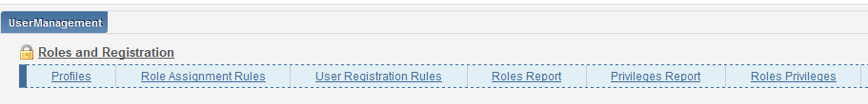

Privileges Report
The Privileges Report provides a detailed list of the privileges associated with each role, such as the privileges that a user with the role of Invoice Operator may have.

Roles Report
The Roles Report provides a detailed list of what a user with a particular role can do in the system, such as the menu items that are shown for a user with a specific role or the pages that the user can access and whether they can add, view, or edit information on that page.
Roles Privileges
The role consists of privileges. Roles delivered with predefined privileges. There is a possibility to activate or de-activate privilege inside the list of supplied privileges. But, it is not possible to add privilege if doesn’t listed. It will require development.

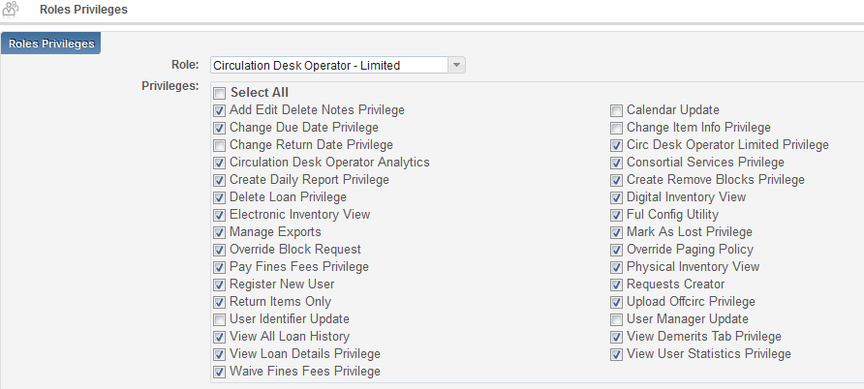

User roles are part of configuration. They can be retained in final load with some conditions.
Migrated users:
Migrated users have user record type ‘Public’. If user primary ID in final load matches the primary id in Alma (and user record is Public) roles are retained.
Currently Internal users created in Alma with user record type ‘Staff’ – user and roles retained.

Alma currently supports two record types – External and Internal.
Users in Alma should generally be external. Only in exceptional cases users are added as internal users in Alma.
External users are users that are stored and managed outside of Alma, usually in another system maintained by the institution (for example, PeopleSoft or any other Student Information System). These users’ information is loaded into Alma and synchronized on a regular basis. It is possible to update an external user’s information manually in Alma, but these updates are overridden by the next synchronization with the user information system.
Authentication of external users is performed outside of Alma, for example by LDAP, Shiboleth, SAML.
Note that your external authentication system must be up and running before you can begin Alma implementation.

Internal users are users that exist only in Alma. They are created manually by library staff and are managed entirely within the library’s scope. Authentication, updates performed using the Alma database. PW stored in Alma.

Roles will be kept for migrated users when they match existing user primary ID and they are have user type Public. Internal users with user type Staff - roles will be kept as well.
Before Alma configured to support external authentication staff users can do the following in order to authenticate into Alma:
- Create additional internal user for testing (and as a backup user record in case external authentication is not stable).

- External user can be converted to internal temporarily

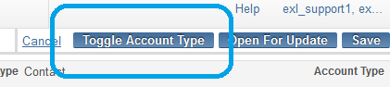

Password will be stored in Alma
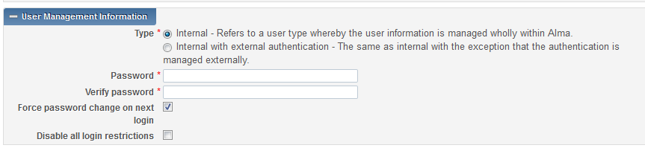

- In case external authentication is set up in Alma one external staff user record can store user roles and be used to Alma and Primo authentication.

Questions from the call:
- Matthew Prutsman: so if we set a patron to "internal" but information is still coming in from the SIS it will create a duplicate patron record? In answer to WHY we would have an internal patron that is in the SIS: we have many patrons who start is internal and then change to external after they register.

Answer:
Duplicate user will not be created and internal user will not be updated by SIS feeds.

This can be a temporary solution to give staff ability to login into Alma until external authentication to Alma is established. Staff user can be internal for the duration of the test load till you have the external authentication working and then you can switch back staff users to external or remain internal, as long as they have the same primary id and Public user type, in the cutover they will become external again with all their roles.

