**Functional Call #2 – Resource Management**

**Agenda:**

* **Creating sets**
* **Metadata Editor**
* **External Search**
* **Creating processes**
* **Consortia Workflows**
* **Authority**
* **OCLC Connexion**
* **Synchronization with OCLC**

**Creating Sets:**

1. Can we search Alma for specific conditions within MARC fields? (Example, if you want to create a set for 856 fields that include the text "ebrary")

Answer:

In order to find records that include specific tag and text in the field use Indication rule.

Steps to take:

1. Create indication rule
2. Create set of records
3. Go to sets
4. Filter set by using indication rule
5. Job will run and new filtered set will be created under Manage sets.

Example:

rule "856 field contains ebrary"

when

exists "856.a.*ebrary*"

then

set indication."true"

end

1. How can you find out the search criteria used to create itemized sets?  With logical sets, the search criteria displays at the top of the results, but there is nothing in that same area above an itemized sets' list of members.

Answer:

Itemized set is a set of randomly selected records. Members of the set are presenting the set itself. Search criteria or query is relevant for logical sets, not itemized.

It is possible to edit itemized set and add members to set by uploading files or searching and selecting records from search results.

1. Regarding files used to load records into itemized sets, please clarify what constitutes the record ID in each of the record types.  Do the Headers MMS ID, PID, and Portfolio ID for titles all refer to the same number?

Answer:

The imported file must be a text file (.txt or .csv) or Excel file (.xls or .xlsx) and have the correct header at the top of the column for the data to be read. The following are acceptable headers:

| **Content Type** | **Header** |
| --- | --- |
| **All Titles, Authorities** | **MMS ID** |
| **Physical items** | **Barcode, Item ID** |
| **Electronic portfolios** | **PID or Portfolio ID** |
| **PO lines** | **PO line number** |
| **Users** | **USERNAME (for the primary ID); other user identifier** |

You can upload users to an itemized set by uploading a file that contains the user’s identifiers. When uploading an Excel file, the A1 cell must contain either the code of the identifier type used in the file or **USERNAME** (for the primary ID), and the ensuing cells of the A column must contain the user identifiers.

Similarly, when uploading a .txt file, the first row must contain either the code of the identifier type used in the file or USERNAME, and the ensuing rows must contain the user identifiers (each separated by a carriage return). For example, if you want to upload a set of user names (default primary ID), enter the text USERNAME in the top row of your Excel/.txt file, and enter the actual user names in the ensuing cells/rows.

User Identifier Type Code Table has definition of valid user identifiers used by institution (Administration > User Management > User Identifier Types)

1. For Physical Items, do the Headers Barcode, PID, Item PID, and Item ID all refer to the barcode?

Answer:

No, barcode and item ID are different identifiers.

Item record:

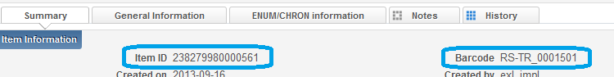

Barcode is an item identifier that used in most cases.

1. When creating user sets, I was able to successfully create sets and view the results for itemized sets and for logical sets where I used the filter option only. But for the sets where I used the find options to create the set, I got results initially and saved the set, but when I went back to view the results of the set nothing was there. I tried this several times (you can see them in the public sets for the Member1 sandbox). I also don’t see a way to “change query” for user sets like I do with repository searches.

Answer:

Please open a case for user set view Results that bringing to a blank screen.

There is no change query in user sets. May be a candidate for enhancement via NERS.

1. When exporting a set to Excel, can we specify what information to include in the export? (Example: If we pulled a set of old POs to review, and only wanted to export the title, fund, and PO date?)

Answer:

No, columns are hard coded. But, you can remove undesired columns from exported Excel.

Adding columns requires enhancement.

1. Can you customize the Excel export in the Manage sets area?  If not, can you customize Excel export of fields in Analytics or any other area of the system?  For example, we may need to create customized Excel exports that include local fields, local bib data, as well as item and holding data for reports.

Answer:

In Analytics export to Excel done based on user created report.

In Alma export to Excel columns are based on the screen and functional area and cannot be modified prior to export.

1. Can you combine types of set creation into a single search (e.g., create a set in Fulfillment and combine it with an Acquisitions or Resource Management set?)  Can you show an example, such as how to create a list of records that cost over $100 that are currently overdue?

Answer:

Advanced search has no replacement cost or inventory price fields in items search indexes.

Analytics should be used for this type of reports.

1. Can you explain when you would use Analytics vs. Create Sets, and provide some examples?

Answer:

Use for complicate reports, reports that do not possible to create by Alma search, or those that combine subject areas.

**Metadata Editor:**

1. After a record is imported how do you clean up alerts? I realize the system will accept the records with the alerts, but it would be nice to have a clean view of the records. Received "Field '019' is not listed in profile" as an alert. The 019 is a standard field that appears in OCLC MARC records. Can settings be changed so this does not get flagged as an alert?

Answer:

There are two validation routines that control alerts.

* MARC21 Bib match validation – defines the way in which validation is handled when a bibliographic record match is performed during the import process or in the MD Editor
* MARC21 Bib validation on save – defines the way in which validation is handled when importing MARC records using an import profile, copy cataloging via an external resource (such as WorldCat or LoC), and saving a bibliographic record in the MD Editor.

You can edit these validation routines here: **Resource Management > Resource Configuration > Configuration Menu > Cataloging > Metadata Configuration > [profile name]) > Validation**

However, you cannot granularly remove a single field from the validation routines, and because you are working in the Network Zone for bibs, these will need to be controlled in the NZ configuration settings. All institutions will need to agree on any changes.

1. When creating holdings records do you enter $$b in the LC call number or do we omit? All of our LC call numbers generally have the $$b in Sierra, but when they appear in the Alma holding records there are no subfields.

Answer:

Alma holding record is in MARC21 format and it has $$b where library is stored.

1. We've noticed that many record templates have errors and warnings, but we don't see a clear explanation of the errors.  Can you explain what kinds of errors and warnings are in records, and where validation rules are set up?

Answer:

See above re: validation rules.

1. Can you create a "brief record" template?  For example, acquisitions staff may need to create a brief placeholder record when they place an order.  Can we create a template that is set up to quickly enable the acquisitions operator to create a brief record?

Answer:

While you can use the Create Inventory process detailed below for Acquisitions, this will probably not be the best course of action for CalState. You will need to determine best practices across the consortium for catalog records when ordering, including:

* Search workflows for determining if a record already exists in the NZ before creating a new NZ record
* Minimum data to include in a NZ record when ordering (title, creator, identifier) so that the record will be overlaid.
* Cataloging workflows from the point of order – you could treat OCLC as authoritative. In this case, all work would start in OCLC and then records would be exported to the NZ. This aids in identifier management.

1. Similarly, can we create an "on the fly" template for fulfillment staff to use, for when a patron brings an item to check out but the barcode is not found / the item has mistakenly not been cataloged?  Or is there another way that "on the fly" records are managed?

Answer:

There is a “on the fly” creation option under Resource Management → Create Inventory. The record is added to the IZ and only Title, Library & Location are required out of the box. This process also adds physical items to the IZ.

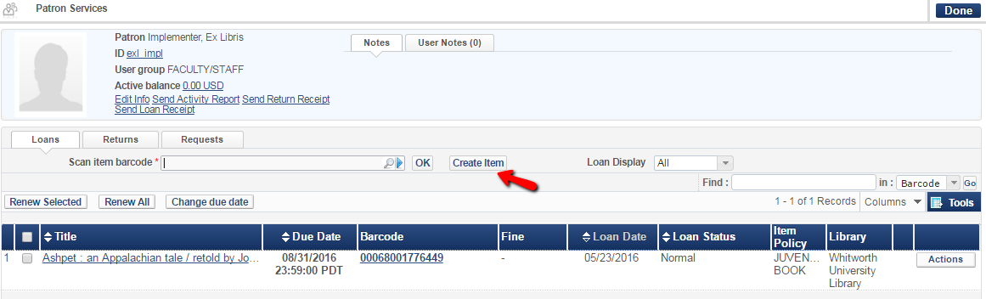The Create Inventory task can also be accessed from “Manage Patron Services” (the main circulation screen) by clicking the “Create Item” button next to the barcode scanning area.

1. Where do we configure how to generate call number from bibliographic record when creating items?

Answer: There is a call number mapping table in the Resource Management Configuration area that determines how the bibliographic record information is used for call numbers when creating a new holdings record.

More information here: <http://knowledge.exlibrisgroup.com/Alma/Product_Documentation/Alma_Online_Help_(English)/Resource_Management/040Metadata_Management/Mapping_Call_Numbers_to_Holdings>

1. In the Metadata Editor, can field labels be turned on? (similar to Sky River or Sierra)

Answer: I am unsure what is meant by field labels. MARC field numeric labels display in Metadata Editor.

1. Please expand on a saving a record as Draft vs as Record. Why not just save as Record and skip Draft?

Answer: Alma auto-saves records as a draft every 30 seconds while you are working on the record. However, if you need to step away from your work and will not return for a period of time, you can choose to save the record as a draft. This will ensure the record is still locked to your user. In addition, while a record is a draft, it is possible reload the original record from the repository and delete any changes you have made to the draft.

1. Also please clarify the options for releasing records and using the "Previous Version" feature?

Answer:

* Release record: Releases the record without saving any changes made to it
* Save and Release record: Saves all changes to the record and releases the record
* Release assignment (Catalog Manager role only): Releases record from any user lock
* Release all records for user (Catalog Manager role only): Releases all records locked by a specific user.

Previous version: When you save a record in the repository, Alma automatically backs up the previous version and saves it for future reference. Previous versions continue to be available even after an open record has been saved and released in the repository, and may be restored in the repository. When you restore a previous version you overwrite the current version in the repository.

**External Search**

1. When searching WorldCat the fields that are available to be searched are pretty limited. How do you search by Sudocs #, limit search to internet resources, limit to DLC records, etc?

Answer:

Search is possible only by fields in the form.

1. Did a search and retrieved 58 records. You are only able to view 10 records at a time then you have to click on the next page. Can the 10 records be increased?

Answer:

This cannot be changed.

1. Can you show an example of searching and importing in a record from an OCLC search?  From there can you show an example of attaching an order?

Answer:

Example - 9780375405662

1. Are the choices for external search the same for everyone or configured per user login?

Answer: configuration of profiles is same for everyone, but selected profile is saved per user.

NZ – if Institution MD Editor Option is set to Network – External Search options are coming from NZ.

NZ – configuration is shared to all consortium and credentials are shared.

**Creating Processes:**

1. Can you further explain the "catalog" function with a set of records, and why the limit of 30 records in a set?  What if you need to bulk edit hundreds of records - for instance, what if you need to add a MARC field to several hundred records - how would you accomplish this?

Answer:

There is a system limit. Hundreds of records cannot be opened and edited in a bulk in Metadata Editor at once.

Records can be changed in bulk by using a process. Process can be created for normalization rule.

In order to add a Normalization Rule as a Process follow the steps:   
  
a. Create normalization rule

b. From the Resource Management Configuration Menu choose Cataloging > Metadata Configuration: from the Metadata Configuration List choose “MARC21 Bibliographic”  
c. From the Profile Details page switch to the Normalization tab and choose “Add Process”.

d. Give a name and description to the new process, click next.  
e. In the “Task List” column select “MarcDroolNormalization” and click “Add to Selection".  
f. Now you will have in the “task parameters” tab an option to add the normalization rules.  
g. Choose the relevant rule.

Create set of records

Run the process on set of records from



Select process from

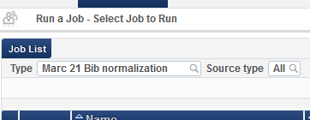

Select set

Submit the process

1. How can multiple item records be edited in batch? For example, we may need to quickly update all barcodes for multiple items attached to a single bib record.  How would this be accomplished?  In Millennium, we have the option to bring up specific fields from a set of item records for quick editing.

Answer:

There is a process –

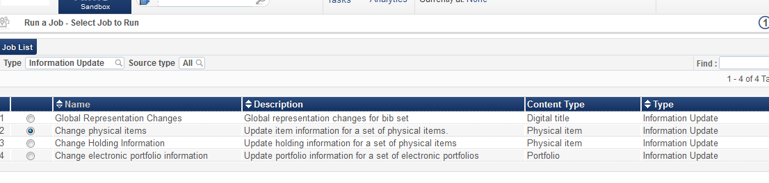

Different item fields can be updated by running job on a set of records

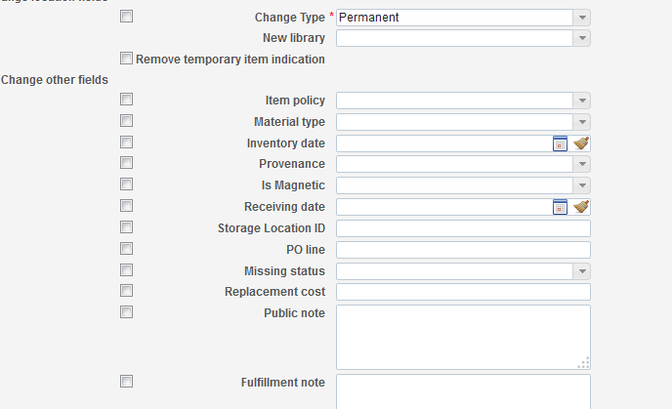

Barcode cannot be updated by this job, as it considered to be a unique field.

1. Are there only predefined "Job Types"? Can we create custom Jobs to save to the Jobs list?

Answer:

Run a Job – MARC BIB Normalization – it is possible to create customized processes using normalization rules.

1. In the Member1 Sandbox, I created a set called “Physical Items with issue year > 2000 which contains 11 items. I used that set to run a job to move them (temporarily) to course reserve but the job gave a status of “ended with error” and the report says “of the 1516 records processed, 200 records failed.” Why was the processing so many items when there were only 11 in the set. (In the Member1 Sandbox, you can see the repository set as it is set to public and the job can be viewed in the Job History tab.)

Answer:

Process is moving each item to a new location. Temporary location defined on item level.

**Consortia workflows:**

1. It seems as if the videos and exercises are developed for a non-consortial library. Can you please explain a typical workflow for a consortial library? For example, we are assuming that we will search the Network Zone for a matching record and somehow attach our library to it. How will we "download" it into our Institutional Zone? How will we update our Holdings in OCLC? When would we make our local modifications to the record?

Answer:

Workflow steps:

* Search NZ for a record
* If record found – Edit
* Add local fields
* Add inventory
* Set synchronize with OCLC flag

1. In a consortial setting, when would we use the Merge function? Will the Network Zone be one of the options for where we can retrieve records? Are our Network Zone OCLC records automatically upgraded when there are "lock/replace" changes made?

Do the changes trickle down to the Institutional records? If so, when that trickle-down happens, will we lose our local modifications to the bib record (e.g. different call numbers, local collection titles, staff notes, stripped undesirable fields, added local notes, etc.)?

Answer:

You will need to come to an agreement as a consortium for when you would use Merge functionality. In addition, you might want to set as a standard that all cataloging happens in the Network Zone. You should work on existing records wherever possible.

NZ bibliographic record is shared record. Only local fields within a specific range of fields are remain local when added as local extensions.

Inventory added in IZ is institution zone inventory. Shelf number is stored in holding record which is IZ record.

1. It says that when a catalog is working on a record in Metadata Editor, the record is "locked".  Please clarify if the "lock" applies to users of the same institution or it also forbid editing of the same record from other campuses? If a record being edited is originated from the Network zone, will the record locked for all campuses until it is released?

Answer:

Yes, record will be locked for other member institution when NZ record is edited in one of the institutions.

**Authority:**

1. How frequently are the authority headings updated?

Answer:

<http://knowledge.exlibrisgroup.com/Alma/Product_Documentation/Alma_Online_Help_%28English%29/Resource_Management/040Metadata_Management/Working_with_Authority_Records>

Alma provides a set of authority records that are updated and maintained regularly by Ex Libris in the Community Zone. Alma maintains the following vocabularies:

* LC Subject (LCSH) – Library of Congress Subject Headings (updated weekly)
* LC Name (LCNAF) – Library of Congress Name Authority File (updated weekly)
* NLM MeSH – United States National Library of Medicine Medical Subject Headings (updated annually)
* GND – German National Library - Subjects and Names Authorities (updated daily)
* BARE (Norwegian Authority System) – BIBSYS Authority Registry - Subjects and Names Authorities (updated daily). See [Working with Norwegian Authority System (BARE) Records](http://knowledge.exlibrisgroup.com/Alma/Product_Documentation/Alma_Online_Help_%28English%29/Resource_Management/040Metadata_Management/Working_with_Authority_Records#Working_with_Norwegian_Authority_System_%28BARE%29_Records) for more information.
* Library of Congress (LoC) – Medium of Performance Thesaurus for Music (updated when available)
* Library of Congress (LoC) – Genre/Form Terms thesaurus records (updated weekly)
* RVK Classification(updated twice a year). See [Working with the RVK Authority Record Classification](http://knowledge.exlibrisgroup.com/Alma/Product_Documentation/Alma_Online_Help_%28English%29/Resource_Management/040Metadata_Management/Working_with_Authority_Records#Working_with_the_Regensburger_Verbundklassification_%28RVK%29_Authority_Record_Classification) for more information.
* Library and Archives Canada (LAC) – Canadian Subject Headings (updated when available)
* Library and Archives Canada (LAC) – Canadian Name/Title Authorities (updated when available)
* National Library of Israel – Multilingual Thesaurus (updated daily)

Alma runs the following jobs automatically every day to authorize the bibliographic records in your catalog:

* Authorities - Link BIB Headings – This job searches all authority (and local authority, if enabled by Ex Libris Support) record fields, including subdivision fields, for complete terms listed in bibliographic records (giving priority to local authorities, if enabled). If exact matches are found, the bibliographic records are linked to the corresponding authority records. If exact matches are not found, the subdivision fields are disregarded, a search of all authority records is performed once again, and the bibliographic records are linked to the matching authority records that are located during the second search.

Authorities - Preferred Term Correction – This job performs preferred term correction on all bibliographic records that are linked to authority records using the Authorities - Link BIB Headings job. For example, if a bibliographic record contains the non-preferred term “Narcotics, Control of,” and the associated authority record contains the preferred term “Drug control,” the Authorities – Preferred Term Correction job replaces “Narcotics, Control of” with the preferred term “Drug control.” Note that bibliographic records are also updated with any subsequent updates to authority records.

**OCLC Connexion:**

1. Are we able to still use Connexion Client as we have in the past to search and export records in Alma or does everything need to be done in Alma?

Answer:

Connexion client can be integrated with Alma and you will be able to export records from Connexion into Alma.

See document for details:

<http://knowledge.exlibrisgroup.com/Alma/Product_Documentation/Alma_Online_Help_%28English%29/Integrations_with_External_Systems/030Resource_Management/Importing_Records_from_OCLC_Connexion>

1. Is it possible to import bibs with holdings from OCLC (in other words, create the holdings record in OCLC, and when exporting the bib, include the holdings into Alma so that a holdings record is automatically created from the OCLC holdings?

Answer:

Not yet possible to create holdings when exporting record from Connexion to Alma.

1. Will the Metadata Editor replace the functions of OCLC Connection?

Answer: No

1. Can we begin our cataloging work directly in OCLC WorldCat and download records directly from OCLC to ALMA? Please describe that process.

Answer:

Configuration:

* Create Connexion profile in Alma
* Configure Connexion to work with Alma

**connexion.oclc.org**

General > Admin > Preferences > Export Options

Hostname:  enter Alma inst host name

Port:            5500

Login ID:     01XXX_INST

Password:  ***enter pwd same as in Connexion profile in Alma***

***Example:***

***for Sandbox - https://sandbox01-na.alma.exlibrisgroup.com/mng/login?institute=01CALS_SJO***

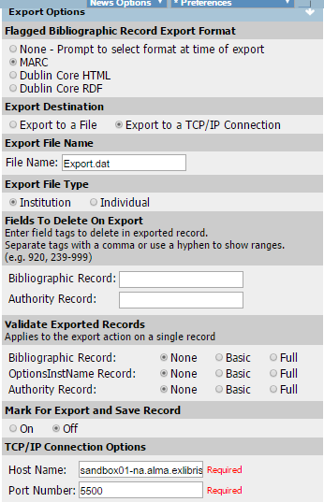

**Testing Export using connexion browser**

1. Click Cataloging (top tab)
2. Search for record – for example:  Kwajalein Marshall Islands
3. Selected:  Kwajalein Infrastructure Prioritization Methodology
4. Select on lower screen Action drop-down:  **Export Record in MARC**
5. Connexion displays message:  **Record Exported**
6. Check for title in Alma

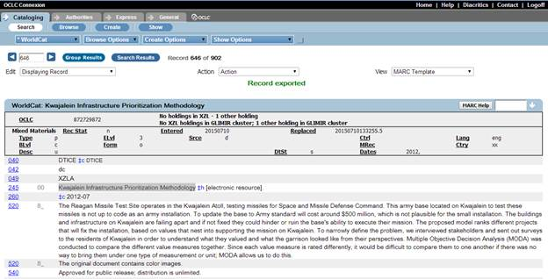

**Synchronization with OCLC**

* 1. The video mentions the process of batch synchronizing ALMA records with OCLC WorldCat-- does it mean matching OCLC records and "attaching library holdings" in OCLC"", or, "to upload edited fields to update OCLC master records"?

Answer:

Yes. There is a processes in Alma which enable to synchronize library holdings with OCLC.

Every record that has OCLC number will migrate into Alma marked for synchronization with OCLC.

Sites that publish data to OCLC required to configure publishing profile in Alma.

Just after final load every site should run baseline publishing in order to activate incremental automatic publishing.