4 Things in Alma have to be configured for your ASRS to function:
- An ASRS Integration Profile (Configure at the Institution Level)
- A Remote Storage Facility (Configure at the Institution Level)
- Physical Location Codes w/ Location Type = Remote Storage AND the remote storage integration profile selected. (Configure at the Library Level)
- Request TOUs for the ASRS location codes must be set to “Is Requestable” and “Allow Requesting Regardless of Availability” for the On Shelf Policy in order for the Request button in Primo to appear. Can be applied to an entire FU, or to individual ASRS locations that may be a part of a different FU.
ASRS Integration Profile and Remote Storage Facility
Under General Configuration.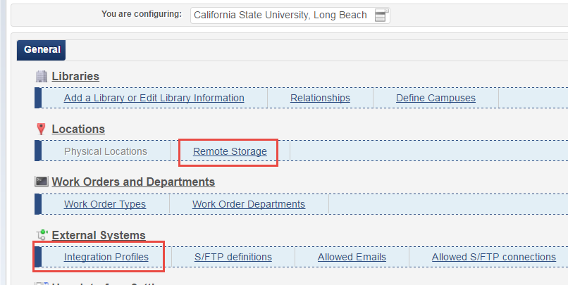

Here’s what we set up for the Integration Profile: (We call our ASRS ORCA).
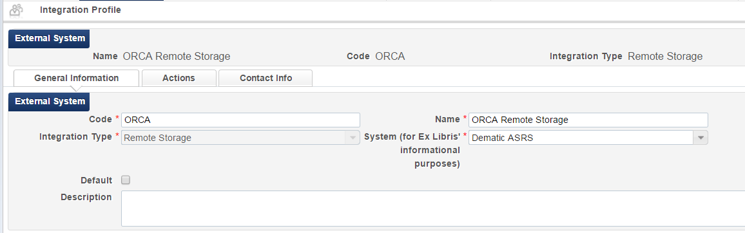
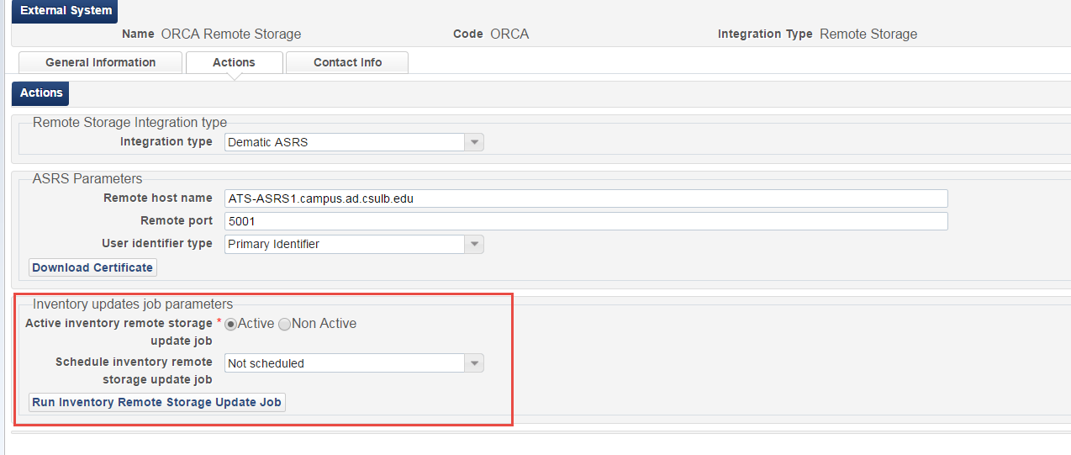
The inventory update job is what adds or removes remote storage inventory. When you put an item in a location that has been defined as a remote storage location (see screenshots below), it will be added to the inventory once the job runs (can be scheduled to run as often as every two hours, or can be run manually from the Integration Profile). Similarly, if something is moved out of a remote storage location code, the update inventory job will remove the item from the remote storage inventory.
Remote Storage Facility:
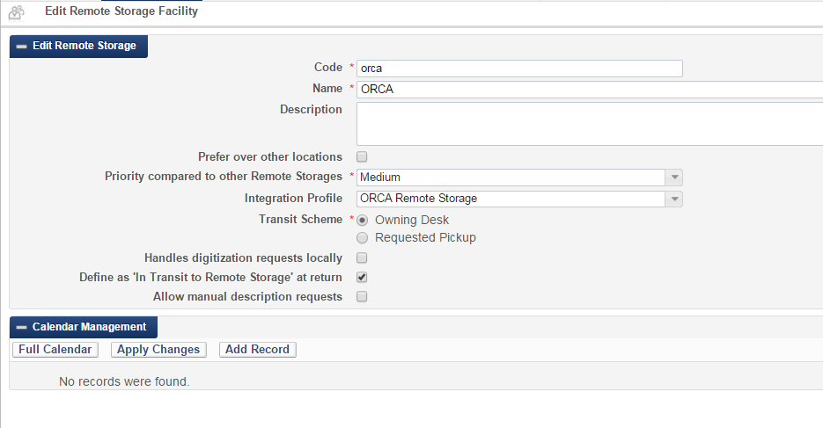
Physical Locations
Mark any physical location codes that you use in your ASRS with “Location Type” = Remote Storage. Also make sure to select the appropriate remote storage integration profile. Edit the physical location at the library level under General Configuration.
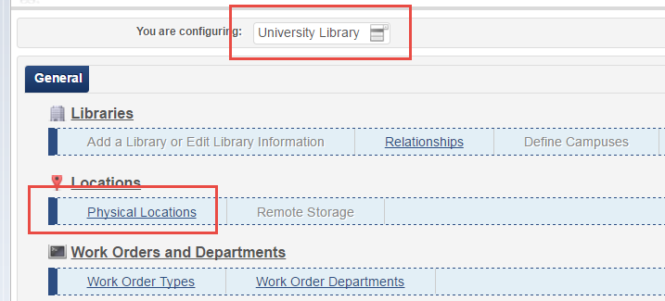

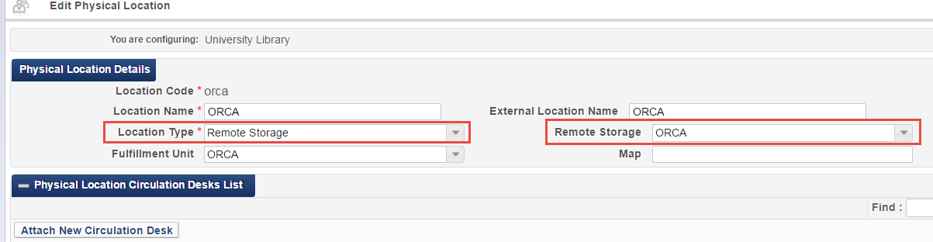

Request TOUs for Primo Request button to appear:
