Using the Vimperator add-on for Firefox to convert most links to keyboard shortcuts

Vimperator is a Firefox add-on that, among other things, enables you to operate Firefox and navigate web pages by using the keyboard exclusively (rather than a mouse) for most operations. It includes keyboard equivalents for common browser commands (such as opening a new tab). Many of these are described at http://www.linux-mag.com/id/7723/. Vimperator also has the ability to convert most links into keyboard shortcuts, which can be used when working in Alma.

Downloading and installing Vimperator

- Google “vimperator” or go to https://addons.mozilla.org/en-us/firefox/addon/vimperator/

- Click “Continue to Download”
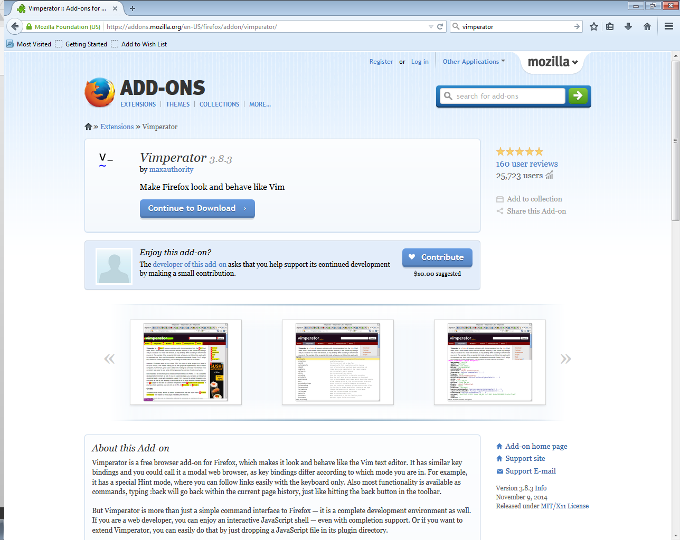
- Click “Add to Firefox”
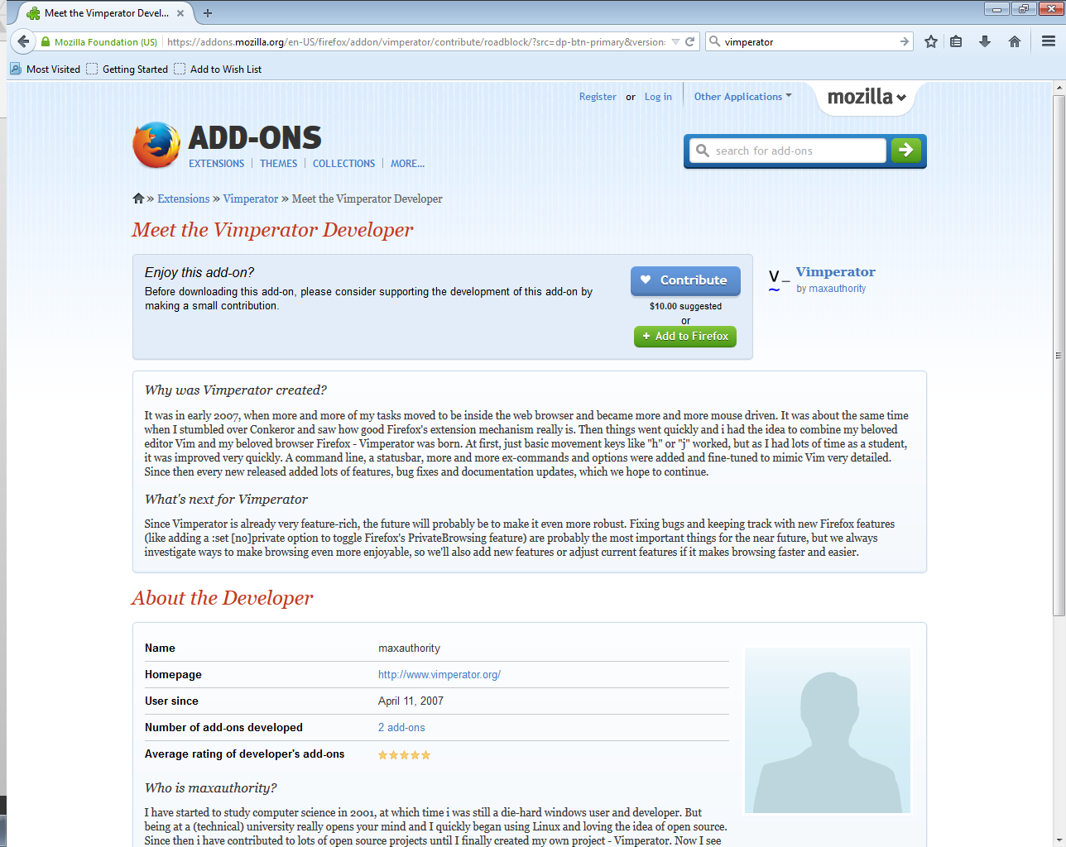
- This box should pop up, click “Install Now”
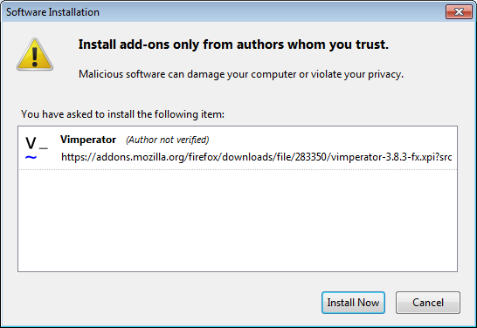
- Vimperator will be installed after you restart Firefox
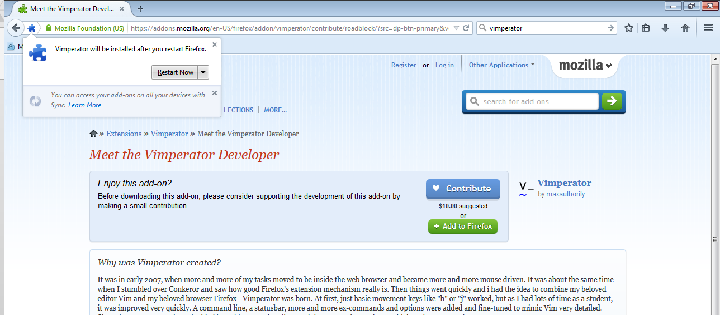

- This page should appear when you close and reopen Firefox
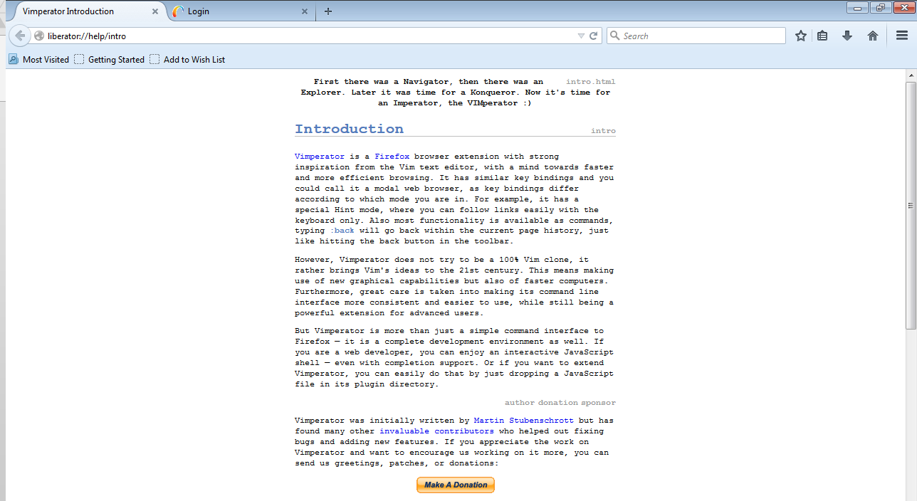

Orientation to Vimperator

By default, Vimperator is turned on when you open your browser. Use Shift + Esc to toggle Vimperator on and off at any time. If Vimperator doesn’t seem to be responding or you want to undo an action (such as “f” to display keyboard shortcuts for links), click Esc to reset Vimperator. Vimperator status can be seen across the bottom of the browser.
After typing “f”:

Vimperator turned off:
To display keyboard shortcuts for links and elements that include links on a page, press the “f” key. This will highlight the links on the page and put numbers next to them. Instead of clicking on a link with the mouse, navigate by typing the number next to the link. Be aware that the “d” key is next to “f” and will close (delete) the current tab.

Using Vimperator in Alma
If you type “f” from the Alma main screen, you will see something like the screen below. To navigate the page, type one of the numbers highlighted in red.

Type “f”.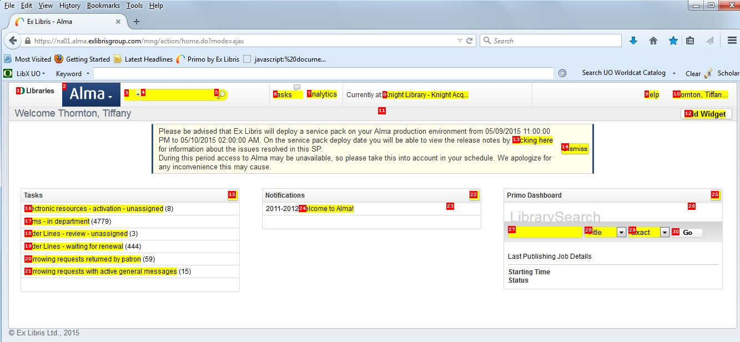

In this example, if you wanted to access the Alma menu, you would type “2”:
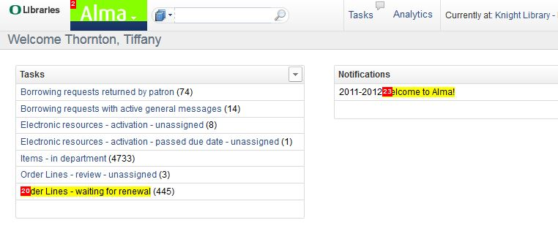Notice that the Alma menu is highlighted in green. This is because it has been given a single-digit number and there are enough links on the page that some links are assigned double digit numbers that begin with that same number. To select a single-digit number, such as the two for the Alma main menu above, type Enter at this point. To select a link with a double-digit number, such as order lines in the above example, type the second digit in the number (0).
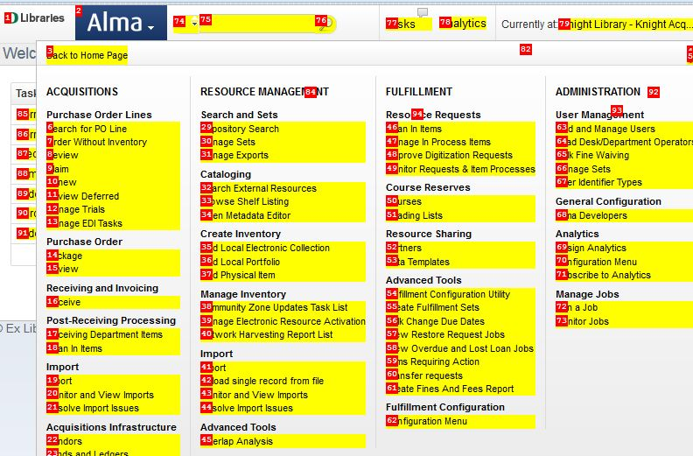

You can access most of Alma’s functions by continuing to type the numbers highlighted in red on successive pages. From this page, if you wanted to access the “add local portfolio” function, you would type “36”.
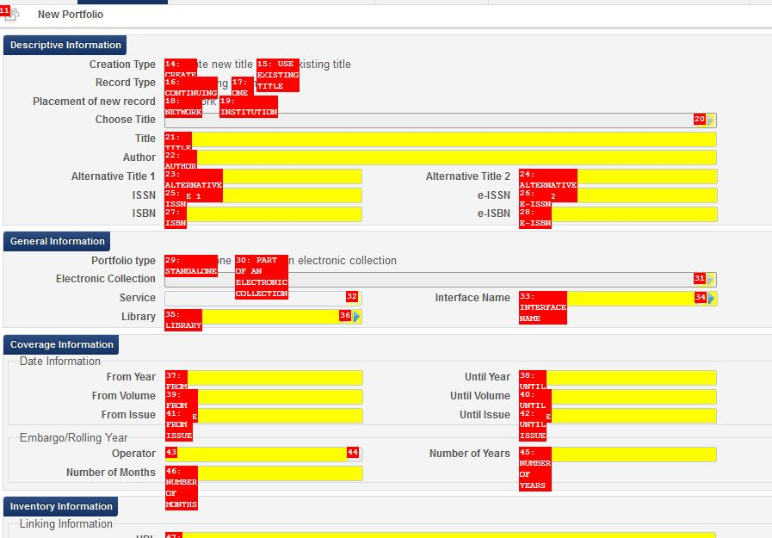
From this screen, if you type “15”, you will prompt Alma to toggle the “use existing title” button.

Vimperator keyboard shortcuts can be used with most Alma functions, but it’s still necessary to use the mouse at certain points.
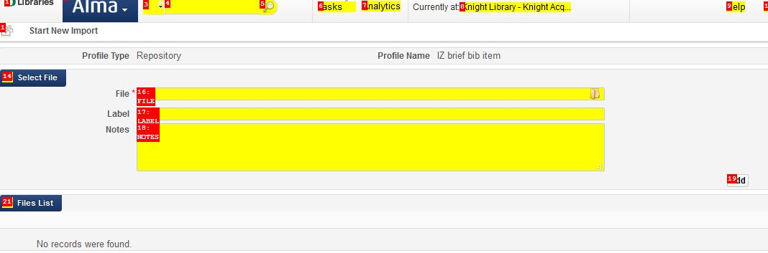

In the example above, once you reach the point where you need to browse to the file you want to import, you will have to use the mouse to click on the file icon; typing the red numbers doesn’t work.
Vimperator will not create keyboard shortcut for floating boxes like the one used to select fields in advanced search. This is another situation in which it is necessary to use the mouse.
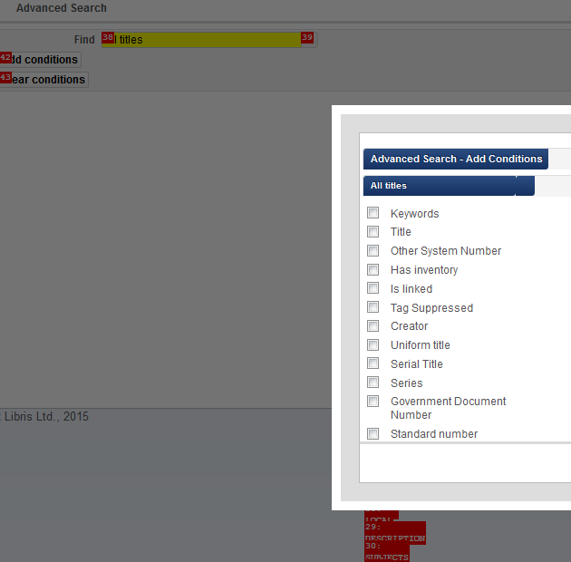

Button overlap:
Sometimes the number of the element you want is obscured by another number, as in the examples below:
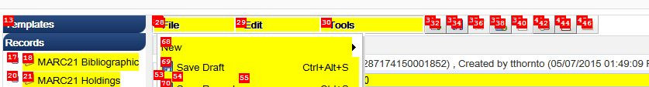

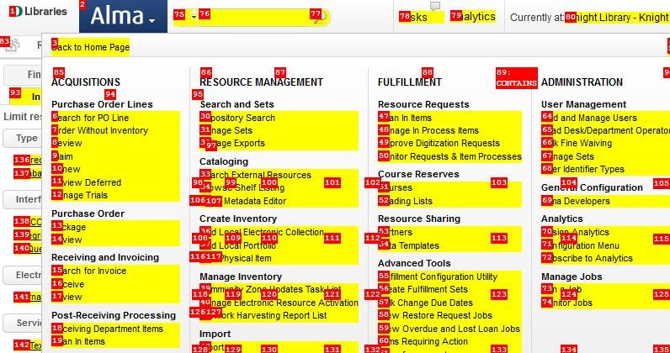
You can usually identify the obscured number by looking at the numerical order of the surrounding numbers. In the first example, you would be reasonably able to assume that the obscured number is 41, and in the second example, that the number is 34.
Numbers are often obscured for dropdown menus, like this one from Manage Sets. By counting up from 59, you can determine that edit is 60, results is 61 and so on.
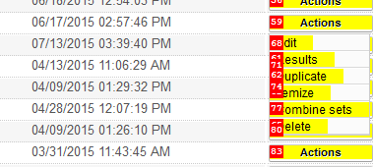
Typing the probable first digit may also identify the correct number. However, notice that in this example, the 60 for edit is still obscured by 68. 68 appears to close the dropdown list.
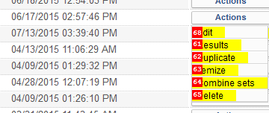

Vimperator in the Metadata Editor

Vimperator will work with Alma’s metadata editor, but there are a couple of potential drawbacks to be aware of. If your cursor is positioned in a box where you are able to type text, you will need to key Esc before typing “f.” Otherwise, the “f” will simply be inserted into the text box as shown below. Hitting Esc takes the cursor out of the text box, which enables you to type “f” to turn on the Vimperator link keyboard shortcuts. This can happen on any screen with text boxes (for example, when editing item records).
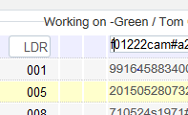
If you choose to use the top menu buttons in the metadata editor, you will have to remember to key Enter after you have keyed the number of the button you want.
For example, to add a holdings record from the metadata editor:

Key “33”
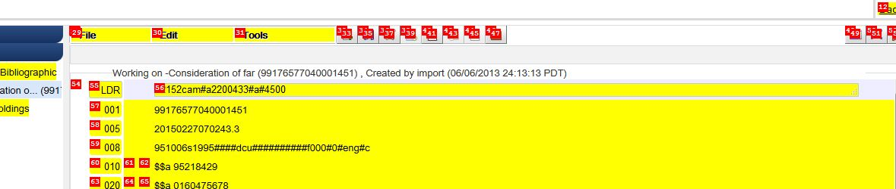
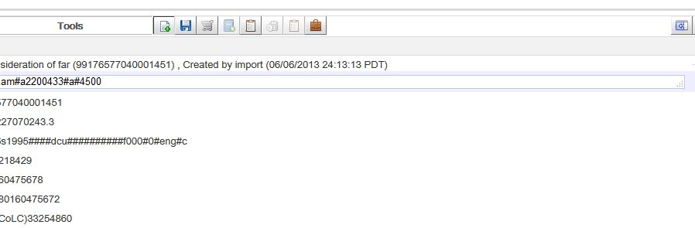

Then key Enter when you see the add holdings button is depressed.
In addition, the Vimperator interpretation of any keystrokes may override the Metadata Editor keyboard shortcuts. However, at least some Alma keyboard shortcuts will continue to work with Vimperator turned on.

